

Dear Parents/Carers,
Welcome to our fourth newsletter. As we approach the half-term, I thought I would take the opportunity to share some of the exciting things coming up
Wear Red Day

On the 23rd October, we will be holding our traditional ‘Wear Red Day’. This is in memory of our lovely Thomas McNamee – who died whilst at school from heart failure. During the day, the children will be able to purchase goodies, get nails painted, hearts drawn on faces etc. The money raised will go towards resources for our children. Rough prices are:
£1 Drinks, chocolate, cookies and doughnuts
50p Crisps, hearts painted, nails painted
Halloween Day

On the 4^{th of} Nov, the children can come into school in their costumes; the best costume in each class will win a small prize.
If you would like to bring in any pumpkins too, they can be placed around the classrooms. There will be some treats on sale too - similar to above prices.
Year 3 Stone-Age Workshops

🔥 Travel Back in Time! 🔥
On the 5th and 6th of November, our year 3s will step into the fascinating world of the Stone Age and discover how people lived thousands of years ago.
🦣 Explore prehistoric life
🏹 Learn about hunters and gatherers
🔥 Discover how early humans survived
🦴 Handle exciting artefacts
🎨 Take part in interactive activities
⭐ A hands-on history experience that brings learning to life! ⭐

Rocksteady Concert

The children attending Rocksteady will share their love of music on the 15th of December at 9:15. Please come along and watch the children showcase all their musical skills live on stage!
Rocksteady concerts are a celebration of music, learning and collaboration, made all the better with friends and family watching. Concerts help children build their confidence by performing in front of a supportive audience.
Concerts are a natural complement to your school's parental engagement offer. In a survey of almost 7,000 Rocksteady parents, 74% of those who have attended a concert said it made them feel more connected to their child's school.
Inclusion Strategy
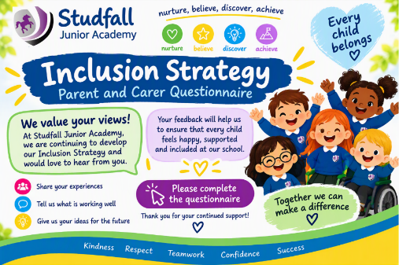
We are developing a new Inclusion Strategy for our school and would greatly value your views.
Inclusion is about ensuring that every child feels welcomed, valued, respected and able to participate fully in school life. While this includes supporting pupils with Special Educational Needs and Disabilities (SEND), inclusion is much broader than this. It also considers how we remove barriers that may affect learning, attendance, wellbeing, participation, belonging and achievement for any child.
Across education, there is growing recognition that the most effective schools are those that create environments where all pupils can thrive, regardless of their starting point, background, needs, circumstances or individual differences. An inclusive school promotes high expectations for all, celebrates diversity and ensures that every child has access to the support, opportunities and experiences they need to succeed.
To help shape our strategy, we are seeking feedback from parents and carers about what is working well, what challenges children and families may face, and what should be prioritised in the future. Your views will play an important role in helping us develop an Inclusion Strategy that reflects the needs of our school community.
The questionnaire is organised around the Seven Principles of Inclusion, which provide a framework for considering how schools create a culture where all children can belong, participate and achieve.
By sharing your experiences and perspectives, you will help us identify strengths, understand any barriers that exist, and develop clear actions to make our school even more inclusive for all children and families. Click on this link for the questionnaire:
Inclusion Questionnaire – Fill in form

MHST Parent Drop-In Coffee Morning
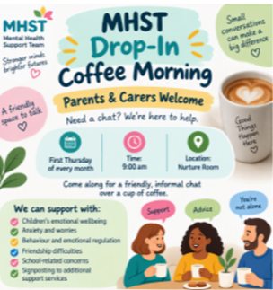
We are pleased to announce that, on the first Thursday of every month, our Mental Health Support Team (MHST) will be holding a Parent Drop-In Coffee Morning.
This is an opportunity for parents and carers to meet with members of the MHST in an informal, supportive setting. One of our Learning Mentors will also be available for a chat and can offer advice and guidance on a range of concerns, including:
- Anxiety and worries
- School attendance
- Sleep routines and management
- Managing emotions and wellbeing
Whether you have a specific concern or would simply like some advice and support, we would be delighted to see you.
Our first session will take place on Thursday 5th November at 9:00am.
Reminders
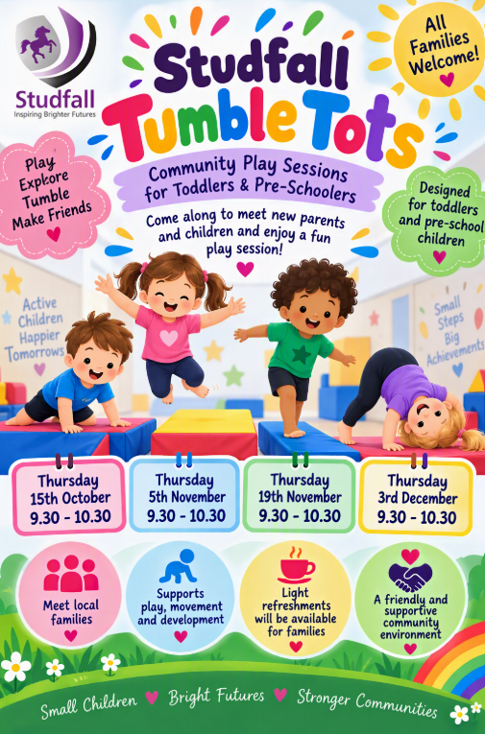
A big thank you to everyone who has attended and supported Studfall Tumble Tots at Studfall Infant Academy. These friendly community play sessions are designed for toddlers and pre-school children, providing a wonderful opportunity for little ones to develop their movement, play and social skills while having fun. Families can meet new friends, enjoy light refreshments and become part of a warm and supportive community. We look forward to welcoming more families and friends to these exciting sessions 😊 Next one is after half term.
School Photos
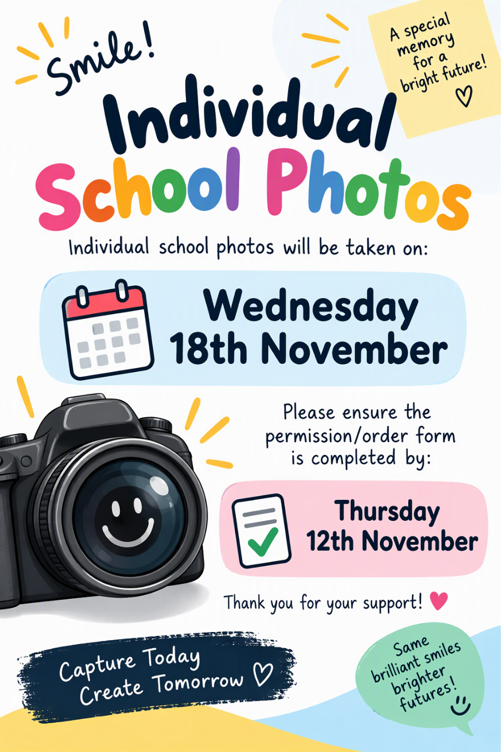
School individual photos will be taken on Wednesday 18th November 2026. Family photos for siblings that do not attend our Academy will be from 8am in the main hall. A link has been sent previously via email to complete if you wish siblings attending our Academy to have their photo taken together on this day. This form needs to be submitted by Thursday 12th November 2026.
School Sibling Photographs – Fill in form
Parents’ Evenings
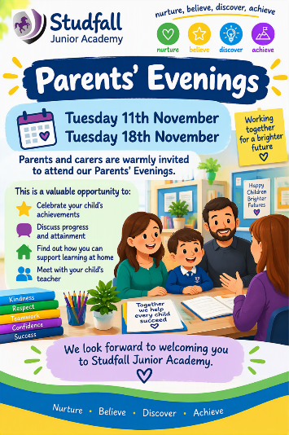
Parents evening will be on Wednesday 11th November and Wednesday 18th November from 3.40pm - 5pm.
If you would like to attend, please message your child's class teacher via Dojo with your preferred date and time. If you have siblings in the school, can you please let your child's class teacher know which class they are in, so we can ensure you have appointments near each other.
We look forward to seeing you 😊

If you require any further information, please don’t hesitate to email either:
admin@studfalljunioracademy.org
or
gmurray@studfalljunioracademy.org
Please do not hesitate to contact any member of staff by email.
Best wishes,

Geri Murray
Head of Academy

Dates for the Diary
Monday 2nd November Training Day
Tuesday 3rd November Children start back Flu vaccinations
Wednesday 4th November Halloween day
Thursday 5th & 6th November Year 3 Stone Age workshops
Wednesday 11 November Parent consultations
Wednesday 11th November Remembrance Day
Friday 13th November Children in Need and World Kindness Day
Monday 16th – 20th November Anti-bullying Week and Internet safety week
Wednesday 18th November Individual photos
Wednesday 18th November Parent consultations
Monday 30th November Science week
Tuesday 1st December Yr 5/6 Sports Hall Athletics
Thursday 10th December New Age Kurling
Friday 18th December CLOSE FOR CHRISTMAS

