3 | Valuing Difference  Recognising and respecting diversity  Being respectful and tolerant  My community  Bullying (inc online)  World Mental Health Day  Black History Month  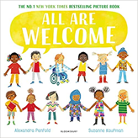  Hate Crime Week  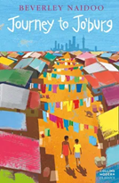 | Me and My Relationships  Rules and their purpose  Cooperation  Friendship (including respectful relationships)  Coping with loss  Online rules,  Restrictions  Online behaviours  How should we treat people?- Pol-Ed  World Kindness Day  Anti-bullying week  Wear Red For Thomas Day  Road Safety Awareness workshop  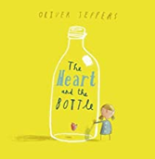 | Rights and Responsibilities  Skills we need to develop as we grow up  Helping and being helped  Looking after the environment  Managing money  Developing critical thinking  What is the law and why do we have it? What are children’s rights? – Pol-Ed  Life Bus workshop  Careers Week  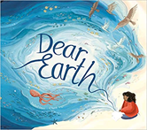 | Being My Best  Keeping myself healthy and well  Celebrating and developing my skills  Developing empathy  How can I share my worries? What is mental health? Pol-Ed  Mental Health Awareness Week  International Women’s Day  World Sleep Day  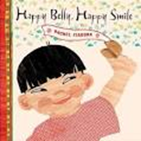 | Keeping Myself Safe  Managing risk  Decision-making skills  Drugs and their risks  Staying safe online  Digital literacy  What are emergency situations? Pol-Ed  First Aid- Emergencies and calling for help  Basic Life Support  Bites and Stings  Mental Health Awareness Week  Well-being week  Sun Awareness week  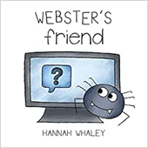  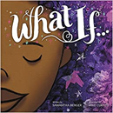 | Growing and Changing  Relationships  (inc online)  Changing bodies and puberty  Keeping safe  Safe and unsafe secrets  Pride Month  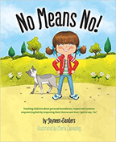
4 | Valuing Difference  Recognising and celebrating difference (including religions and cultural difference)  Understanding and challenging stereotypes  What is hate crime?  Pol-Ed  World Mental Health Day  Black History Month  Hate Crime Week    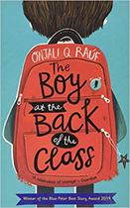 | Me and My Relationships  Healthy relationships  Listening to feelings  Bullying  Assertive skills  What is peer influence?-Pol-Ed  World Kindness Day  Anti-Bullying Week  Road Safety Awareness Workshop  Wear Red For Thomas Day  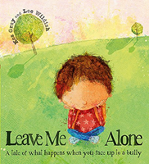  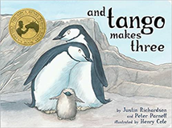 | Rights and Responsibilities  Making a difference (different ways of helping others or the environment)  Media influence and digital literacy  Decisions about spending money  Life Bus Workshop  Careers Week  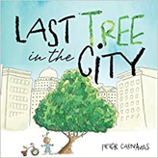 | Being my Best  Having choices and making decisions about my health  Taking care of my environment  My skills and interests  How does school build my character?How do my choices help to keep me healthy? Pol-Ed  Mental Health Awareness Week  International Women’s Day  World Sleep Day  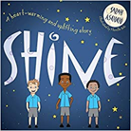  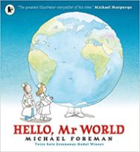 | Keeping myself Safe  Managing risk inc online  Online safety and behaviours  Understanding the norms of drug use (cigarette and alcohol use)  Influences  First Aid _ Emergencies  Basic First Aid  Asthma  How can I keep myself safe on the road? Pol-Ed  Well-being week  Solve It  Sun Awareness week  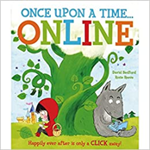 | Growing and Changing  Body changes during puberty  Managing difficult feelings  Relationships including marriage  Pride Month  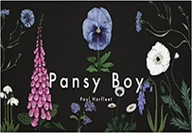
5 | Valuing Difference  Recognising and celebrating difference, including religions and cultural  Influence and pressure of social media  Critical digital awareness  Online bullying and self-esteem  What are protected characteristics?Pol-Ed  World Mental Health Day  Black History Month  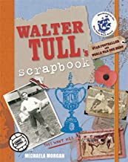  Hate Crime Workshop  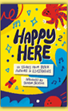 | Me and my Relationships  Feelings  Friendship skills, including compromise  Assertive skills  Cooperation  Recognising emotional needs  What is grooming?-Pol-Ed  World Kindness Day  Road Safety awareness week  Anti-Bullying Week  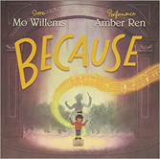  Workshop for Anti-bullying week  Wear Red For Thomas Day | Rights and Responsibilities  Rights and responsibilities  Rights and responsibilities relating to my health  Making a difference  Decisions about lending, borrowing and spending  Media manipulation  Artificial intelligence  What are the risks with money?  How do rules help our community? Pol-Ed  Careers Week/Challenging Stereotypes  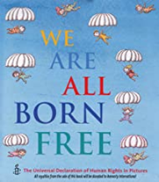 | Being my Best  Growing independence and taking responsibility  Keeping myself healthy  Media awareness and safety  My community  What is media influence? Pol-Ed  Mental Health Awareness Week  International Women’s Day  World Sleep Day  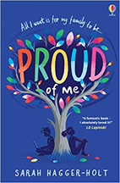 | Keeping Myself Safe  Managing risk, including online safety  Norms around use of legal drugs (tobacco, alcohol)  Decision-making skills  Bullying (inc online)  What are deep fakes? How can drugs and alcohol make people feel? Pol-Ed  Well-being week  Sun Awareness week  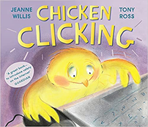 | Growing and Changing  Managing difficult feelings  Preparing and managing changes at puberty  How my feelings help keeping safe  Getting help  How might puberty impact the way I feel? Pol-Ed  First Aid-Emergencies  Basic First Aid  Bleeding  RSE  Alcohol Workshop  Pride Month  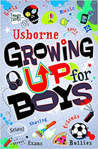  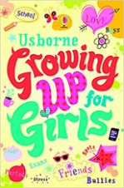
6 | Valuing Difference  Recognising and celebrating difference Recognising and reflecting on prejudice-based bullying  Understanding Bystander behaviour  Gender stereotyping  How can we be allies against racism?  How can we challenge sexism? Pol-Ed  World Mental Health Day  Black History Month  Hate Crime Workshop  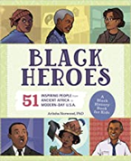  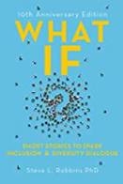  St Columba’s Church visit  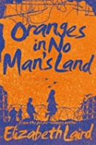 | Me and my Relationships  Assertiveness  Cooperation  Safe/unsafe touches  Positive relationships  How can we respect different relationships? Pol-Ed  World Kindness Day  Anti-Bullying Week  Wear Red For Thomas Day  Road Safety Awareness week  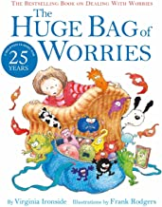 | Rights and Responsibilities  Understanding media bias, including social media  Digital critical thinking  Caring: communities and the environment  Earning and saving money  Understanding democracy  What is antisocial behaviour? What different types of crime are there? Pol-Ed  Careers Week/Challenging Stereotypes  Moneysense Workshops with Natwest  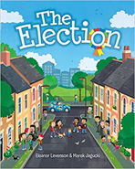 | Being my Best  Aspirations and goal setting  Managing risk  Looking after my mental health  Digital literacy and critical thinking skills  How can I reframe my thinking?  How can I seek support for mental health? Pol-Ed  Mental Health Awareness Week  International Women’s Day  World Sleep Day  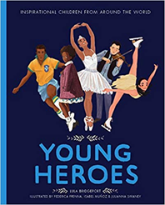 | Keeping Myself Safe  Understanding emotional needs  Staying safe online  Drugs: norms and risks (including the law)  Digital footprint  What is spiking? What is the issue with addiction?  RSE  Warning Zone trip  Solve It  Alcohol Workshops  Well-being Week  First Aid  Sun awareness week  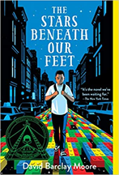 | Growing and Changing  Coping with changes  Keeping safe (inc online)  Body Image  Sex education  Self-esteem  AI- deep fakes  How can I cope with leaving school?Pol-Ed  Pride Month  Secondary School Transition  

