 | Year 3 Long Term Plan 2026 -2027
Year 3 | Autumn 1 | Autumn 2 | Spring 1 | Spring 2 | Summer 1 | Summer 2
TOPIC | How did the Steel Works change Corby? | How did daily life change in Britain from the Stone Age to the Iron Age? | Is the coast a good place to live? | What’s under our feet? | What did the Romans do for Britain? | Why do people visit the Mediterranean?
DRIVER | History | History | Geography | Geography | History | Geography
Humanities | Topic: History of Corby including the steelworks.  Curriculum focus:  A local history study. A study of an aspect of a site dating back from a period beyond 1066 that is significant in the locality.  PSHE Links to emotions and change. | Curriculum focus:  Bronze and Iron age religion, technology and travel.  Iron age hill forts: tribal kingdoms, farming, art and culture.  Changes in Britain from the Stone Age to the Iron Age- late Neolithic hunter-gatherers and early farmers, Skara Brae  Stone Age to Iron Age Day to launch the topic. | Science links:  Rocks topic  Living in Cornwall.  Subject: Geography  Curriculum focus:  -Locational knowledge  -Place knowledge  -Human and physical Geography  -Geographical skills and fieldwork  English Link to text: Mousehole Cat  Coastal link – using the text to investigate Mousehole as a coastal village to launch the topic. | Curriculum focus:  -Locational knowledge  -Human and physical Geography | Curriculum focus: The Roman Empire and its impact on Britain.  Roman Day to launch the topic. | Curriculum focus:  -Locational knowledge  -Place knowledge  -Human and physical Geography  -Geographical skills and fieldwork
Art | Drawing Skills
Art | Driver: History of Corby including the Steelworks  Skill: Drawing  Focus: Tone  Key Experiences:  - Experiment with media  - Light and dark in the environment  - Recognise different tones of one colour  Suggested Outcomes: Industrial scene tonal drawing |  | Driver: What do our coasts look like?  Skill: Collage  Focus: Texture  Key Experiences:  - Combine a range of materials  - Embellish on collage work  - Simple weaving  Suggested Outcomes: Collaborative collage |  | Driver: Why do people go to the Mediterranean?  Skill: Painting  Focus: Colour  Key Experiences:  - Harmonious colours  - Tertiary colours (mixture of secondary colours and their opposite primary colours in the circle)  - Matching colour to environment  Suggested Outcomes: Painting on canvas
Suggested Artists-  Stimuli | - L S Lowry  - Industrial landscapes by day/night/sunrise/set  - Any appropriate artists conveying dark/light to reinforce objectives |  |  | - Kurt Schwitters  - Impressionist other than Monet and Van Gogh  Any real or imaginary composition | - Paul Cezanne
D&T |  | Construction  Levers/Linkages and Pop-ups  Christmas Cards with Moving Parts |  | Food  Design an organic deli sandwich – Instruction writing DT books |  | Food  Design and make a new pizza-based product
RE | Diversity within Hindu Dharma: What are the important beliefs to Hindus and how do they live? | How and why are people welcomed into different communities? | Diversity within Hindu Dharma: Why is Diwali an important festival to Hindus? | Why is Jesus a special person to some religious people? | What do Jews learn about Passover? What special things might they do? | How do beliefs and ideas about land shape the way human beings live?
Indoor PE | Gymnastics  Perform jumps, rolls, balances and apply to a sequence with apparatus.  (New Primary P.E Plan.) | Dance -  Greatest Showman  (New Primary P.E plan.) | OAA  (New Primary P.E plan.)  Swimming  (2 classes) | OAA  (New Primary P.E plan.)  Swimming  (2 classes) | Circus Skills  Splat circus  (Cambridgeshire Plan) | Dance –  The Romans  (New Primary P.E plan.)
Outdoor PE | Ball skills –  Hand ball  (New Primary P.E plan.) | Hockey – Quick sticks  (New Primary P.E plan.) | Multi-Skills  (New Primary P.E plan.) | Multi-Skills  (New Primary P.E plan.) | Tag rugby  (New Primary P.E plan.) | Athletics  (New Primary P.E plan.)
Computing  E Safety  Computer Science  Digital Literacy  Information Technology | Unit 7  E Safety Respect online.  CS - Programming and control. | Unit 8  CS – Debugging and Problem Solving | Unit 13  E-Safety How to stay safe online.  CS - Programming  E-Safety  Cyberbullying | Unit 14  CS - Programming  I T - Inputs & Outputs | Unit 15  CS - Programming Control  E-Safety Sharing Information  Unit 16  CS - Loops + Sequences | Unit 17  CS –Programming  Properties and Sequences  DL - Jobs in Computing  Unit 18  E-Safety:  Email Safety  CS –Programming  Repetition  IT Using Forums  & Blogs  E-Safety  Password Safety
PSHE | Equality, diversity and inclusion is woven throughout the curriculum. Where it is mentioned below, this is because there is a particular focus on this- following our ethos: Nurture, Believe, Discover, Achieve.
PSHE | Valuing Difference  Recognising and respecting diversity  Being respectful and tolerant  My community  World Mental Health Day  Black History Month  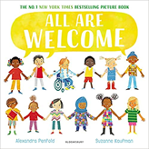  Hate Crime Week  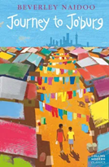   | Me and My Relationships  Rules and their purpose  Cooperation  Friendship (including respectful relationships)  Coping with loss  Anti-bullying week  Wear Red For Thomas Day  Road Safety Awareness workshop  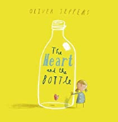   | Rights and Responsibilities  Skills we need to develop as we grow up  Helping and being helped  Looking after the environment  Managing money  Life Bus workshop  Careers Week  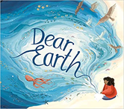     | Being My Best  Keeping myself healthy and well  Celebrating and developing my skills  Developing empathy  Mental Health Awareness Week  International Women’s Day  World Sleep Day  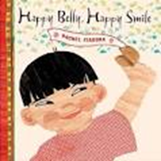 | Keeping Myself Safe  Managing risk  Decision-making skills  Drugs and their risks  Staying safe online  First Aid- Emergencies and calling for help  Basic Life Support  Bites and Stings  Mental Health Awareness Week  Well-being week  Sun Awareness week    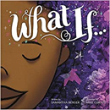 | Growing and Changing  Relationships  Changing bodies and puberty  Keeping safe  Safe and unsafe secrets  Pride Month  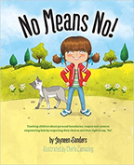
Music | Let your Spirit Fly.  Musical Genre: RnB  Artists:  Joanna Mangona  Marvin Gaye  Barry White | Glockenspiel Stage 1  Performance focus | Composer Focus:  Mozart  Austrian  Classical Period  Focus Piece:  Horn Concerto No.4 – 3rd movement | Three little Birds  Musical Genre: Reggae  Artists:  Bob Marley  Ziggy Marley  Amy Winehouse  Pluto Shevington  Easter Concert | The Dragon Song  Musical Genre: Folk songs – Focus on China | Bringing us together  Musical Genre: Disco  Artists:  Nile Rodgers  Chaka Khan  Sister Sledge  Rose Royce
Composers | Film Music  John Williams  John Powell  Thomas Newman  Benj Pasek and Justin Paul | Music from other cultures  Scott Joplin  Duke Ellington  Made Subandi  Babatunde Olatunji | British Composers  Edward Elgar  Ralph Vaughan-Williams  Henry Purcell  Benjamin Britten | Female Composers  Clara Schumann  Judith Weir  Zoe Keating  Anna Clyne  Anna Meredith | Most influential composers  Mozart  J.S Bach  Beethoven  Tchaikovsky  George Gershwin | Children’s Choice
MFL | Getting to know you  Focus: Greetings, ages, numbers 0-10 | All about you  Focus: Clothes, my body, colours | Food glorious Food  Focus: colours, food | Family & Friends  Focus: Family members, pets, alphabet | Our school  Focus: school resources, subjects | Time  Focus: Days of the week, Months, Numbers 11-31
Trips, special days and Weeks | - Mental Health Awareness week  - European Day of Languages  - Black History Month | - Children in Need Day  - Anti-bullying Week  - Halloween  - Remembrance Day  - Maths Superhero Day | - Careers’ week/ Challenging Stereotypes  Book Week | - Science and Engineering Week  - Internet Safety Week (when it’s your turn in the suite.) | - Well-being Week  - National Schools Sports Week. | Transition Day
Year 3 | Autumn 1 |  | Autumn 2 |  | Spring 1 |  | Spring 2 |  | Summer 1 |  | Summer 2
English | Informal letter writing to our new teacher – first person. Week one.  Email in role (My Cat Charlie)  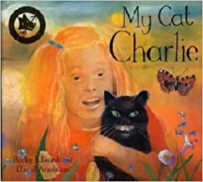  Visual Literacy linked to R.E.  Comic Relief – Farhad.  Retelling a familiar story - the story of Farhad, a refugee. |  | Character Description  Instruction writing  (History link – Iron Age.)  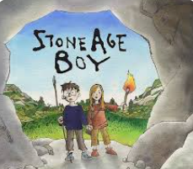  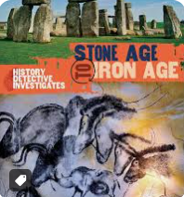 |  | Narrative with dialogue for a story main event.  (Science / Geography link.)  Instructional writing.  (D and T link – Food: Deli  sandwich)  Mousehole Cat  Narrative – story opening. Use of descriptive and figurative language.  Narrate using suspense.  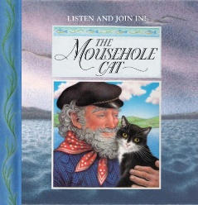 |  | Biography of Mary Anning – including her significant discoveries.  Diary in role as Mary Anning.  (Science / Geography link.)  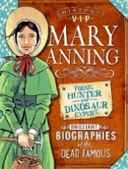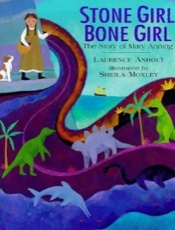 |  | Descriptive and figurative language for a character description.  Newspaper report.  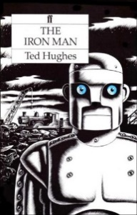 |  | Visual literacy  Descriptive and figurative language -character description.  Narrative – story opening with dialogue.  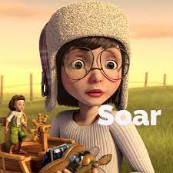
English Texts (including Visual Text) | My Cat Charlie- Becky Edwards  Visual Literacy: Farhad Comic Relief | Stone Age Boy  Iron Age to Stone Age – The history detective investigates. |  | The Mousehole Cat- Antonia Barber |  | Biography of Mary Anning VIP |  | The Iron Man- Ted Hughes |  | Soar (Visual Literacy)
Maths | Maths is largely assessment led. Below is a guide to the areas of study.
Maths | Autumn Term  Number: Place Value  Number: Addition and Subtraction  Number: Multiplication and Division |  |  | Spring Term  Number: Multiplication and Division  Measurement: Money  Statistics  Measurement: Length and Perimeter  Number: Fractions |  |  |  | Summer Term  Number: Fractions  Measurement: Time  Geometry: Properties of Shapes  Measurement: Mass and Capacity
Science | Light and shadows |  | Forces: friction and magnets |  | Rocks, soils and fossils |  | Movement and nutrition for the human body |  | Flowering plants and plant growth |  | Flowering plants life cycle
Scientists | Justus Von Liebig Mirrors  James Clerk Maxwell  (Visible and Invisible Waves of Light) |  | Andre Marie Ampere-  Electro-magnetism  The Wright Brothers  Airplanes  Henry Ford- Cars |  | Mary Anning- Fossil hunter  Dr Anjana Khatwa Geologist  Ursula Marvin- Geologist  William Smith Fossils strata  Inge Lehrmasn -Earth’s Mantle  Katia Krafft - Geologist and Volcanologist |  | Marie Curie- Radiation  Wilhelm Rontgen - X rays  Adelle Davis -Nutritionist |  | Joseph Banks- Botanist  Ahmed Mumin Warfa - Botanist  Marianne North- Botanist |  | Joseph Banks- Botanist  Ahmed Mumin Warfa - Botanist  Marianne North- Botanist

