Pupil premium strategy statement

This statement details our school’s use of pupil premium for the 2024 to 2025 academic year funding to help improve the attainment of our disadvantaged pupils.

It outlines our pupil premium strategy, how we intend to spend the funding in this academic year 2025 to 2026 and the effect that last year’s spending of pupil premium had within our school.

School overview
Detail | Data
School name | Studfall Junior Academy
Number of pupils in school
Proportion (%) of pupil premium eligible pupils | 30/114 in Year 3 26%  28/117 in Year 4 27%  36/117 in Year 5 31%  41/114 in Year 6 36%  135 whole school 29%
Academic year/years that our current pupil premium strategy plan covers | 2025 to 2026
Date this statement was published | 16th September 2025
Date on which it will be reviewed | Sept 26
Statement authorised by | Louise McGeachie
Pupil premium lead | Louise McGeachie
Governor / Trustee lead | Charlotte Krzanicki
Funding overview
Detail | Amount
Pupil premium funding allocation this academic year | £210,864
Total budget for this academic year  If your school is an academy in a trust that pools this funding, state the amount available to your school this academic year | £210,864

Part A: Pupil premium strategy plan

Statement of intent
Our ethos of Nurture/Believe/Discover/Achieve(See background on Curriculum intent)
Nurture: we will ensure that all children’s basic needs are met
Believe: we will celebrate difference and strengths to help build aspirations and self-belief
Discover: we will ensure that we offer a wide curriculum which will allow the children to explore and discover and try new things.
Achieve: we will ensure that each child has a feeling of success in range of areas. We will enable them to find their strengths.

Challenges

This details the key challenges to achievement that we have identified among our disadvantaged pupils.
Challenge number | Detail of challenge
1 | Parental engagement is low – very little reading/homework completed – low attendance at any offers of training etc but parents love to come to superhero days, play days etc
2 | Poor oral language skills – Corby was listed as one of the towns in the uk where a high percentage of households did not have any books in their house.
3 | Number sense is a very weak baseline in reception start of school
4 | Semi-skilled and unskilled manual workers; those on state benefit/unemployed, & lowest grade workers Last year, Corby was named the personal loans capital of Britain, with borrowers in the area making more inquiries than in any other place in the UK. According to an analysis by MoneySuperMarket, there were 75.5 per 1,000 residents in Corby – 47% higher than the UK average. We have a large number of families on Zero hour contracts and working poor, this isn’t reflected in our pupil premium numbers
5 | National statistics and department for work and pensions figures suggest that the rate of unemployment is higher than the national average and higher than for Northants  We have a high level of residents with either no qualifications or qualifications equal to 1 or more GCSE at grade D or below.  Corby has 20% less higher and intermediate managerial, administrative or professional households than the national average.

Intended outcomes
This explains the outcomes we are aiming for by the end of our current strategy plan, and how we will measure whether they have been achieved.
Intended outcome | Success criteria
To increase positive outcomes in Reading, Writing, Maths | Current Year 6  Entry Year 2 Target  Reading 50% 36% 62% 26/42  Writing 60% 31% 61% 26/42  Maths 52% 48% 59% 25/42
Current Year 5
Entry Year 2 Target
Reading 45% 45% 59% 21/35
Writing 43% 35% 66% 23/35
Maths 60% 48% 71% 25/35
Current Year 4
Entry Year 2 Target
Reading 50% 50% 52% 15/28
Writing 46% 43% 60% 17/28
Maths 50% 58% 60% 17/28
Current Year 3
Entry Year 2 Target
Reading 37% 50% 15/30
Writing 27% 37% 11/30
Maths 43% 63% 19/30
To ensure children experience a broad and balanced curriculum and that their strengths are celebrated | Pay for additional clubs – e.g Rock Steady  MMA etc  Support payment for trips/residentials
To ensure families have the basic needs to be successful. | Support with food/breakfast club/clothing/ electric etc…
Learning and teaching policy has a clear pedagogy which means ALL children every lesson have access to the teacher | Learning and teaching policy

Activity in this academic year
This details how we intend to spend our pupil premium (and recovery premium funding) this academic year to address the challenges listed above.

Teaching (for example, CPD, recruitment and retention)
Budgeted cost: 95,000
Additional teacher in year 6 mornings.= £50,000
Release of teachers to support 1 day a week x 2 cover = £300 per week x 30 weeks = 15,000
Subject leaders release time to coach and support: £40,000

Activity | Evidence that supports this approach | Challenge number(s) addressed
Peer Tutoring across all year groups. | Children have feedback that they have benefitted from peer support. We have mixed the top sets in maths up and added in an additional teacher so that the expected+ children and those below expected can have targeted support. | 1/2/3/5
Peer tutoring of adults  Support with resources and differentiation – particularly for catch-up | Releasing good and better teachers to support teachers in different areas. This is to enhance the use of PIXL/varied curriculum and to raise pupil attainment.  Coaching and mentoring has been successful in raising attainment. | 1/2/3/5
Clear AIP that is reviewed termly to support and improve pupil progress | C:\Users\lmcgeachie.87\Greenwood Academies Trust\SFJ_SLT - Documents\.Charlotte Important Docs\AIP\Autumn 1 Action Plan 2024.docx

Targeted academic support (for example, tutoring, one-to-one support structured interventions)
Budgeted cost: £ 79,700
£40,000 Learning mentor half of 2 salaries
£1500 for books
Purchase of Nessy £1200
1 week’s cover £25,000
Level 3 TA £22,000

Activity | Evidence that supports this approach | Challenge number(s) addressed
Additional leadership teacher in year 6 to teach catch-up programme | Smaller targeted groups that allows us to target the HAP pupil premium as well as the MAP and LAP. | 1/3
Where there is an intervention in year 6 they are being led by the class teachers.  All have been allocated 1 session per week. | Where teachers either pre-teach or target children for intervention – there is a greater impact as this is assessed daily and weekly. | 1/2/3/5
To release the teachers for 1 hour each for intervention  2 afternoons per week  Small groups – extra teacher for year 6 targeted groups.  Maths 5 x per week  Reading 2 x per week | Geri focus on Year 6 1:12 (7 PP)  Lesley numbers 1:9 (8 PP)  Middle Colin 1:14 (9 PP) and Rachel 1:13(7 PP)  Ben 1:14 (9 PP)  Year 5 after SATS 2026 | 1/2/3/5
Support staff with targeted intervention – see provision map for what intervention each child with PP is receiving | Identifying gaps and working on what intervention.  Special 30 min daily slots x 4 maths catch-up, phonics, reading etc | 1/2/3/5
Nessy programme to support reading and spelling | Children working in school and home on phonics, reading and spelling | 1/2/3/5
Nurture curriculum – behaviour and emotional strategies such as Superflex, emotional regulation. | Emotional strategies to secure school place, to feel valued to succeed. To have a school that nurtures and is inclusive – tolerance and acceptance – all of this increases opportunities for success. | 4/5

Wider strategies (for example, related to attendance, behaviour, wellbeing)
Budgeted cost: £ 16,164
£8,000 for vouchers
£8,164 for breakfast clubs, extra curricular clubs, essentials etc Poverty support

Activity | Evidence that supports this approach | Challenge number(s) addressed
To try to encourage parents who are entitled to register for PP and to improve attitudes to school and learning | Get a £50 voucher to spend on photos, trips, books and uniform  The basic needs are being met. You are not ready to learn | 4/5
To financially support some critical cases (extreme poverty)  To ensure access to extra-curricular clubs etc  To improve PP attendance. | Through EHA’s etc we have provided some essential items e.g have bought a bed/ washing machine and food.  Need basic skills met  Financed breakfast club to ensure some children attend school on time.  https://educationendowmentfoundation.org.uk/ | 4/5

Total budgeted cost: £ 210,864

Part B: Review of outcomes in the previous academic year

Pupil premium strategy outcomes
This details the impact that our pupil premium activity had on pupils in the 2024 to 2025 academic year.

 | Studfall PP 2025 | National PP 25 | Studfall Non-PP 25 | National  Non-PP 25 | Gap | Studfall PP 2024 | National PP 24 | Studfall Non-PP 24 | National Non-PP 24 | Gap
R | 60% | 63% | 71% | 81% | 11  2  N 18 | 56% | 62% | 76% | 80% | 20  N18
W | 58% | 59% | 73% | 78% | 15  6  N 19 | 63% | 58% | 84% | 78% | 21  N16
M | 58% | 61% | 78% | 80% | 20  11  N 19 | 65% | 59% | 83% | 78% | 18  N 19
2025 5 children DSP PP took out
Year 6 Summer 2025

Reading:
KS1 | Target | End of year PP | Progress PP | More than Exs progress | End of year Non-PP | Progress | More than exs Progress
42% | 74% | 60% | 87% | 17% | 64% | 79% | 26%

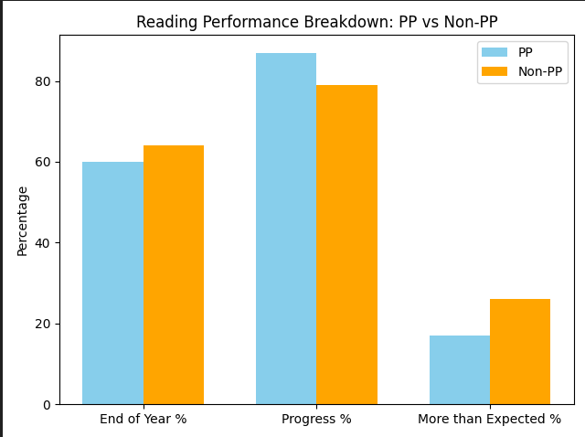
Analysis of impact:
- PP students show stronger performance in Progress % from their starting points compared to Non PP.. This demonstrates the effective impact of the strategy, where targeted support ensures they make expected or better progress.
- Non-PP students outperform PP students in both End of Year % and More than Expected %, suggesting higher overall attainment and a greater proportion reaching more than EXS progress in reading.

KS1 | Target | End of year PP | Progress PP | More than Exs progress | End of year Non-PP | Progress | More than exs Progress
37% | 52% | 58% | 90% | 14% | 63% | 86% | 38%

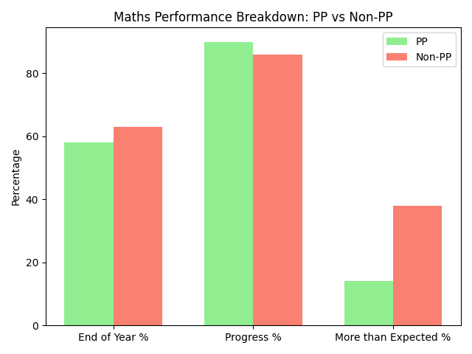
Analysis of impact:

- Both groups show strong progress, PP students outperform Non-PP progress %.This demonstrates the effective impact of the strategy, where targeted support ensures they make expected or better progress.
- Non-PP students have a marginally higher percentage in End of Year % and a significantly higher percentage in the More than Expected %

KS1 | Target | End of year PP | Progress PP | More than Exs progress | End of year Non-PP | Progress | More than exs Progress
34% | 71% | 58% | 84% | 30% | 67% | 82% | 18%

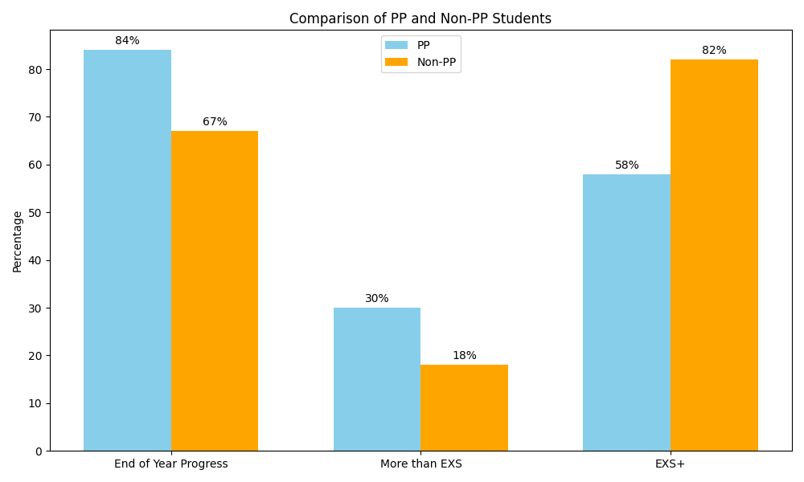
Analysis of impact:
- PP students demonstrate strong progress, with 84% making expected or better progress, outperforming their Non-Pupil Premium (Non-PP) peers at 67%.This demonstrates the effective impact of the strategy, where targeted support ensures they make expected or better progress.
- 30% of PP students achieved greater depth (more than EXS), compared to 18% of Non-PP students, This demonstrates the effective impact of the strategy, where targeted support ensures they make expected or better progress.
- The proportion of PP students achieving the expected standard or above (EXS+) was lower at 58%, compared to 82% for Non-PP students, highlighting a continued need to close the attainment gap at the expected standard level.

COMBINED
Year | PP combined | Non-PP | GAP | National
2025 | 21% | 45% | 24%
2024 | 40% | 66% | 26% | 47% 66%  19%

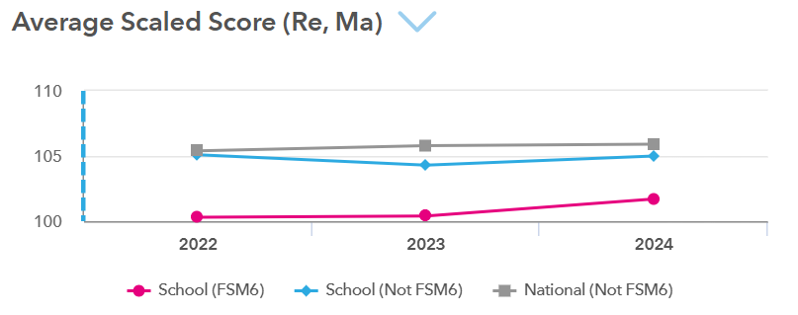

Year 5
2 EHIC
OYG/BLW – 31% R, 29% W and 12% M
Reading:
KS1 | Target | End of year PP | Progress PP | More than Exs progress | End of year Non-PP | Progress | More than exs Progress
38% | 50% | 51% | 94% | 35% | 67% | 79% | 23%

- Non-PP students outperformed PP students in End of Year Achievement (67% vs 51%).
- PP students showed significantly higher Progress (94%) compared to Non-PP students (79%).
- PP students also had a higher percentage of More than Expected Progress (35% vs 23%).
Next steps
- Investigate why PP students’ strong progress isn’t fully translating into final achievement.
- Provide targeted support to PP students to boost End of Year Achievement.
- Apply successful PP strategies to Non-PP students to improve their progress.
- Maintain and refine interventions that drive high progress for PP students.

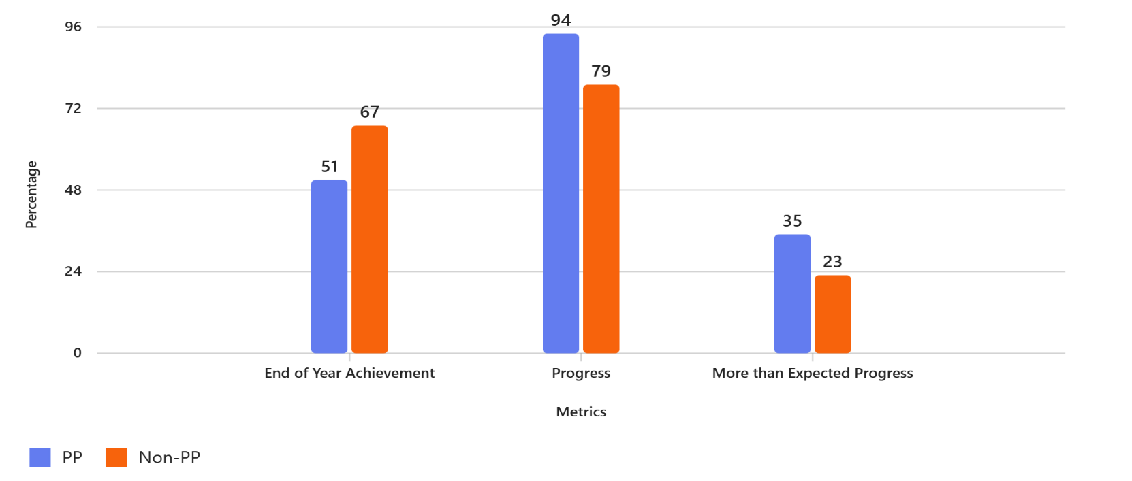

Maths:

KS1 | Target | End of year PP | Progress PP | More than Exs progress | End of year Non-PP | Progress | More than exs Progress
50% | 65% | 54% | 75% | 23% | 60% | 74% | 20%

- Non-PP students outperformed PP students in End of Year achievement (60% vs 54%).
- PP students showed slightly higher Progress (75% vs 74%).
- PP students had a higher percentage of More than Expected Progress (23% vs 20%).
Next steps
- Investigate why PP students’ progress is not fully translating into higher achievement.
- Maintain and enhance strategies that support strong progress among PP students.
- Share effective PP strategies with Non-PP students to boost their More than Expected Progress.

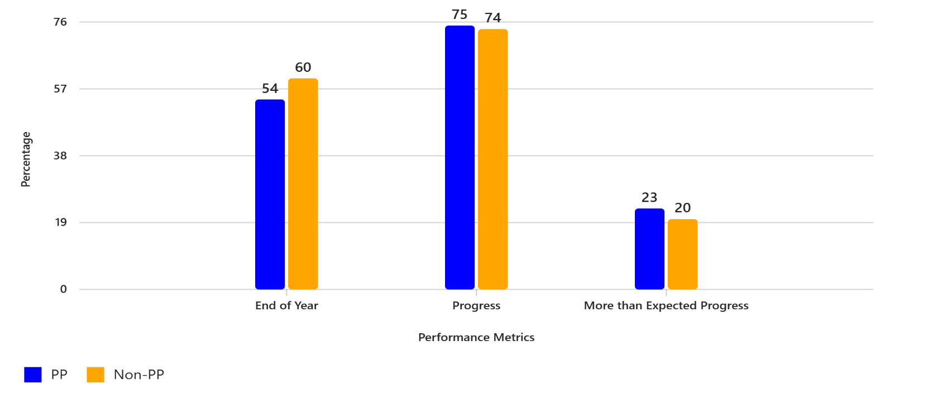

Writing

KS1 | Target | End of year PP | Progress PP | More than Exs progress | End of year Non-PP | Progress | More than exs Progress
33% | 53% | 61% | 92% | 32% | 65% | 87% | 32%

- Non-PP students slightly outperformed PP students in End of Year achievement (65% vs 61%).
- PP students showed stronger Progress (92% vs 87%).
- Both groups had equal performance in More than Expected Progress (32%).
Next steps
- Continue supporting PP students to maintain high progress levels.
- Investigate strategies used by Non-PP students to improve End of Year achievement.
- Explore ways to increase the proportion of students achieving More than Expected Progress in both groups.
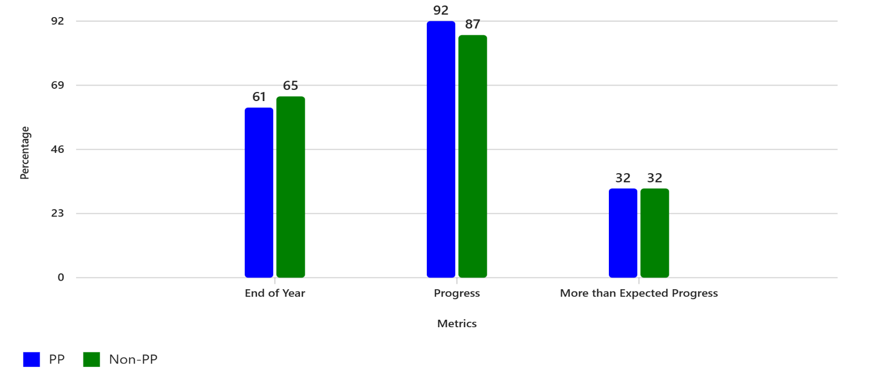

Year 4

1 child PP has a plan – 40% OYG and BLW Year 2 Reading, 34% in writing, 29% in maths

Reading:
KS1 | Target | End of year PP | Progress PP | More than Exs progress | End of year Non-PP | Progress | More than exs Progress
34% | 69% | 44% | 91% | 12% | 58% | 76% | 14%

- Non-PP students outperformed PP students in End of Year achievement (58% vs 44%).
- PP students showed significantly stronger Progress (91% vs 76%).
- Non-PP students had a slightly higher percentage of More than Expected Progress (14% vs 12%).
Next Steps
- Investigate why PP students’ strong progress is not translating into higher End of Year achievement.
- Provide targeted support to PP students to improve final outcomes.
- Share effective PP progress strategies with Non-PP students to boost their progress.
- Explore interventions to increase the proportion of students achieving More than Expected Progress in both groups.
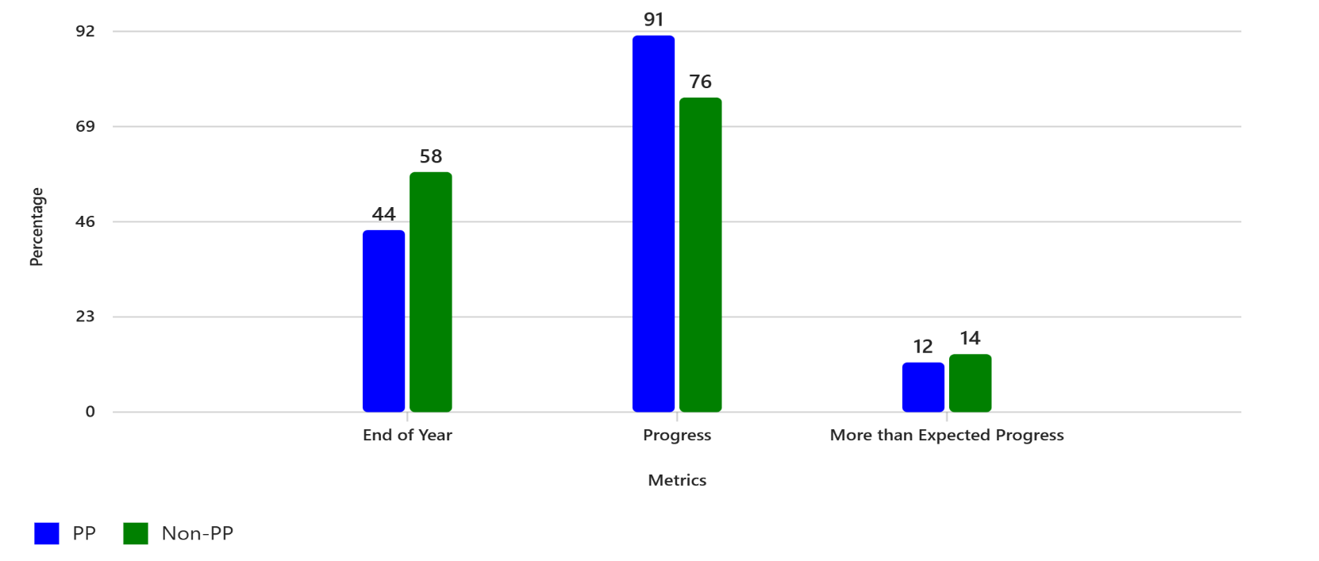

Maths:
KS1 | Target | End of year PP | Progress PP | More than Exs progress | End of year Non-PP | Progress | More than exs Progress
29% | 62% | 58% | 83% | 21% | 63% | 81% | 14%

- Non-PP students outperformed PP students in End of Year achievement (63% vs 58%).
- PP students showed slightly stronger Progress (83% vs 81%).
- PP students had a significantly higher percentage of More than Expected Progress (21% vs 14%).
Next steps
- Investigate strategies used by Non-PP students to improve End of Year achievement and apply them to PP students.
- Maintain and enhance interventions that support strong progress among PP students.
- Explore ways to increase the proportion of students achieving More than Expected Progress in both groups.
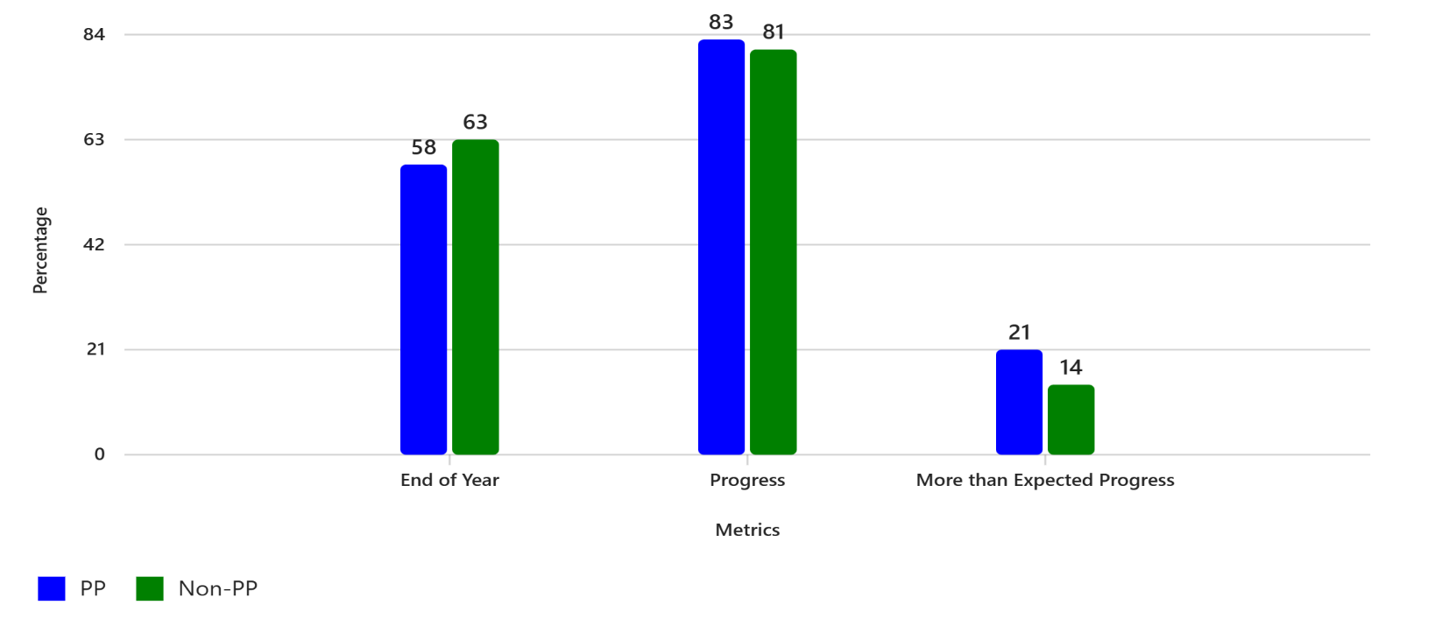

Writing
KS1 | Target | End of year PP | Progress PP | More than Exs progress | End of year Non-PP | Progress | More than exs Progress
34% | 54% | 42% | 96% | 12% | 47% | 85% | 21%

- Non-PP students outperformed PP students in End of Year achievement (47% vs 42%).
- PP students showed significantly stronger Progress (96% vs 85%).
- Non-PP students had a higher percentage of More than Expected Progress (21% vs 12%).
Next steps
- Investigate why PP students’ strong progress is not translating into higher End of Year achievement.
- Provide targeted support to PP students to improve final outcomes.
- Share effective PP progress strategies with Non-PP students to boost their progress.
- Explore interventions to increase the proportion of students achieving More than Expected Progress in both groups.
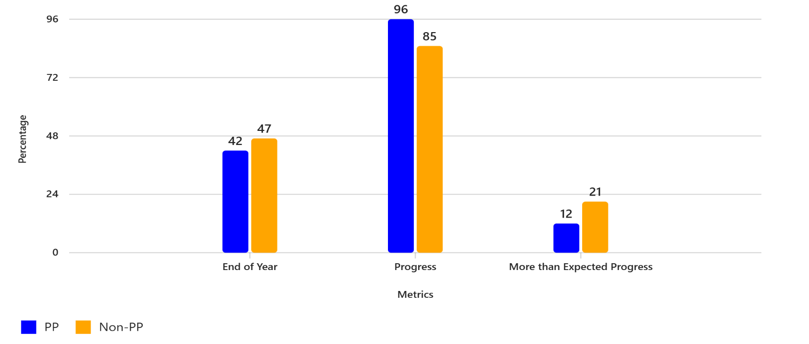

Year 3
10/28 children OYG 36%
Reading:
KS1 | Target | End of year PP | Progress PP | More than Exs progress | End of year Non-PP | Progress | More than exs Progress
48% | 62% | 50% | 96% | 0% | 66% | 77% | 15%

- Non-PP students outperformed PP students in End of Year achievement (66% vs 50%).
- PP students showed significantly stronger Progress (96% vs 77%).
- Non-PP students had a higher percentage of More than Expected Progress (15% vs 0%).
Next Steps
- Investigate why PP students’ strong progress is not translating into higher End of Year achievement.
- Provide targeted support to PP students to improve final outcomes.
- Share effective PP progress strategies with Non-PP students to boost their progress.
- Explore interventions to increase the proportion of students achieving More than Expected Progress in both groups.
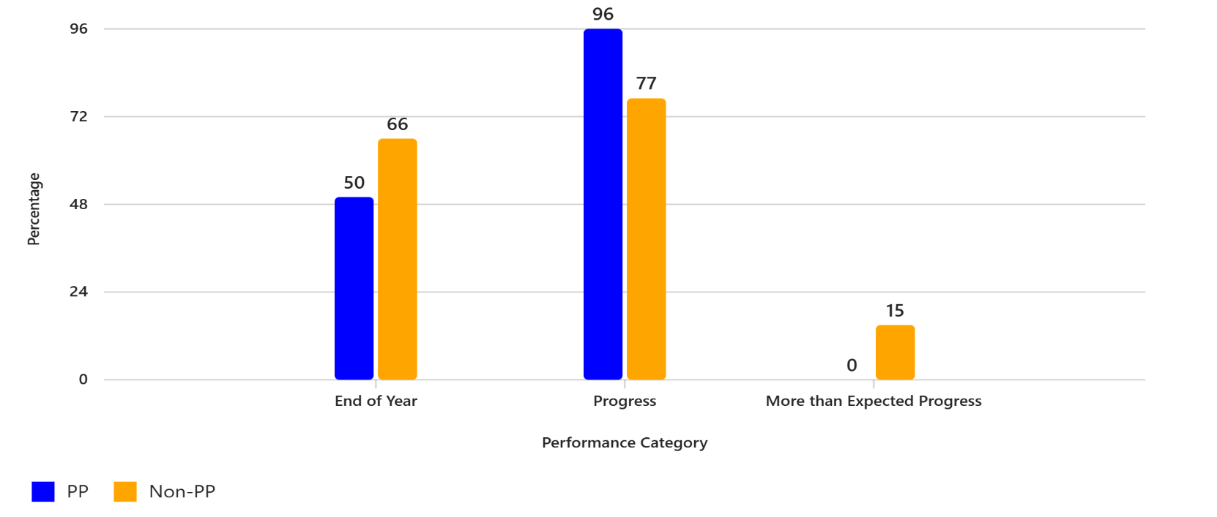

Maths:
KS1 | Target | End of year PP | Progress PP | More than Exs progress | End of year Non-PP | Progress | More than exs Progress
56% | 66% | 50% | 92% | 12% | 76% | 89% | 16%

- Non-PP students outperformed PP students in End of Year achievement (76% vs 50%).
- PP students showed slightly stronger Progress (92% vs 89%).
- Non-PP students had a higher percentage of More than Expected Progress (16% vs 12%).
Next steps
- Investigate why PP students’ strong progress is not translating into higher End of Year achievement.
- Provide targeted support to PP students to improve final outcomes.
- Share effective PP progress strategies with Non-PP students to boost their progress.
- Explore interventions to increase the proportion of students achieving More than Expected Progress in both groups.
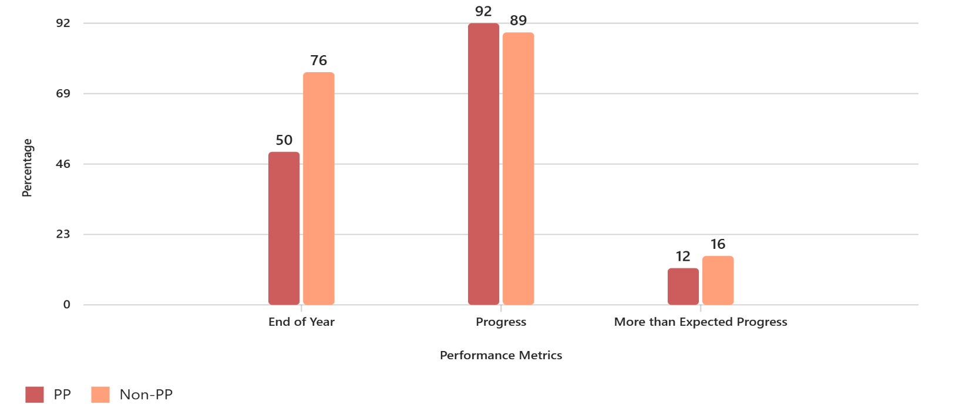

Writing
KS1 | Target | End of year PP | Progress PP | More than Exs progress | End of year Non-PP | Progress | More than exs Progress
41% | 58% | 46% | 96% | 8% | 63% | 89% | 19%

- Non-PP students outperformed PP students in End of Year achievement (63% vs 46%).
- PP students showed significantly stronger Progress (96% vs 89%).
- Non-PP students had a higher percentage of More than Expected Progress (19% vs 8%).
Next steps
- Investigate why PP students’ strong progress is not translating into higher End of Year achievement.
- Provide targeted support to PP students to improve final outcomes.
- Share effective PP progress strategies with Non-PP students to boost their progress.
- Explore interventions to increase the proportion of students achieving More than Expected Progress in both groups.
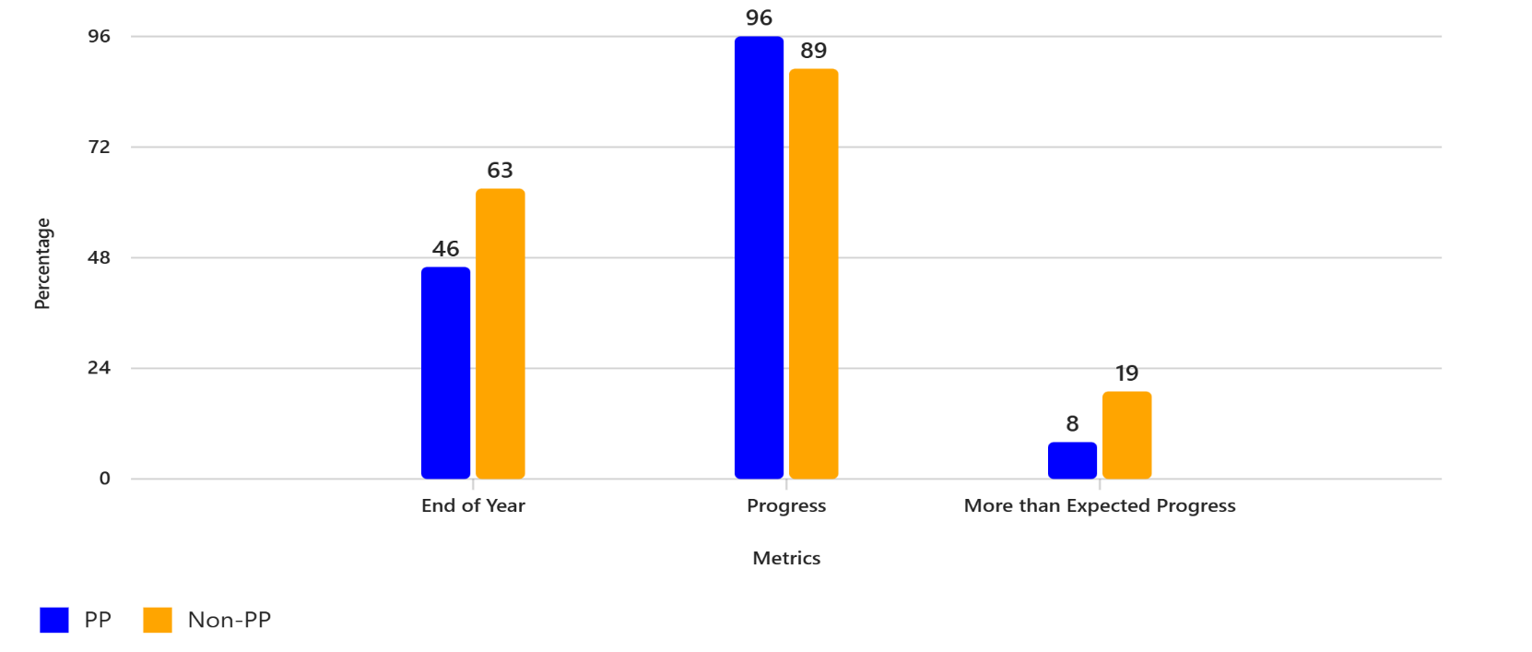

X TABLES MTC

Year | National  25/25  PP | Studfall  25/25  PP | National  25/25  Non-PP | Studfall  25/25  Non-PP | GAP  For Studfall | National average scaled score PP | Studfall Average scaled score  PP | National average scaled score  Non-PP | Studfall average scaled score Non-PP | GAP
2025 |  | 44% |  | 54% | -10% | 18.9 | 21 | 21.3 | 22 | 1
2024 | 25% | 41% | 37% | 35% | +6% | 18.3 | 20 | 21.3 | 23 | 3
2023 | 21% | 18% | 33% | 46% | -28% | 17.9 | 18 | 19.8 | 22 | 4
Whole School

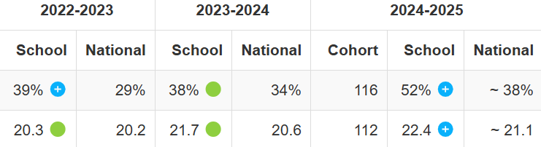

As a result of the Studfall Junior approach to the preparing pupils in being secure in their times table knowledge e.g Compulsory part of every maths lesson in particular in year 3 and 4. TT Rockstars to identify gaps and promote accuracy and speed. We teach through metre sticks to make connections etc
We have ensured:
Sig improvements in both PP and non PP
PP 3 yr improvement - % scoring 25/25 and av scores
PP and Non PP sig above NA - % scoring 25/25 and av scores
PP to Non PP gap is closer than that of NA whilst being sig above NA in outcomes as well - % scoring 25/25 and av scores
Pupils are more secure and confident in x tables, readily applying in everyday contexts both in and beyond maths lessons. This is reflected in the improving picture in maths.

ATTENDANCE
See individual cases
2024 to 2025
PP
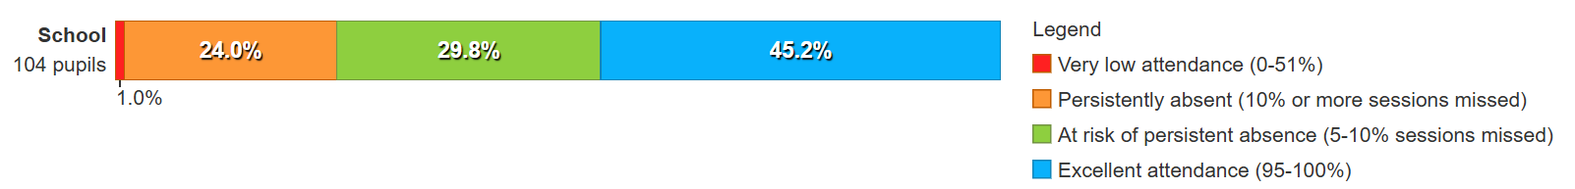
Non-PP
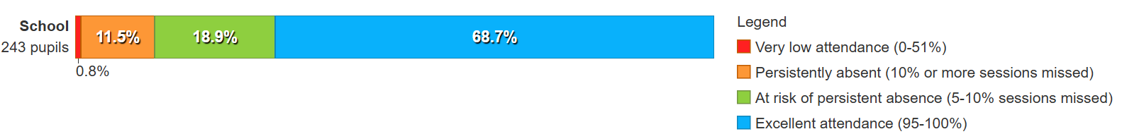

Pupil Premium Year 6 NON PP Year 6
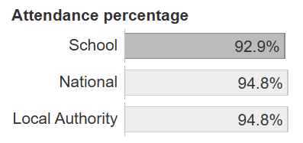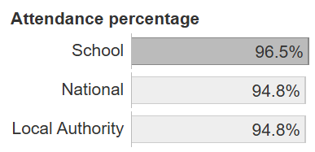
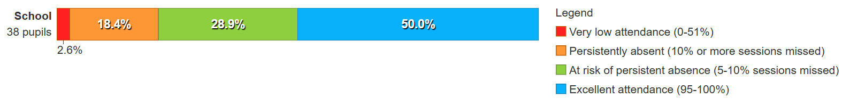
Dusty See individual case

Pupil Premium Year 5 NON PP Year 5
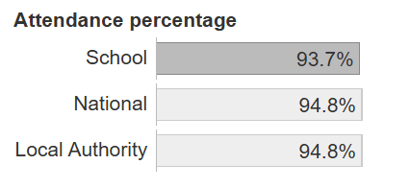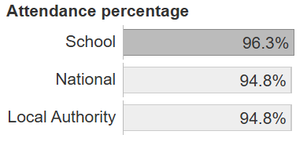
Pupil Premium Year 4 NON PP Year 4
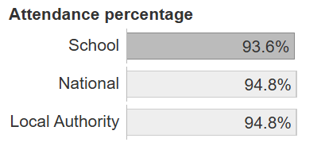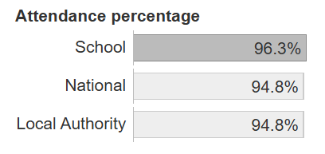
Pupil Premium Year 3 NON PP Year 3

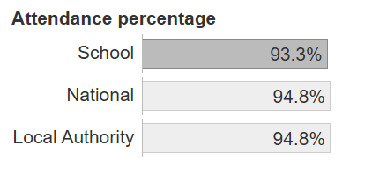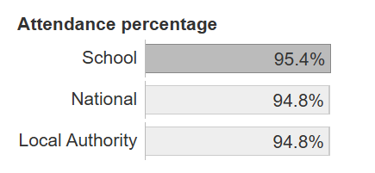

Suspensions:
2024 to 2025
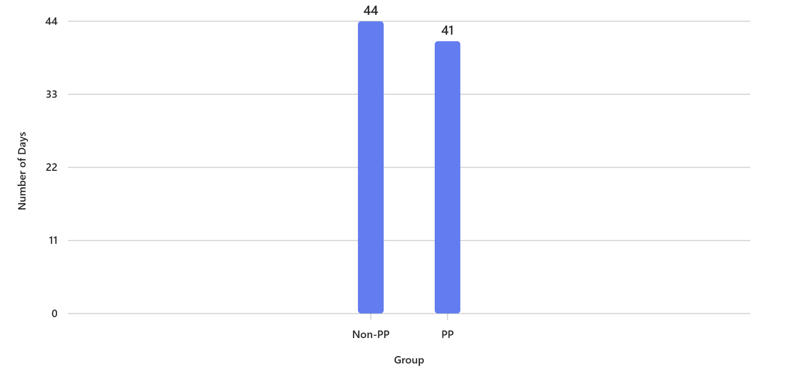

Involved 9 boys
6 children PP 3 Non-PP
4 of those boys no longer attend school 3PP and 1 Non-PP
5 boys still attend and with interventions, nurture, forest school, adult support. No longer have had any suspensions.

