Equality Objectives Statement
STUDFALL JUNIOR ACADEMY:

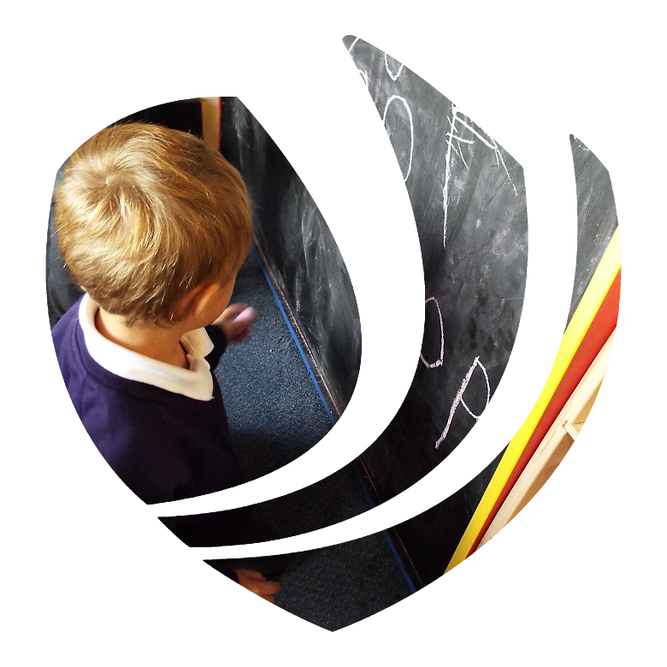

Skegness Academy

Greenwood Academies Trust


Date: 18th January 2025
Author: Louise McGeachie and SLT

Background
(1) A public authority must, in the exercise of its functions, have due regard to the need to—
(a) eliminate discrimination, harassment, victimisation and any other conduct that is prohibited by or under this Act;
(b) advance equality of opportunity between persons who share a relevant protected characteristic and persons who do not share it;
(c )foster good relations between persons who share a relevant protected characteristic and persons who do not share it.

(2) A person who is not a public authority but who exercises public functions must, in the exercise of those functions, have due regard to the matters mentioned in subsection (1).

(3) Having due regard to the need to advance equality of opportunity between persons who share a relevant protected characteristic and persons who do not share it involves having due regard, in particular, to the need to—
(a) remove or minimise disadvantages suffered by persons who share a relevant protected characteristic that are connected to that characteristic;
(b) take steps to meet the needs of persons who share a relevant protected characteristic that are different from the needs of persons who do not share it;
(c) encourage persons who share a relevant protected characteristic to participate in public life or in any other activity in which participation by such persons is disproportionately low.

(4) The steps involved in meeting the needs of disabled persons that are different from the needs of persons who are not disabled include, in particular, steps to take account of disabled persons' disabilities.

(5) Having due regard to the need to foster good relations between persons who share a relevant protected characteristic and persons who do not share it involves having due regard, in particular, to the need to—

(a) tackle prejudice, and
(b)promote understanding.

(6) Compliance with the duties in this section may involve treating some persons more favourably than others; but that is not to be taken as permitting conduct that would otherwise be prohibited by or under this Act.

(7) The relevant protected characteristics are—
- age;
- disability;
- gender reassignment;
- pregnancy and maternity;
- race;
- religion or belief;
- sex;
- sexual orientation.

Schools must publish information relating to persons who share a relevant protected characteristic who are affected by their policies and practices. However, data about employees will not need to be published where a public authority has fewer than 150 employees. This means that for the great majority of schools, only pupil-related data will need to be published. Schools are not required to collect any statistical data which they do not already collect routinely.

Part A- Information which demonstrates how we are complying with the Public Sector Equality Duty for our Pupils and our People (Annual review of information)
- Date last reviewed: January 2025
Age
- Within the staffing, there are a range of ages in the school and on SLT
- Key ages such as transition from Year 2 to 3 and Year 6 to 7 are planned in and catered for. Additional visits and appropriate transition arrangements appropriate to their needs are organised.
- Where staff have requested flexible working, we do everything we can to accommodate this.
- School Council and Wellbeing Ambassadors are represented by children in every year group in school.
Disability
- We have purchased appropriate equipment to support staff who have a disability.
- The school building is adapted to support all children and enable access e.g door handles for children with dwarfism.
- We have written a curriculum for our resourced provision which enables the children to access a wide enriched curriculum and has a clear progression of skills. This includes life skills.
- Pupil voice is important and children attend their annual reviews, meetings and give their voice in whatever way suits them best.
- We ensure we have all the resources that are required and if not, we obtain them e.g Wobble cushions, ear defenders, special pencils, overlays, Nessy, enlarged print, sensory play equipment, fiddle toys, PECS, SALT resources, Radio and mics, help cards, CB therapy, staff training on emotional coaching , sensory processing and dyslexia friendly classrooms.
- We utilise technology to promote inclusivity such as immersive reader, which can read text aloud.
- Staff are trained in Cued articulation, Colourful Semantics, OT, Physio
- School trips are planned to ensure children and staff with disabilities have equal access.
- During Sports week every year, we have the Mintridge Foundation which creates empathy – e.g Year 6 playing wheelchair basketball etc…
- Additional support is given to children to ensure they can access extra-curricular activities such as New -Age Kurling, archery and boccia.
- Staff are trained in diabetes, Speech and Language, ASD training, emotional coaching, zones of regulation, Epi-pen etc
- We liaise with practitioners from other services such as speech and language, occupational therapy, physiotherapy , Autism Outreach, Mental Health Support Team and the Hearing Impaired Service to ensure our pupils receive the highest level of care.
- We are an inclusive school and the children are tolerant and supportive to those that have additional needs
Gender re-assignment
- As part of our RSE programme and during awareness weeks, we discuss differences sensitively and teach children to recognise prejudice and discrimination.
- Our curriculum follows the EDI approach which facilitates conversations about respecting differences and celebrating diversity.
- Our school ethos underlies the concept of acceptance and promoting difference.
Marriage and Civil Partnership
- As part of our KS2 curriculum pupils have an opportunity to learn about relationships and marriage.
- As part of home-school communication, the academy uses the term carer.
- RSE lessons cover the diversity of a family unit/relationships/marriage and partnerships.
Pregnancy & Maternity
- We recently updated our RSE programme in KS2 to cover the topic of consent
- Our school nurse led a recent event with Year 6 pupils around puberty
Race
- For PSHE we have used the GAT Equity, Diversity & Inclusion guidance (EDI) to increase the diversity of text used across the curriculum.
- Our curriculum includes key people from a range of cultures and faiths through books, films and writing.
- British Values is embedded throughout our curriculum and tolerance and respect is a focus of assemblies, lessons and awareness days.
- We study a range of influential people, Rosa Parks, Walter Tull etc and children lead assemblies on inspirational people from around the world and the challenges they face.
- We celebrate European Day of languages and adapt according to our cohort
- We ensure pupil voice in school is represented by children from a range of multi-cultural groups e.g School Council, Well-being Ambassadors, Playground Pals.
- Through our families we share celebrations that they share with us e.g Eid
- Assemblies celebrate key events and celebrations from a range of cultures.

Religion or Belief
- Given the local context we visit a local church and have links with the Reverend and the community choir.
- Adjustments are made to recognise the religious beliefs of pupils and staff e.g special holidays/fasting.
- Assemblies are planned throughout the year to celebrate a range of religious festivals such as Eid, Diwali and Rosh Hashanah
- We promote understanding and respect for the similarities and differences in our school and wider community
- Children have demonstrated increasing knowledge of a range of religious beliefs through RE lessons, assemblies, visits and visitors.
- Religious holidays and special religious celebrations are observed and adjustments made e.g fasting.
- School trips are planned so as not to coincide with religious holidays.
- All staff have received training on extremism and radicalisation
Sex
- Careers curriculum, challenging stereotyping and promoting equality of opportunities through teaching, pupil voice, awareness days, workshops and school trips.
- Annual Takeover Day -an opportunity to take on the role of any adult within the school.
- We provide equal opportunities for all children throughout the curriculum in assemblies, trips and sporting events.
Sexual Orientation
- RSE policy acknowledges differing relationships and family groups.
- Our PSHE/RSE curriculum teaches children that loving relationships can take many forms.
- Staff of all sexual orientation are valued and treated with respect and equality (diverse staff)
- We have LGBTQ+ books in the library and use terminology in an accurate and respectful way.
- We have assemblies and awareness days that celebrate diversity e.g “Dress to Express.”
- Pupil uniform is not defined by gender and staff clothing is also gender neutral.

Part B- Statistical data (annual review of data)
- Date last reviewed: January 2025
- This information below should be based upon information readily available in your academy. For achievement in GAT (national performance measures, where appropriate) this is usually for end of EYFS (GLD), end of Key Stage 1, 2, 4 and 5
- For attendance and exclusions in GAT this is usually broken down by year group
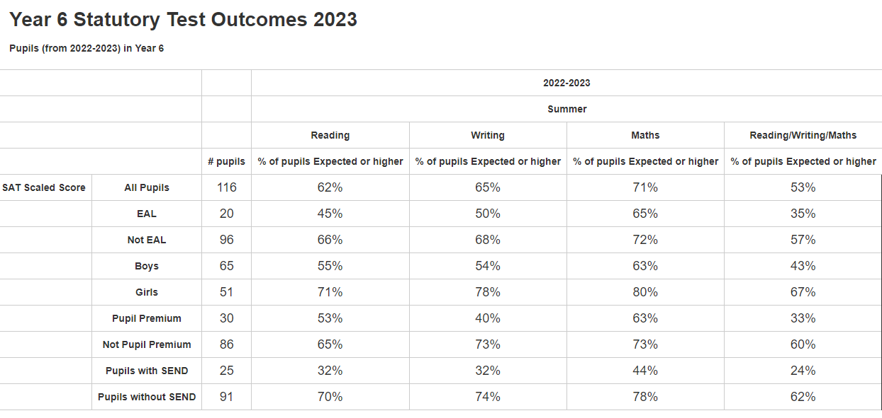

Part C- Equality Objectives (4-yearly priorities)
- Readily available data/information within your academy should be used to help shape these
- Date objectives set:
Objective | Actions | Who | By when | Commentary of progress  (yearly)
Leadership of our pupil’s & people
To continually plan in CPD to enable all staff knowledge and awareness around equality and the protected characteristics and equip subject leaders to continue to audit the curriculum. | SLT – to plan in CPD from Sept 2022 to July 2023  For our staff and children.  (Adapt for the cohort that we have)  Be mindful of new legislation  Be aware of changing needs of staff and children in the school | Mental health lead  LL  Sendco – ES  Principal LM | July 2022 first term  Dec 2022 for Spring and April 2023 for  Summer  Ongoing  Ongoing | End of year 1 progress summary  Corby Mental Health team led staff training on anxiety on September 14th 2022  PSHE lead delivered staff training on embedding EDI in the curriculum  End of year 2 progress summary  We have achieved the Healthy Schools Bronze award  Attachment training for all staff  End of year 3 progress summary  Mental Health Support team training on recognising the signs of mental illness.  Training on zones of regulation to all staff  EDI books have been bought to compliment PSHE/RSE curriculum and LTP includes suggestions for lessons to promote EDI.  End of year 4 progress summary
Quality of Education for our pupils & people
Ensuring our curriculum reflects the rich diversities of the UK and our local area and the needs of our children, irrespective of race, gender, disability, sexual orientation and religion.  To review the texts used in the KS2 curriculum, to secure appropriate breadth and depth of different race and cultures  CPOMS showed an increase in hate crime related behaviours | We have reviewed the books within the text driven literacy but we need to audit other subjects and the opportunities in the library.  Focus group research and questionnaires have shown that children would like to have more visitors into school from different faiths and cultures. We will make contact with the local synagogue and mosque and make arrangements. | Subject leaders | 2025 | End of year 1 progress summary  We have purchased some EDI books and Staff training was given by mental health lead on TD Sept 2nd 2022  End of year 2 progress summary  Subject leads have had time to look at influences across cultures we have particularly looked at women in science.  End of year 3 progress summary  Teaching and learning about protected characteristics are fully integrated into the PSHE/RSE curriculum through age appropriate content.  British Values is integrated throughout the curriculum. Lessons, pupil voice- Questionnaires and surveys, an elected School Council and Wellbeing Ambassadors, children are involved in decision making and assemblies to promote tolerance, diversity, kindness and resilience.  Books have been purchased to celebrate the protected characteristics throughout the curriculum e.g – race/gender/different family groups/stereotypes/disability. Awareness days/weeks e.g – Black History/Cultural diversity  Specialist workshops have delivered topics such as hate crime, racism, anti-bullying and challenging stereotypes.  Assemblies have been delivered to develop tolerance, promote diversity and celebrate cultural events throughout the year.  End of year 4 progress summary
Personal Development of our pupils & people
Mental Health Lead to disseminate effective practise throughout the coming academic year  Create a consistent whole school approach to mental health and wellbeing in school  To ensure the diversity of the local community is represented through visitors/visits/workshops | Mental Health Policy - I will write with consultation from staff, children and parents.  Staff training on good equalities practice to ensure curriculum is diverse and accessible to all.  Staff training on early intervention to create a safe and calm environment and strengthen resilience before mental health problems occur.  Healthy Schools Award- We will be carrying out an audit and a pupil survey to assess areas of need and implement an action plan to achieve a Healthy Schools Award. We are part of Northamptonshire Mental Health Support Team and will be receiving training and support. They will also be providing targeted mental health support for children and their families.  We will be conducting staff, pupil and parent wellbeing surveys to identify any gaps in provision.  Pupil Questionnaire showed that some children in school did not enjoy breaktimes- due to friendship issues – we will set up Playground Pals and train them to diffuse minor disputes and organise games on the playground. More playground equipment may have to be purchased. | Lesley  Louise |  | End of year 1 progress summary  Healthy Schools Audit completed and action plan implemented.  Wellbeing Ambassadors have received training on mindfulness and relaxation techniques to teach in class.  Mental health policy is almost ready for consultation with staff, parents and pupils  SHEU survey completed- action plan in place to target areas of need.  End of year 2 progress summary  We have worked with the Corby Mental Health team to support individual families.  Mental Health Lead is attending mental health First Aid training.  Mental Health support team have delivered staff training on early intervention and signs of mental illness.  End of year 3 progress summary  Mental Health Policy in place  Mental Health lead attends termly partnership meetings with Healthy Schools Initiative to discuss issues and make links with support groups.  Staff and child questionnaires sent out and data analysed to address any target areas.  Safer Corby Team delivered a workshop to year 5/6 on racism  Mental Health Support Team and Happy Heads have supported individual families and children in school.  Mental Health Support Team have delivered an assembly on strategies to support mental health and provided drop in sessions for families.  Signposting events for families regarding mental health have been provided.  Careers event in school- visitors from industry, police and fire crews, BAME backgrounds  Playground Pals have been successful- less disputes on playground and more children involved in active play- e.g skipping  Life Education workshop has been into school to promote strategies to support mental health/going for goals/healthy minds.  Assemblies, workshops and awareness weeks have prevented stigma of mental health conditions.  Focus groups and questionnaires have shown an increased awareness of mental health and strategies to support.  Wellbeing Ambassadors have had training on strategies to support children in class- mindfulness and relaxation, growth mindset. Classes are using relaxation techniques regularly in the classroom.  End of year 4 progress summary
Behaviour & Attitudes of our pupils & people
To continue to plan and support a pupil profile which supports and helps improve the behaviour of those at risk of exclusion. | Workshops and visits throughout the year form an integral part of the PSHE and Citizenship curriculum and reflect the needs of the local area. | Principal  Vice Principal  Sendco  Learning Mentors |  | End of year 1 progress summary  Workshops: Growing Against Violence, anti- bullying, knife crime, alcohol, drug and solvent abuse, hate crime, visits to local places of worship, University visit for PP and vulnerable groups, PCSO visit, first aid, bikeability,  End of year 2 progress summary  2022 to 2023 we reduced suspensions over the year with White British boys. This has continued as we have progressed into 2024.  End of year 3 progress summary  Mental Health Support Team have delivered specialist counselling and therapies to individual children and parents.  Learning Mentors and nurture groups offer support to develop social emotional skills such as self-regulation, relationships and communication skills.  Whole school awareness weeks and workshops have taught therapeutic techniques to help regulate pupil behaviour and develop coping strategies.  End of year 4 progress summary

