3 | Valuing Difference  Recognising and respecting diversity  Being respectful and tolerant  My community  World Mental Health Day  Black History Month  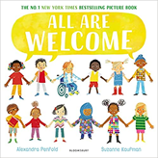  Hate Crime Week  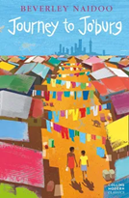   | Me and My Relationships  Rules and their purpose  Cooperation  Friendship (including respectful relationships)  Coping with loss  World Kindness Day  Anti-bullying week  Wear Red For Thomas Day  Road Safety Awareness workshop  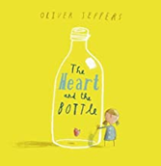  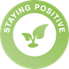 | Rights and Responsibilities  Skills we need to develop as we grow up  Helping and being helped  Looking after the environment  Managing money  Life Bus workshop  Careers Week  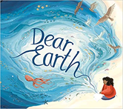     | Being My Best  Keeping myself healthy and well  Celebrating and developing my skills  Developing empathy  Mental Health Awareness Week  International Women’s Day  World Sleep Day  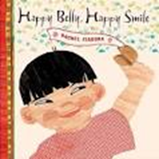 | Keeping Myself Safe  Managing risk  Decision-making skills  Drugs and their risks  Staying safe online  First Aid- Emergencies and calling for help  Basic Life Support  Bites and Stings  Mental Health Awareness Week  Well-being week  Sun Awareness week  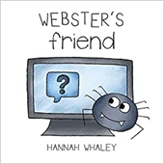  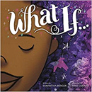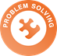 | Growing and Changing  Relationships  Changing bodies and puberty  Keeping safe  Safe and unsafe secrets  Pride Month  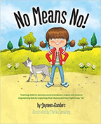
4 | Valuing Difference  Recognising and celebrating difference (including religions and cultural difference)  Understanding and challenging stereotypes  World Mental Health Day  Black History Month  Hate Crime Week    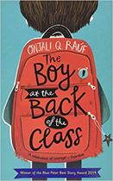 | Me and My Relationships  Healthy relationships  Listening to feelings  Bullying  Assertive skills  World Kindness Day  Anti-Bullying Week  Road Safety Awareness Workshop  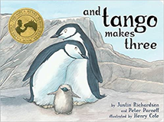  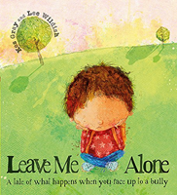  Wear Red For Thomas Day | Rights and Responsibilities  Making a difference (different ways of helping others or the environment)  Media influence  Decisions about spending money  Life Bus Workshop  Careers Week  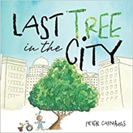 | Being my Best  Having choices and making decisions about my health  Taking care of my environment  My skills and interests  Mental Health Awareness Week  International Women’s Day  World Sleep Day  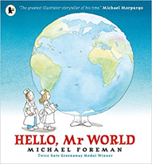  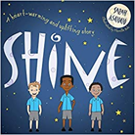 | Keeping myself Safe  Managing risk  Understanding the norms of drug use (cigarette and alcohol use)  Influences  Online safety  First Aid _ Emergencies  Basic First Aid  Asthma  Well-being week  Solve It  Sun Awareness week  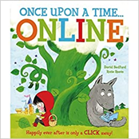 | Growing and Changing  Body changes during puberty  Managing difficult feelings  Relationships including marriage  Pride Month  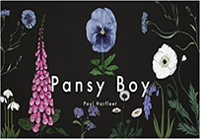
5 | Valuing Difference  Recognising and celebrating difference, including religions and cultural  Influence and pressure of social media  World Mental Health Day  Black History Month  Hate Crime Workshop  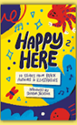  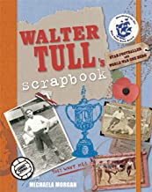  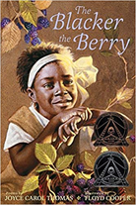 | Me and my Relationships  Feelings  Friendship skills, including compromise  Assertive skills  Cooperation  Recognising emotional needs  World Kindness Day  Road Safety awareness week  Anti-Bullying Week  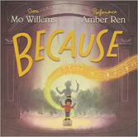  Workshop for Anti-bullying week  Wear Red For Thomas Day | Rights and Responsibilities  Rights and responsibilities  Rights and responsibilities relating to my health  Making a difference  Decisions about lending, borrowing and spending  Careers Week/Challenging Stereotypes  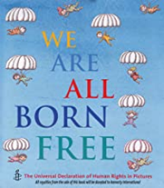 | Being my Best  Growing independence and taking responsibility  Keeping myself healthy  Media awareness and safety  My community  Mental Health Awareness Week  International Women’s Day  World Sleep Day  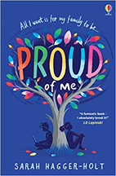 | Keeping Myself Safe  Managing risk, including online safety  Norms around use of legal drugs (tobacco, alcohol)  Decision-making skills  Well-being week  Sun Awareness week  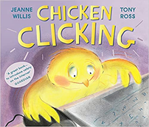 | Growing and Changing  Managing difficult feelings  Managing change  How my feelings help keeping safe  Getting help  First Aid-Emergencies  Basic First Aid  Bleeding  RSE  Alcohol Workshop  Pride Month  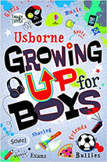  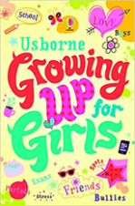
6 | Valuing Difference  Recognising and celebrating difference Recognising and reflecting on prejudice-based bullying  Understanding Bystander behaviour  Gender stereotyping  World Mental Health Day  Black History Month  Hate Crime Workshop  St Columba’s Church visit    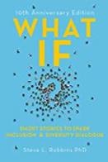  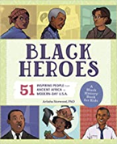 | Me and my Relationships  Assertiveness  Cooperation  Safe/unsafe touches  Positive relationships  World Kindness Day  Anti-Bullying Week  Wear Red For Thomas Day  Road Safety Awareness week  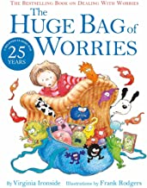 | Rights and Responsibilities  Understanding media bias, including social media  Caring: communities and the environment  Earning and saving money  Understanding democracy  Careers Week/Challenging Stereotypes  Moneysense Workshops with Natwest  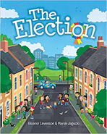 | Being my Best  Aspirations and goal setting  Managing risk  Looking after my mental health  Mental Health Awareness Week  International Women’s Day  World Sleep Day  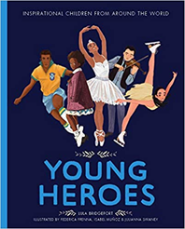 | Keeping Myself Safe  Understanding emotional needs  Staying safe online  Drugs: norms and risks (including the law)  RSE  Warning Zone trip  Solve It  Alcohol Workshops  Well-being Week  First Aid  Sun awareness week  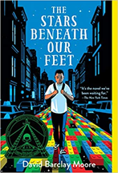 | Growing and Changing  Coping with changes  Keeping safe  Body Image  Sex education  Self-esteem  Pride Month  Secondary School Transition  

