 | Year 3 Long Term Plan 2025 -2026
Year 3 | Autumn 1 | Autumn 2 | Spring 1 | Spring 2 | Summer 1 | Summer 2
TOPIC | How does change affect us?  How did the Steelworks change Corby? | How did things change from Stone Age through to Iron Age? | Is the coast a good place to live? | What’s under our feet? | What did the Romans do for Britain? | Why do people visit the Mediterranean?
DRIVER | History | History | Geography | Geography | History | Geography
Humanities | Topic: History of Corby including the steelworks.  Curriculum focus:  A local history study. A study of an aspect of a site dating back from a period beyond 1066 that is significant in the locality.  PSHE Links to emotions and change. | Curriculum focus:  Bronze and Iron age religion, technology and travel.  Iron age hill forts: tribal kingdoms, farming, art and culture.  Changes in Britain from the Stone Age to the Iron Age- late Neolithic hunter-gatherers and early farmers, Skara Brae  Stone Age to Iron Age Day to launch the topic. | Science links:  Rocks topic  Living in Cornwall.  Subject: Geography  Curriculum focus:  -Locational knowledge  -Place knowledge  -Human and physical Geography  -Geographical skills and fieldwork  English Link to text: Mousehole Cat  Coastal link – using the text to investigate Mousehole as a coastal village to launch the topic. | Curriculum focus:  -Locational knowledge  -Human and physical Geography | Curriculum focus: The Roman Empire and its impact on Britain.  Roman Day to launch the topic. | Curriculum focus:  -Locational knowledge  -Place knowledge  -Human and physical Geography  -Geographical skills and fieldwork
Art | Drawing Skills
Art | Driver: History of Corby including the Steelworks  Skill: Drawing  Focus: Tone  Key Experiences:  - Experiment with media  - Light and dark in the environment  - Recognise different tones of one colour  Suggested Outcomes: Industrial scene tonal drawing |  | Driver: What do our coasts look like?  Skill: Collage  Focus: Texture  Key Experiences:  - Combine a range of materials  - Embellish on collage work  - Simple weaving  Suggested Outcomes: Collaborative collage |  | Driver: Why do people go to the Mediterranean?  Skill: Painting  Focus: Colour  Key Experiences:  - Harmonious colours  - Tertiary colours (mixture of secondary colours and their opposite primary colours in the circle)  - Matching colour to environment  Suggested Outcomes: Painting on canvas
Suggested Artists-  Stimuli | - L S Lowry  - Industrial landscapes by day/night/sunrise/set  - Any appropriate artists conveying dark/light to reinforce objectives |  |  | - Kurt Schwitters  - Impressionist other than Monet and Van Gogh  Any real or imaginary composition | - Paul Cezanne
D&T |  | Construction  Levers/Linkages and Pop-ups  Christmas Cards with Moving Parts |  | Food  Design an organic deli sandwich |  | Food  Design and make a new pizza-based product
RE  Prior learning | Is charity a key element of religions including Humanism?  *What is charity?  *Are all religions charitable; why?  *Why do humans need to be charitable? | Charity (continued)  Nativity Story  *I know what Advent is and why it represents hope to many.  *I can retell the story of the Nativity *I understand why Christmas is a celebration. | How does Christianity help the world?  What do you already know about how religions/ moral philosophies encourage charity, care, understanding and compassion?  *Light in the darkness is a phrase Christians and other religions use; why?  *I understand that Christians perceive Jesus Christ as a Saviour and teacher that taught about love, looking after others, forgiveness and respect for all. | What are the main commitments impacting life as a Sikh? | Is Peace necessary for citizens in our world?
Indoor PE | Gymnastics  Perform jumps, rolls, balances and apply to a sequence with apparatus.  (New Primary P.E Plan.) | Dance -  Greatest Showman  (New Primary P.E plan.) | OAA  (New Primary P.E plan.)  Swimming  (2 classes) | OAA  (New Primary P.E plan.)  Swimming  (2 classes) | Circus Skills  Splat circus  (Cambridgeshire Plan) | Dance –  The Romans  (New Primary P.E plan.)
Outdoor PE | Ball skills –  Hand ball  (New Primary P.E plan.) | Hockey – Quick sticks  (New Primary P.E plan.) | Multi-Skills  (New Primary P.E plan.) | Multi-Skills  (New Primary P.E plan.) | Tag rugby  (New Primary P.E plan.) | Athletics  (New Primary P.E plan.)
Computing  E Safety  Computer Science  Digital Literacy  Information Technology | Unit 7  E Safety Respect online.  CS - Programming and control. | Unit 8  CS – Debugging and Problem Solving | Unit 13  E-Safety How to stay safe online.  CS - Programming  E-Safety  Cyberbullying | Unit 14  CS - Programming  I T - Inputs & Outputs | Unit 15  CS - Programming Control  E-Safety Sharing Information  Unit 16  CS - Loops + Sequences | Unit 17  CS –Programming  Properties and Sequences  DL - Jobs in Computing  Unit 18  E-Safety:  Email Safety  CS –Programming  Repetition  IT Using Forums  & Blogs  E-Safety  Password Safety
PSHE | Equality, diversity and inclusion is woven throughout the curriculum. Where it is mentioned below, this is because there is a particular focus on this- following our ethos: Nurture, Believe, Discover, Achieve.
PSHE | Valuing Difference  Recognising and respecting diversity  Being respectful and tolerant  My community  World Mental Health Day  Black History Month  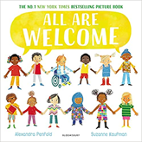  Hate Crime Week  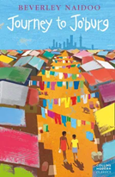   | Me and My Relationships  Rules and their purpose  Cooperation  Friendship (including respectful relationships)  Coping with loss  Anti-bullying week  Wear Red For Thomas Day  Road Safety Awareness workshop  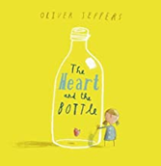   | Rights and Responsibilities  Skills we need to develop as we grow up  Helping and being helped  Looking after the environment  Managing money  Life Bus workshop  Careers Week  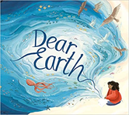     | Being My Best  Keeping myself healthy and well  Celebrating and developing my skills  Developing empathy  Mental Health Awareness Week  International Women’s Day  World Sleep Day  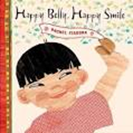 | Keeping Myself Safe  Managing risk  Decision-making skills  Drugs and their risks  Staying safe online  First Aid- Emergencies and calling for help  Basic Life Support  Bites and Stings  Mental Health Awareness Week  Well-being week  Sun Awareness week  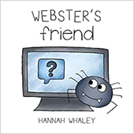  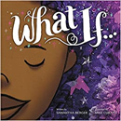 | Growing and Changing  Relationships  Changing bodies and puberty  Keeping safe  Safe and unsafe secrets  Pride Month  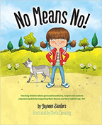
Music | Let your Spirit Fly.  Musical Genre: RnB  Artists:  Joanna Mangona  Marvin Gaye  Barry White | Glockenspiel Stage 1  Performance focus | Composer Focus:  Mozart  Austrian  Classical Period  Focus Piece:  Horn Concerto No.4 – 3rd movement | Three little Birds  Musical Genre: Reggae  Artists:  Bob Marley  Ziggy Marley  Amy Winehouse  Pluto Shevington  Easter Concert | The Dragon Song  Musical Genre: Folk songs – Focus on China | Bringing us together  Musical Genre: Disco  Artists:  Nile Rodgers  Chaka Khan  Sister Sledge  Rose Royce
Composers | Film Music  John Williams  John Powell  Thomas Newman  Benj Pasek and Justin Paul | Music from other cultures  Scott Joplin  Duke Ellington  Made Subandi  Babatunde Olatunji | British Composers  Edward Elgar  Ralph Vaughan-Williams  Henry Purcell  Benjamin Britten | Female Composers  Clara Schumann  Judith Weir  Zoe Keating  Anna Clyne  Anna Meredith | Most influential composers  Mozart  J.S Bach  Beethoven  Tchaikovsky  George Gershwin | Children’s Choice
MFL | Getting to know you  Focus: Greetings, ages, numbers 0-10 | All about you  Focus: Clothes, my body, colours | Food glorious Food  Focus: colours, food | Family & Friends  Focus: Family members, pets, alphabet | Our school  Focus: school resources, subjects | Time  Focus: Days of the week, Months, Numbers 11-31
Trips, special days and Weeks | - Mental Health Awareness week  - European Day of Languages  - Black History Month | - Children in Need Day  - Anti-bullying Week  - Halloween  - Remembrance Day  - Maths Superhero Day | - Careers’ week/ Challenging Stereotypes  Book Week | - Science and Engineering Week  - Internet Safety Week (when it’s your turn in the suite.) | - Well-being Week  - National Schools Sports Week. | Transition Day
Year 3 | Autumn 1 |  | Autumn 2 |  | Spring 1 |  | Spring 2 |  | Summer 1 |  | Summer 2
English | Informal letter writing to our new teacher – first person. Week one.  Diary in role (My Cat Charlie)  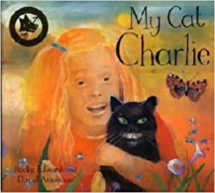  Visual Literacy linked to R.E.  Comic Relief – Farhad.  Retelling a familiar story - the story of Farhad, a refugee. |  | Diary in role (Stone Age Boy)  Information text  Stone Age to Bronze Age  (History link – Iron Age.)  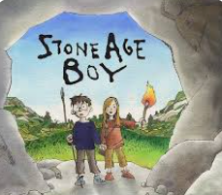  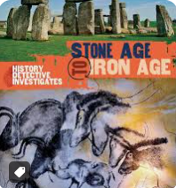 |  | Narrative with dialogue for a story main event.  (Science / Geography link.)  Instructional writing.  (D and T link – Food: Deli  sandwich)  Mousehole Cat  Narrative – story opening. Use of descriptive and figurative language.  Narrate using suspense.  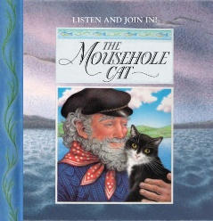 |  | Biography of Mary Anning – including her significant discoveries.  Diary in role as Mary Anning.  (Science / Geography link.)  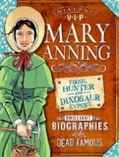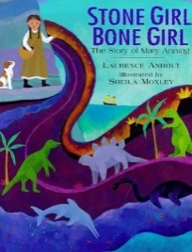 |  | Descriptive and figurative language for a character description.  Newspaper report.  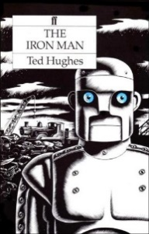 |  | Visual literacy  Descriptive and figurative language -character description.  Narrative – story opening with dialogue.  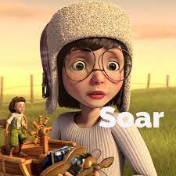
English Texts (including Visual Text) | My Cat Charlie- Becky Edwards  Visual Literacy: Farhad Comic Relief | Stone Age Boy  Iron Age to Stone Age – The history detective investigates. |  | The Mousehole Cat- Antonia Barber |  | Biography of Mary Anning VIP |  | The Iron Man- Ted Hughes |  | Soar (Visual Literacy)
Maths | Maths is largely assessment led. Below is a guide to the areas of study.
Maths | Autumn Term  Number: Place Value  Number: Addition and Subtraction  Number: Multiplication and Division |  |  | Spring Term  Number: Multiplication and Division  Measurement: Money  Statistics  Measurement: Length and Perimeter  Number: Fractions |  |  |  | Summer Term  Number: Fractions  Measurement: Time  Geometry: Properties of Shapes  Measurement: Mass and Capacity
Science  Science (Continued) | How do plants and trees in our locality change over time?  What is autumn like? (Our Changing World)  Describe functions of flowering plants, roots, stems, leaves and flowers  Working scientifically – observation over time, pattern seeking
Science  Science (Continued) | (Light)  How do we see things?  We need light to see things  Darkness is the absence of light  When light hits a material some of it is reflected off the materials  Sunlight can be dangerous, and they need to protect their eyes  Opaque materials block the light and a shadow is formed  The size of shadows changes according to the size and shape of objects and the distance from the light source  Working scientifically – fair tests, pattern seeking  Maths link: Measuring the distance in shadow sizes. |  |  |  | (Forces and magnets)  What happens with the power of force?  Can compare how things move over different surfaces  Pushing and pulling can make things start moving, stop, go faster or slower  Some forces need contact between two objects  Some forces act between objects although they are not in contact  When one object moves over another one there will be a force between them that opposes motion. This is called friction  Magnets can act at a distance  Magnets exert attractive and repulsive forces on each other  Some materials are magnetic some are not  Describe magnets as having two poles  Predict whether two magnets will attract or repel each other depending on which way they are facing  Working Scientifically  Comparing and grouping |  | (Rocks)  What’s under our feet?  Compare and group together different rocks on the basis of appearance and simple physical properties. (including in their locality)  Fossils are formed when things that have lived are trapped within rocks.  Solids are a mixture of rocks and organic matter.  Working scientifically Observation, secondary research, Fair tests  Maths link:  Venn diagram sort. |  | (Animals inc humans)  Why are animal and human bodies so amazing?  identify that animals, including humans, need the right types and amount of nutrition, and that they cannot make their own food; they get nutrition from what they eat.  identify that humans and some other animals have skeletons and muscles for support, protection and movement.  Working scientifically – identifying and classifying groups |  | (Plants)  How does your garden grow?  To stay healthy, plants need light, water, nutrients, and room to grow.  Plants make seeds to produce more plants (sexual reproduction)  Know that plants make their own food but not how.  Maths links:  Measuring and bar charts.
Scientists | Justus Von Liebig Mirrors  James Clerk Maxwell  (Visible and Invisible Waves of Light) |  |  |  | Andre Marie Ampere-  Electro-magnetism  The Wright Brothers  Airplanes  Henry Ford- Cars |  | Mary Anning- Fossil hunter  Dr Anjana Khatwa Geologist  Ursula Marvin- Geologist  William Smith Fossils strata  Inge Lehrmasn -Earth’s Mantle  Katia Krafft - Geologist and Volcanologist |  | Marie Curie- Radiation  Wilhelm Rontgen - X rays  Adelle Davis -Nutritionist |  | Joseph Banks- Botanist  Ahmed Mumin Warfa - Botanist  Marianne North- Botanist

