

Studfall Junior Academy: Learning and Teaching Policy
Studfall Junior Academy is a flourishing school. There is a family feel about the place. Pupils enjoy their learning. Pupils are proud of their school. They told the inspector, ‘Staff really help us understand the learning.’ Pupils said that they feel safe. OFSTED 2022

Introduction
At Studfall Junior Academy, we view the design of the curriculum as an evolving and fluid process which takes into consideration: the needs and character of our children; the children’s prior learning; children’s experiences; the community in which school exists, the statutory curriculum (National Curriculum) and educational research which is evaluated and relevant to our school. We have designed a curriculum which teaches what matters to our children so that they know more, remember more, and understand more.

Curriculum Intent:

To build a curriculum which nurtures children’s learning behaviours and develops a curiosity towards the exploration of knowledge so that they know more, remember more, and understand more.
To design a curriculum which grows the key skills of collaboration, independence, resilience, communication, leadership, and enthusiasm so that children know how they learn.

To build a curriculum which ensures children can be creative, inquisitive and have an opportunity to explore and try new things.
Teachers plan lessons which create enquiry, curiosity, and the opportunity to explore new ideas, scenarios. Children are asked as part of their “Mind Maps'' what they would like to find out about a specific topic. Themed weeks. School visits from outside organisations. School trips including the residential programme for years 5 and 6.

To build a curriculum which ensures children know right from wrong, celebrate diversity and that difference is ok. To recognise their strengths.
To design a curriculum which results in children developing crucial life-skills, and positive moral traits so that understand their role within the community and wider world. To understand what it means to be a British Citizen or, someone from another country who lives in Britain. To be aware of the rule of law, tolerance and being mutually respectful whilst understanding what it means to live in a democracy and to have individual liberty. To experience cultural capital and to use this to make links across their learning. To celebrate their success and that of others.

To build a curriculum which develops learning and results in the acquisition of knowledge so that they know more, remember more, and understand more.
To design a curriculum with appropriate subject knowledge, skills and understanding as set out in the National Curriculum so that children can reach and exceed their potential.

School Ethos
RESPECT RESILIENCE RELATIONSHIPS
EXPECT THE UNEXPECTED!
Our vision for Studfall Junior Academy reflects a passionate commitment to learning and recognition of the uniqueness of individual learners. It is driven by our desire to offer the best possible education for our children in partnership with parents, carers, and the local community.
In order to achieve this vision, we will:
- include all children into the school community.
- promote an ethos within school, which provides a happy and supportive environment for all.
- aim for high standards of academic achievement.
- create a positive learning environment in which good behaviour is rewarded.
- offer a wide and enjoyable curriculum, which develops awareness of health issues, well-being and cultural differences.
- take account of the diversity of learning styles.
- celebrate achievement in any area and at any level.
- share good practice amongst ourselves and with others.
- keep abreast of current trends in education and adopt those which will be of value to the children we work with.
- support parents in a variety of ways to enable them to help their own children.
- work closely with our colleagues at Studfall Infant School to enable a positive transition for pupils and offer a supportive resource for the community.
- work closely with other professionals to meet the needs of the individual child.
- offer extended facilities to provide a range of support on the academy site.

OUR VALUES
Values are fundamental expressions of what we think and believe. As a school we encourage the children to think about personal and social values, to become aware of and involved in the life and concerns of their community and society, and so develop their capacity to be active and effective future citizens.
AT STUDFALL, OUR CORE VALUES ARE:
FRIENDSHIP
We value friendship as fundamental to the development and fulfilment of ourselves and others, and the good of the community.
RESPECT
Develop self-respect and respect for others. Promote inclusion and appreciate the diversity of people’s backgrounds and circumstances.
RESPONSIBILITY
Take responsibility for the way we lead our lives, how we use our talents, rights, and opportunities.
PERSEVERANCE
Maintain a ‘can do’ attitude and aspire to achieve your goals.
KINDNESS
Show care and concern and exercise goodwill towards others.
HAVING FUN
To demonstrate that learning is fun, for school to be a place that you want to be!
INCLUSION
Treat children and others fairly, equitably and with dignity and respect, to maintain an inclusive culture.
BEING WELL ORGANISED AND SYSTEMATIC
Establish good communication links, embed consistently applied policies and practices that ensure effective day-to-day running of the school.
OUR AIMS
Aims reflect our beliefs and values and represent our vision and what we want to achieve as an academy community. WE AIM TO BE:
VALUES CENTRED
Promote our core values and foster positive attitudes to all people, races, religions and ways of life.
DYNAMIC AND INNOVATIVE
Deliver a dynamic and innovative curriculum that challenges, excites and inspires children to achieve their best.
COMMUNITY ORIENTATED
Help children develop an understanding of citizenship and empower them to make valuable contributions locally and globally. Engage with the academy and wider community to enrich and enhance children’s achievement and personal development.
INCLUSIVE
Treat children and others fairly, equitably and with dignity and respect, to maintain an inclusive culture.

ACCOUNTABLE AT ALL LEVELS
Promote collective responsibility for raised standards and improved outcomes for children by ensuring that everyone understands their role in contributing to the success of the academy.
LEARNING CENTRED
Create an inclusive learning culture where children and others within the academy community are challenged in their thinking, strive for continuous improvement, and are committed to life-long learning.
CARING AND SUPPORTIVE
Create a happy, caring, and supportive environment, through a strong partnership between our families, the community and the school. Ensure the safety of every child and promote opportunities to adopt a healthy and active lifestyle.
WELL ORGANISED AND SYSTEMATIC
Establish good communication links, embed consistently applied policies and practices that ensure effective day-to-day running of the school.
HAVE HIGH EXPECTATIONS
Set high expectations to enable children to become effective, enthusiastic, independent learners.
CELEBRATE SUCCESS
Nurture self-esteem through the celebration of children’s achievements.

Effective Learning
We acknowledge that people learn in different ways, and we recognise the need to develop pedagogies which enable all children to learn in ways which suit them.
We offer ways for children to learn in different ways including:
- Investigation and problem-solving.
- Open-ended tasks.
- Reasoning.
- Research and finding out, with independent access to a range of resources.
- Group work, paired work, and independent work.
- Effective questioning.
- Presentation and drama.
- Use of ICT.
- Visitors and educational visits.
- Creative activities, designing and making.
- Use of multimedia, visual or aural stimulus.
- Participation in physical or athletic activity.
- Homework.
- Extra-curricular clubs and activities.

Thinking Skills
Following training on Bloom’s Revised Taxonomy and research carried out by our Maths leader, we have introduced a whole school approach to enable children to develop their thinking skills in Maths. This has been extended into many other areas.
The characters are:


Captain Conjecture: this is where a child is challenged to say what they will think will happen in a range of contexts.
Convince Me Vince: this is when a child is asked to give reasons for their ideas- perhaps looking at patterns or using concrete resources to show why this is the case.
Generate Jess: using existing knowledge to create a new problem or idea. This may be a new design in a DT project, develop a word problem for a situation.
These characters can be used in teaching sessions to reinforce and develop concepts. The characters are developmental in the order of Blooms Taxonomy – Conjecture, Convince then Generate. However, they may be used out of sequence if it helps to develop children’s learning and a character is better suited to a particular lesson.
We do not expect all lessons to include the use of these characters, but this type of reasoning should be undertaken on a regular basis.
Evidence of the use of the characters will be seen through their use in planning, in children’s work and through marking. Posters for all of the characters are displayed in most classrooms. Stickers for all of the characters are available and can be used in books to identify where the skills have been used and to encourage deeper thinking.

Implementation
- We plan using the National Curriculum.
- We enhance the curriculum using progression grids.
- Subject Progression grids are used to develop long term planning.
- A progression of vocabulary is developed within these long-term plans.
- Teachers use the long-term planning to plan units of work and deliver individual lessons.
- We are currently developing WAGOLL books in humanities so that teachers can see the differentiated expected outcomes for each lesson to ensure parity across the year group, and to support assessment.
- The curriculum areas are driven by history and geography where possible. It is designed to exploit links with these to other subjects being taught that term.
- Quality written and visual texts are used to drive the English curriculum, again exploiting links with other curriculum areas to deepen the understanding wherever possible.
BASIC SKILLS
From 8.40am, children start learning as they arrive. Official start time is 8.50. Basic skills finish at 9am. During basic skills, different concepts are addressed, this will include the following:
- Nessy intervention
- Reading, including Accelerated reader, comprehension based on a domain etc
- X tables
- Handwriting
- Spelling

WRITING
At Studfall, every year group develops their writing skills and ability through a variety of high-quality texts; visual sources and planned cross-curricular topics. Year teams have developed knowledge organisers for each term to support the children in their learning journey. Vocabulary books have successfully been introduced over the last couple of years. Here, the children have access to a wide range of ambitious vocabulary which they are encouraged to add to and use in their writing. Regular opportunities for children to edit and improve their writing is actively encouraged.
Modelled writing is used to demonstrate good practice. This includes using children’s work in addition to adults modelling.
Children at Studfall are encouraged to take pride in their work and celebration pieces are displayed around the school. Kinetic letters are taught to support handwriting and Nessy is used to further children's knowledge where there are gaps in their phonic knowledge.
Monitoring of writing is every 3 weeks, where sampling of a range of books takes place by the writing lead and the leadership team. The particular focus is on those children who are working towards the expected standard. This is followed by action planning and next steps for each teacher.
We have termly writing awards.
In summer 2, every book is moderated, and levels agreed by writing lead and leadership team. This is in addition to moderation by the Trust termly.
All our children have access to Spelling Shed which can be used at home and in school. Our Year teams provide children with regular spellings where they are able to practise spelling strategies in an exciting way! To celebrate year groups, and individual spelling achievement, we have termly awards


Reading at Studfall Junior Academy
Reading is valued as the fundamental life skill that underpins every area of success. Children take part in a variety of reading activities in a typical week including one to one reading, group and guided reading or reading for pleasure. A reading development journey is supported through phonic books, banded books and 'real' books. Access to quality texts is enhanced through online library and reading app systems. At Studfall children read, are read to and see adults reading to promote a positive reading culture.
We have 2 sessions a week in the morning, where a 30/30/30 strategy is in place. This ensures that every child has a session that is independent, a session with the teacher and a session with the teaching assistant.
This is in addition to reading sessions after lunch for 20mins and access during basic skills.
We have a set format of how tables are usually set out into a U shape, we have found this is an effective way of ensuring all children have good access to teaching, questioning and assessment.
Strategies used are:
- Fastest finger
- I read, you read
- Find the word
- Tell me where in the text……..?
Reading is monitored every 3 weeks by the reading lead and the leadership team. This is followed up by giving teachers next steps, any additional support etc
We have termly reading awards.

Maths
In addition to the maths superheroes mentioned earlier in the policy, we have a huge focus on arithmetic.
We set for maths.
A 30/30/30 carousel strategy is generally used to ensure that the children’s misconceptions are taught. This is assessed each week, with an arithmetic test each week. This information is kept on an arithmetic tracker online but also in a child’s book so that the children can track their own progress.
This strategy also ensures that each child has access to the teacher, an opportunity to be independent, and an intervention by the teaching assistant.
In school we celebrate weekly, those in the 20 club, 30 club and the 40 club i.e., children that have now scored 20, 30 and so on.
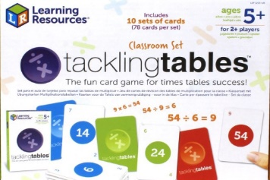

We use Tackling Tables to support our teaching of x tables. This is a fun and engaging way to not only teach times table facts but also the corresponding division facts, percentages, equivalent fractions, etc. The children have access to tackling tables cards, in addition to accessing the online resource.
We have an annual Maths Superhero morning, where parents are welcome to join their child in their maths learning.
We have termly maths awards to celebrate achievements and successes.
We use an online programme called Freckle to support maths learning to develop reasoning.

QUESTIONING
Questions are often divided into two broad categories: closed questions and open questions.
Closed questions often involve the recall of facts and knowledge previously taught and usually require a short answer, for example, yes or no or true or false.
- Is Romeo a Montague or a Capulet?
- Is _______ an acid or alkali?
- Is 5 a prime number?
- Is the word ______ masculine or feminine?
- What is the capital city of Australia?
Open questions usually require more thinking and can have more than one possible answer. They can focus on a topic, subject or the learning process. They often explore things in greater breadth or depth.
- What do we know about the Romans?
- What makes a good leader?
- How could we make the world a fairer place?
- Should children get paid to go to school?
- Is this the best way to solve this problem?
Both closed questions and open questions have huge value. Closed questions can help learners to retrieve and build knowledge, while open questions help them to consolidate, extend and apply knowledge in a range of different contexts.
Thinking about the types of questions we ask is important to make sure that we are stretching and challenging all learners and helping them to learn effectively.
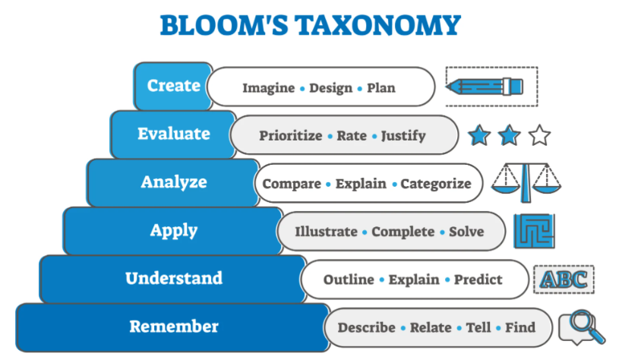
No hands up or direct questioning.
We discourage a hands up approach. We encourage the use of:
- Whiteboards
- Partner talk
- Movement e.g., stand up if you think this is the correct answer
- Thumbs up and down
Hinge questions. A hinge question is based on an important concept in a lesson that is critical for all learners to understand before you move on.
Here is an example for maths:
Choose the best description of a rhombus.
(a) A 2D shape with two pairs of parallel sides.
(b) A quadrilateral with two pairs of parallel sides, each side being of equal length.
(c) A quadrilateral where all four sides have equal length. Opposite sides are parallel and opposite angles are equal.
(d) A quadrilateral where all four sides have equal length. Opposite sides are parallel and all angles are right angles.
Relay technique
After you have explained a topic or asked or a series of questions on a topic, ask a learner to relay back or explain what they have understood. This gives the learner the opportunity to demonstrate what they have understood and allows you to fill gaps and identify misconceptions.
Say it again, say it better
You ask a learner to give an initial response to a question. The learner might make a false start, stumble, or hesitate as they work out their response. You allow this but then ask the learner to ‘Say it again, say it better.’
Low-stakes quizzes and retrieval practice
Low-stakes quizzes, or tests, are short quizzes that have no effect or influence on grades or results. They are a good way to check surface learning and support learners to practice retrieving knowledge. They work well as starter activities and can often be marked by the learner or their peers. They support learners’ ability to remember and retrieve important information and are often used to identify misconceptions or learning that is not yet secure.
Wait time
It is estimated that learners on average only have 0.9 seconds of thinking time between the teacher asking a question and having to respond. Try increasing wait time by three seconds to allow learners to process the question and begin to order their thinking. Increasing thinking time can improve the quality and depth of responses.
Think-pair-share
Think-pair-share is a strategy often used by teachers to enable learners to explore and respond to questions together. It is important to give learners time to think individually before discussing with a partner then sharing ideas with the whole class.
Example
Think −Think about what you already know about volcanoes. Jot it down.
Pair − Discuss your ideas with your partner.
Share − Share and pool your ideas as a group. Be prepared to give feedback to the rest of the class.

Support Staff
Support staff have a question matrix to support them with questioning in lessons.
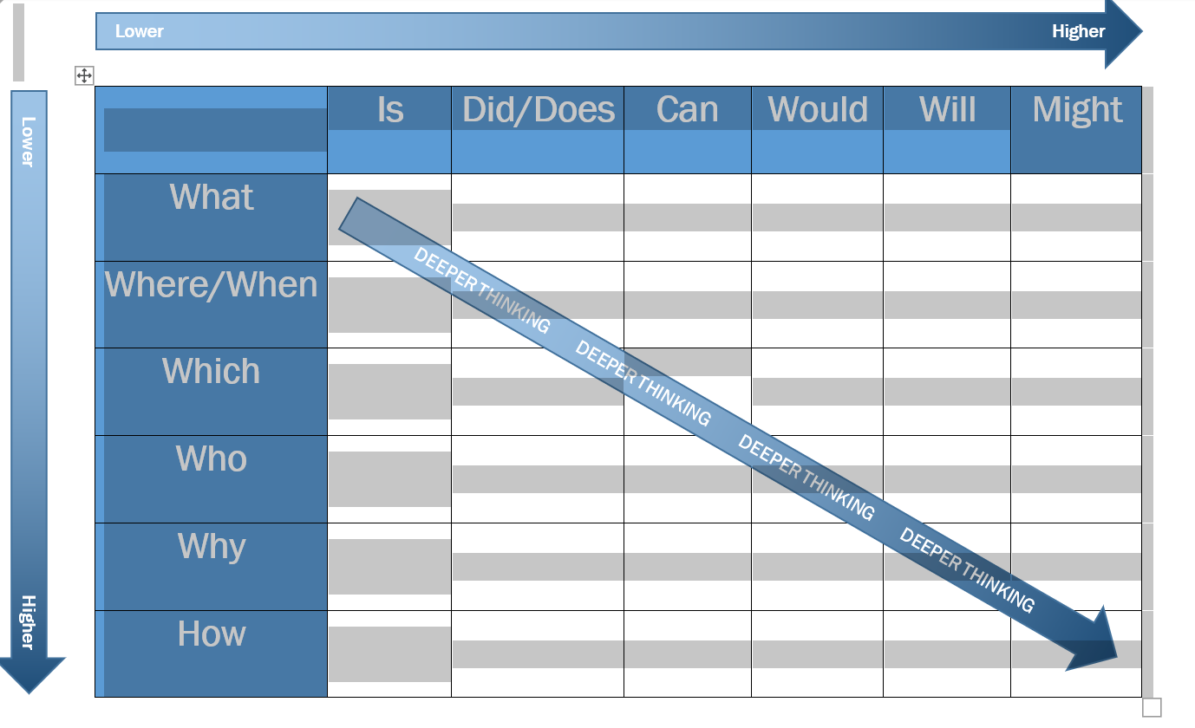
And a Vipers Grid to support reading questions, this is logged on the reading records to ensure that children have the opportunity to access a range of questioning.
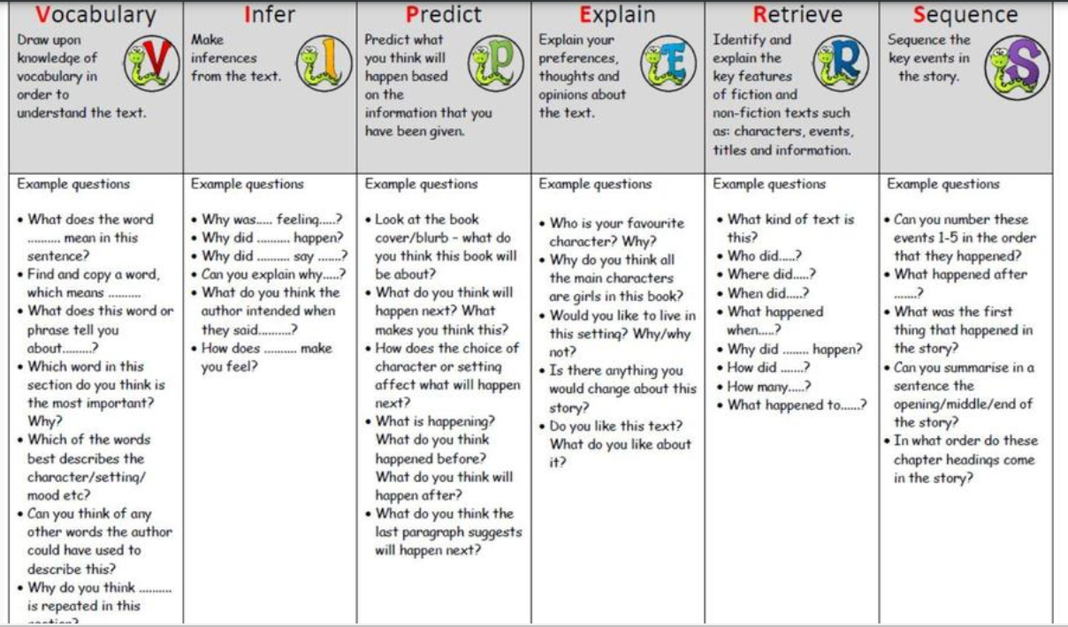

RESOURCED PROVISION

Class 18 is a caring environment where children have the opportunity to grow in so many ways.
The children access a differentiated curriculum to help them develop their early learning skills along with life skills. Many different practical tasks give the children a hands-on approach to learning and making sense of the world in which they live.
We cover important skills to help the children stay safe and healthy. Visitors are invited in to help promote this. This year we have had dental technicians, road safety advisers and the fire service. We have this year welcomed the specialist SEND music teacher from the music service.
Children are not full-time members of Class 18. Each child is part of a mainstream class and can access whatever extra they need in Class 18. Some of our children spend some of the morning in Class 18 for English and Maths whilst others may go to the mainstream class for PE and other lessons that they can access. We aim for the children to spend 50% of their day with their mainstream class. Each child’s needs are carefully considered, and their timetable personalised.


Our resourced provision curriculum has been designed to support the development of the whole child and to help them understand how they are developing personally and socially.


We encourage the children to believe in themselves and to develop their own sense of self-worth.


We encourage the children to feel safe and have the confidence to try new things.

We aim to provide the accessibility to a curriculum for each child to maximise their opportunities for success.

We ensure all children have access to the National Curriculum and a wide range of subjects. We have been updating our progression of skills and our long-term plan for the provision.

CLASSROOM ENVIRONMENT
The learning environment will be managed in such a way as to facilitate different styles of learning. Opportunities will be made for:
- whole class teaching.
- group work, organised according to appropriate criteria (i.e., ability, mixed ability, friendship, etc.).
- one to one teaching.
- collaborative learning in pairs or groups.
- Peer tutoring
- independent learning.
- Teaching of reading U shaped tables

All areas of the learning environment will be planned for, including, where appropriate, the outside areas, to ensure opportunities for a range of practical activities, which will develop appropriate knowledge, skills and understanding.

The classroom will be organised to facilitate learning and the development of independence. For example:

- pupils will be involved in the maintenance and care of all equipment and resources.
- Working walls for maths and literacy will display current learning and supportive materials.

Pupils will receive class dojos for hard work and effort. We also have dojos to reflect out ethos of nurture, believe, discover, achieve.

Assessment

When Assessment for learning is used appropriately children receive personalised learning at its best, and for this reason we see assessment as being fundamental in every lesson.
A range of strategies must be used to ensure effective AfL including:
- open-ended and differentiated questioning,
- talk partners,
- use of mini whiteboards,
- guided group work,
- time for reflection
- review using strategies such as thumbs up or down
- traffic lights to ascertain understanding (with appropriate action taken quickly to secure learning),
- self and peer assessment.

If, by the end of the lesson, it is clear the child has not met the learning intention then additional teaching/ intervention to address misconception can be put in before the end of the day or before the next lesson and planning should be adapted for the next lesson.
Regular assessments are made of pupils’ work to establish the level of attainment and to inform current and future planning. Formative assessment is used to guide the progress of individual pupils. It involves identifying each child’s progress in each area of the curriculum, determining what each child has learned and what therefore should be the next stage in his/her learning.

Formal summative assessment is carried out termly using PIXL and of course the KS2 tests at the end of year 6

Suitable tasks for assessment include:
- group discussions.
- pupils work
- short tests in which pupils write answers.
- discussions in which children are encouraged to appraise their own work and progress.
- pupil observations
- SATs
- Pixl analysis
- Arithmetic trackers
- Accelerated reader

In reading, levels are assessed through their ability to work on VIPERS (Vocabulary, inference, prediction, explanation, recall and sequencing) this may be in reading sessions, one to one work, guided reading activities, test outcomes.

Teachers enter children’s levels for maths, writing, reading and GPS termly into Insight.

Teachers weekly enter data for arithmetic, reading and x tables.

High expectations should be the norm in all lessons and children should have flexibility between groups. In order to achieve accurate and fair judgements of a pupil’s level of attainment, moderation activities are regularly planned into the staff meeting timetable. Cross year group and cross phase moderation also takes place as part of this process of achieving accurate assessment.

MARKING:

Marking is a formal or informal recognition of work in progress or completed. This includes open- ended questioning, dialogue focusing on learning intentions and writing observations and learning targets onto work.

Specific formative comments on pupils' work act as a record as well as being a reminder of the focus for future progress. Marking should be comprehensible to pupils and parents and to this end be consistent and should use words, numbers, or pictures.
- helps children understand how to improve and comments aim to be positive and constructive.
- Children need to be given time to either extend or improve through marking.
- at best this is completed while a task is being carried out through discussion between child and teacher.
- written work is used sensitively and with discretion so that a child can assimilate a limited number of corrections at one time. This will vary according to the age, ability, and task.

Feedback to pupils about their own progress is achieved through discussion and the marking of work and is most effective during the lessons.
We believe that ‘live’ marking within the sessions, is more effective as teachers and support staff can quickly identify if a child has a misconception which can be addressed within a session. (See marking guidance) Good marking after the lesson would require the children to interact with their work in a very focused way e.g., Put in a relative clause.
This approach means children are much more likely to absorb the development point.

MONITORING AND EVALUATING

Pupils’ work will be monitored and moderated regularly in each of the core curriculum areas by teaches and members of SLT. A termly review of monitoring procedures is held with all members of the teaching staff in the form of Pupil Progress Meetings which includes discussions around our whole academy targets and the attainment and progress of key groups. Subject leaders will regularly monitor children’s books, assessing progress and outcomes.

