
STUDFALL JUNIOR ACADEMY


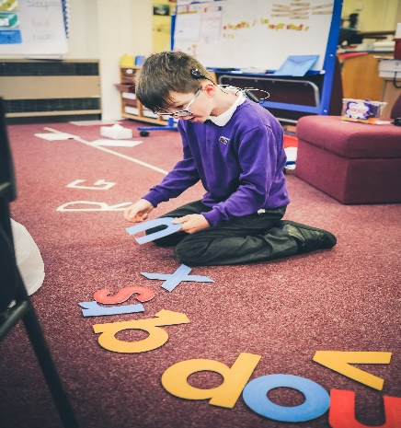
OFSTED SAYS:
You have created an inclusive, supportive and nurturing environment where every pupil is valued. Pupils are kind, considerate and respectful of diversity. Teachers and staff support pupils’ needs very well because they take the time to understand their specific needs.


CONTENTS
2 About Our Academy
5 Parents in Partnership
6 Joining the School
8 Essential Information
12 Our Curriculum
22 Staffing
WELCOME TO STUDFALL JUNIOR ACADEMY
This Prospectus has been put together by the children, staff and parents of the academy. We hope it helps you gain an understanding of how our academy is organised, and to appreciate the exciting opportunities on offer to the children in our care. All schools have their own distinctive ‘feel’ which makes each one unique. We believe that the ‘special feel’ at Studfall is to do with our caring, friendly atmosphere. Our academy continues to develop in many exciting ways, providing an even more enriching experience for our children. We have been over-subscribed for the past few years and have increased our numbers to 116 although we ensure we can take all of our children from the infant academy so do have year groups above that number. We have approx. 450 children in the Junior building.
In September 2012, Studfall Junior School and Studfall Infant and Nursery School hard federated, with one governing body and 2 headteachers. The academy was last inspected in March 2017 when we were judged to be a ‘good’ school in all key areas of the inspection. The full Ofsted report is available on the academy website https://www.studfalljunioracademy.org/ From June 1st 2018, the academy joined the Greenwood academy trust.
The academy has a Designated Special Provision for up to 24 children with significant to severe learning difficulties serving Corby and the surrounding villages. Studfall offers an inclusive provision for pupils who require arrangements over and above that which an everyday mainstream school can provide through an Education Health and Care Plan (EHCP). They may need additional teaching to help them with their learning, speech, language and communication needs. The children are mainly taught within the class groups with some withdrawal facilities available for specialist or small group teaching.
We are extremely proud to lead a team that is committed to achieving high standards and providing the best opportunities for the children in our care. Staff, supported by governors and parents, work hard to deliver a rich and challenging curriculum; to prepare children for future education and to help them acquire the skills and enthusiasm needed to pursue learning for the rest of their lives, to achieve their best!
We look forward to welcoming you and your child/children to our school and, to a happy and successful partnership.
Louise McGeachie & Kim Kirchin
Joint Principals
OFSTED SAYS: Leaders have organised opportunities for teachers to share their expertise in school and hence increase the proportion of outstanding teaching.

ABOUT OUR ACADEMY
OUR VISION
“Nurture – Believe – Discover – Achieve’
EXPECT THE UNEXPECTED!
Our vision for Studfall Junior Academy reflects a passionate commitment to learning and recognition of the uniqueness of individual learners. It is driven by our desire to offer the best possible education for our children in partnership with parents, carers and the local community.
In order to achieve this vision we will:
- include all children into the school community
- promote an ethos within school, which provides a happy and supportive environment for all
- aim for high standards of academic achievement
- create a positive learning environment in which good behaviour is rewarded
- offer a wide and enjoyable curriculum, which develops awareness of health issues, well-being and cultural differences
- take account of the diversity of learning styles
- celebrate achievement in any area and at any level
- share good practice amongst ourselves and with others
- keep abreast of current trends in education and adopt those which will be of value to the children we work with
- support parents in a variety of ways to enable them to help their own children
- work closely with our colleagues at Studfall Infant School to enable a positive transition for pupils and offer a supportive resource for the community
- work closely with other professionals to meet the needs of the individual child
- offer extended facilities to provide a range of support on the academy site

OUR VALUES  Values are fundamental expressions of what we think and believe. As a school we encourage the children to think about personal and social values, to become aware of and involved in the life and concerns of their community and society, and so develop their capacity to be active and effective future citizens.  AT STUDFALL, OUR CORE VALUES ARE:  FRIENDSHIP  We value friendship as fundamental to the development and fulfilment of ourselves and others, and the good of the community.  PERSEVERANCE  Maintain a ‘can do’ attitude and aspire to achieve your goals.  RESPECT  Develop self-respect and respect for others. Promote inclusion and appreciate the diversity of people’s backgrounds and circumstances.  RESPONSIBILITY  Take responsibility for the way we lead our lives, how we use our talents, rights and opportunities.  KINDNESS  Show care and concern and exercise goodwill towards others.    TO HAVE FUN  To demonstrate that learning is fun, for school to be a place that you want to be!  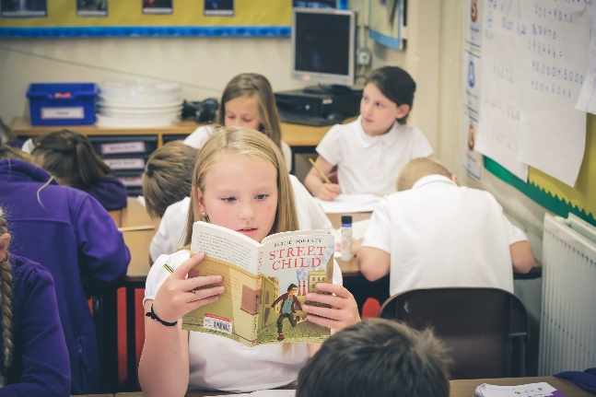 | OUR AIMS  Aims reflect our beliefs and values and represent our vision and what we want to achieve as an academy community. WE AIM TO BE:  VALUES CENTRED  Promote our core values and foster positive attitudes to all people, races, religions and ways of life.  DYNAMIC AND INNOVATIVE  Deliver a dynamic and innovative curriculum that challenges, excites and inspires children to achieve their best.  INCLUSIVE  Treat children and others fairly, equitably and with dignity and respect, to maintain an inclusive culture.  ACCOUNTABLE AT ALL LEVELS  Promote collective responsibility for raised standards and improved outcomes for children by ensuring that everyone understands their role in contributing to the success of the academy.  LEARNING CENTRED  Create an inclusive learning culture where children and others within the academy community are challenged in their thinking, strive for continuous improvement and are committed to life-long learning.  COMMUNITY ORIENTATED  Help children develop an understanding of citizenship and empower them to make valuable contributions locally and globally. Engage with the academy and wider community to enrich and enhance children’s achievement and personal development.  CARING AND SUPPORTIVE  Create a happy, caring and supportive environment, through a strong partnership between our families, the community and the school. Ensure the safety of every child and promote opportunities to adopt a healthy and active lifestyle.  WELL ORGANISED AND SYSTEMATIC  Establish good communication links, embed consistently applied policies and practices that ensure effective day-to-day running of the school.  AND  HAVE HIGH EXPECTATIONS  Set high expectations to enable children to become effective, enthusiastic, independent learners.  CELEBRATE SUCCESS  Nurture self-esteem through the celebration of children’s achievements.

OFSTED SAYS:
Since the last inspection, leaders have ensured that teachers extend pupils’ thinking and set more challenging tasks.

PARENTS IN PARTNERSHIP
At Studfall Academy, we firmly believe that children will make the most progress when home and school work together. We are pleased to welcome all parents into the academy. You will understand that during academy hours the teachers are busy with the children, but they will always be happy to talk with you before the start or at the end of the academy day.
There are many opportunities for parents and carers to become involved in the life of the academy and to gain a greater understanding of its work. Parents’ support and expertise can be used in many ways and is greatly valued. DBS checks and safety checks are carried out on all adults working in the academy, including regular volunteers.

PLEASE REGISTER FOR GROUPCALL (FORMS IN PACK) THIS WILL ENSURE THAT YOU RECEIVE ALL LETTERS AND ANY MESSAGES FROM THE ACADEMY.
COMMUNICATION WITH PARENTS  We communicate with parents and carers in various ways, for example, through our newsletters, questionnaires, social events, parent workshops, Class Dojo e.g. how to help your child read, stay and play, family activities within the curriculum e.g. Science week and Book week.  There are a number of opportunities during the school year for you to visit the academy to talk about your child :  Autumn Term:  Just before the first break in October we have  parent consultations throughout the school, when  you will hear how your child has settled into the  new academy year.  Spring Term:  There will be a second Parent consultation in  February for Literacy and Maths  Summer Term:  At the beginning of July, you will receive a written  report which will tell you how your child is  progressing in each area of the curriculum. If your  child is in Year 6, this report will also give you  information on the end of Key Stage 2 statutory  assessments in the core curriculum areas.  In the summer term, we also hold an Open Afternoon/Evening for Parents, Staff and Governors. This offers a chance to look around the academy, and to meet with staff and to discuss issues. | JOINING THE ACADEMY ADVISORY COUNCIL  We have an Academy Advisory Council of parents, the Principals and representatives from Greenwood, etc. The main aims are:  - To provide feedback to the Principals on the appropriate day to day procedures of the academy, from a parental and community viewpoint. For example this may include the practicalities of the school day, for instance; start and end times, pupil transport considerations, uniform, provision of lunch and other food/drink at the Academy, etc.  - To consider and explore the extra-curricular activities and opportunities that may be of benefit to pupils at the Academy and facilitate their delivery.  - To consider and explore the possibilities for work experience, work placements and other similar opportunities that would benefit pupils at the Academy. Create appropriate links with external local organisations to facilitate the delivery of such opportunities.  - Receive and consider updates from the Academy Principal on other initiatives at the Academy which engage the pupils and community, for example Student Voice.  - To request that any areas of concern about the Academy, including concerns around pupil progress, are raised in the meeting and documented in the minutes so that they can be brought to the attention of the Regional Education Director.  To provide representation on the pupil exclusion panels and regarding other staff policies as appropriate (e.g. disciplinaries), as required from time to time.
JOINING THE ACADEMY
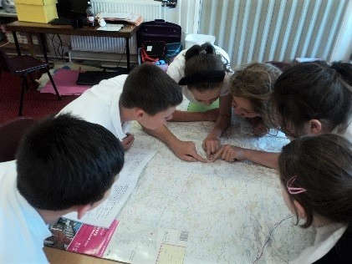
Administration of admission arrangements to County schools is dealt centrally by Northamptonshire County Council. A booklet ‘Applying for a Primary School Place’, setting out the Junior admissions procedures and criteria for each academy/school. Completed forms, or online admissions must be returned to the School Admission Team by the submission date in the January, prior to starting.
Parents or carers of children seeking to join the academy in other years, should in the first instance contact the in-year Admissions Team of the County Council on 0300 126 1000
ACADEMY TIMES AND ATTENDANCE
Main Academy
Morning session begins 8.50am
Morning session end 12.10pm
Afternoon session begins 1.10pm
Afternoon session ends 3.25pm
Parents are asked to encourage children to arrive on time. Frequent lateness will be followed up by letter and by the Academy Learning Mentors. We regularly remind children not to leave the premises at the end of the day unless an adult or older brother or sister (over 14 years) has come to meet them. Parents who wish to make alternative arrangements, are asked to let us know of these in writing or verbally at the start of the academy year if a family has decided that their child is mature enough to walk home. Children are only handed over to adults who are named on the admission form unless parents notify the academy of alternative arrangements.
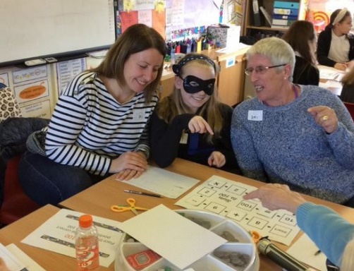

OFSTED SAYS:
The school is currently meeting the national average for overall attendance. The attendance for pupils who are eligible for free school meals is also improving.

Attendance Policy
It is important that children learn the right attitudes about school from the start of their education. Parents are asked to support the academy in this by encouraging prompt and regular attendance.
Parents are asked to give a reason for any absence which the child has from the academy. This may done by letter or a telephone call to the academy. Unauthorised absences will be followed up by a slip asking parents to give a reason for the absence and any which continue to be unauthorised will be recorded on your child’s report at the end of the year. Frequent or unexplained absence or lateness will be followed up by daily telephone calls.
Where a child’s attendance is low a letter will be sent to families to notify them of the drop and offer to discuss any potential issues or concerns.
Each term children celebrate their attendance with an assembly and prizes are awarded.
Since September 2014, the Head teachers may not grant any leave of absence during term time unless there are exceptional circumstances.
The academy has drawn up an Attendance Policy – Please sign and return
We now have an attendance line you can contact us directly on to keep the academy updated when your child is not attending the academy. You call on 01536 202621.

Jewellery
Jewellery should not be worn at the academy. Staff cannot take any responsibility for any valuable items which are brought to the academy by children.
We are responsible for ensuring that children participate in the full school curriculum, including P.E., and children will therefore be required to take earrings out for P.E. lessons. Other jewellery will also be removed for P.E., and whilst every care will be taken, the school cannot be responsible for any loss or damage to property which should not be in the academy.
Children are also discouraged from bringing toys or other items to the academy as they are often lost and can lead to arguments between children. If teachers ask children to bring items related to a particular topic e.g. “Transport” or “Changes” then they will be carefully looked after in the classroom.
Any money should be sent to the academy in a sealed, named envelope via the academy office or class teacher.

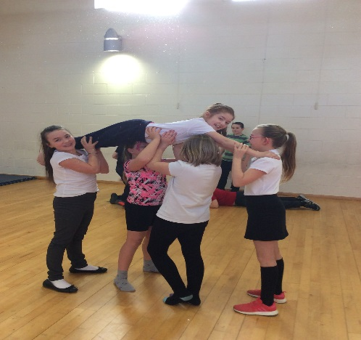
Medical and other issues
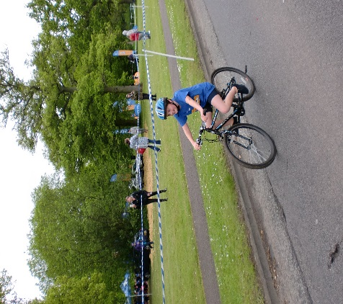
When your child starts the academy, you are asked to complete a form outlining any medical history including any allergies suffered, that we should be aware of. It is important that this record, including contact details is kept up-to-date.

First Aid
Basic first aid is given at the academy when necessary by qualified First Aiders. If an accident needs hospital attention, we will make every effort to contact parents and carers. We ask you to ensure all contact details are kept up-to-date so that we can contact you in an emergency. All injuries are recorded.


Medicines
Parents are notified of any medical or dental inspections which are to be held in school and are welcome to attend. Children in reception undergo Health Surveillance together with hearing and eyesight tests.

A parent/carer may at any time request a special appointment e.g. for a
hearing test. Sometimes teachers may request such tests, but this would only be done in consultation with the parent and with their approval. The academy may recommend referral to a Speech Therapist, but again, this would be done in consultation with the parent.
Where a child needs to take prescription medication, this must be brought to the academy office. Families will be asked to complete a form giving all necessary information. Prescription medicine must be kept in its original box with prescription label on. We will only administer medicines that are prescribed by a doctor.
Head Lice - This is a recurring problem all schools and can only be dealt with by vigilance on the part of parents and staff. Children should not be sent to the academy with
untreated head-lice, and if we notice that a child has live head-lice, then the parent will be asked to treat them. Where head-lice recur regularly with the same child, we will ask the parent to make an appointment to see the school nurse.
Children who have been sick at home should not be sent to school for at least 24 hours, or until the sickness has stopped. This will help to prevent germs spreading at the academy, and prevent the child becoming distressed if they are ill. For more details about excluded illnesses, please contact the academy office.

OFSTED SAYS
Pupils feel safe at the school and are confident that their concerns are quickly dealt with by staff. They know precisely how the school keeps them safe. Pupils know how to keep themselves safe online and they enjoy the e-safety weeks that serve as important reminders.

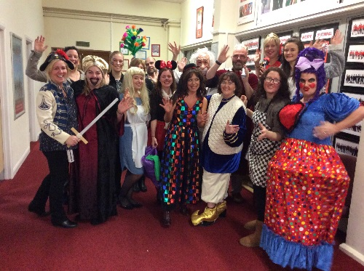
Safeguarding
We have a Safeguarding Policy which explains how the academy works to ensure that children are thriving and safe. Full policy is on the Greenwood Academy website: https://www.greenwoodacademies.org/page/?title=Trust+Policies&pid=19
We take safeguarding and the protection of children very seriously. We offer support for all families in need and can help access other agencies if required. There are learning mentors available.
If you would like any support please talk to the class teacher, a learning mentor or one of the principals.

Academy uniform
The academy uniform has proved very popular and children are encouraged to wear it to feel part of the academy community. All uniform is ordered online at Price & Buckland www.pbparentsonline.co.uk/studfallacademy
It consists of:
- Purple academy sweatshirt, cardigan or jumper - Black for year 6
- White or White with purple trim academy Polo Shirt
- Grey or Black trousers, skirt or pinafore
In summer:
- Grey or black shorts or purple/white dress
- Grey or white socks or tights
- Black or grey shoes
- Uniform fleeces and waterproof jackets are available, and are popular all the year round.
N.B. Trainers with long laces and shoes or sandals with high heels are not suitable for school.

Sun Protection
During the summer months all children should have a named sun hat in the academy, which they will be encouraged to wear when playing outside.
Academy staff are not permitted to apply sun cream to children, but we would ask that you apply a long-lasting sunscreen before school in sunny weather. Children may reapply their own sun cream which must be provided in a clearly named container.
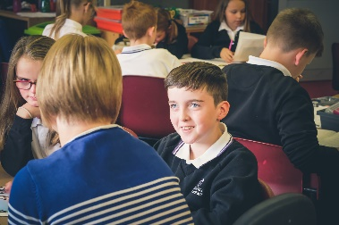


Academy Meals
Kingswood Kitchens provides our hot meals, which are cooked on site. The caterer provides vegetarian meals and a packed lunch alternative. These need to be ordered one week in advance on the Wednesday by midnight. Alternatively, children may bring a packed lunch to the academy. See leaflet enclosed in pack for more details of meals provided by Kingswood Kitchens.
Children who bring packed lunches bring their own non-fizzy drink, or water is freely available. Parents may send cartons of drink to the academy. Flasks, cans or bottles are not acceptable because of the dangers of breakage or leakage. We also ask that parents do not put sweets or nuts into lunchboxes.
Milk will be offered free of charge to children entitled to free school meals.
Pupil Premium: Would you like to have a £50 voucher?
IF YOU THINK YOUR CHILD MAY BE ELIGIBLE TO FREE SCHOOL MEALS BECAUSE OF YOUR FINANCIAL CIRCUMSTANCES, THEN PLEASE APPLY.
THIS WILL HELP THE ACADEMY TO GET EXTRA FUNDING AND WE WILL ABLE TO SUPPORT YOU. (EVEN IF YOU DO NOT WANT THE ACTUAL MEAL.)
All children at the infant academy are entitled to a free school meal, but from nursery to year 6 you may also be eligible for PUPIL PREMIUM.
The government allocates extra funding to a school in the form of ‘Pupil Premium’.
One of the criteria used to calculate this additional funding for a school is the number of pupils at the school who are eligible to receive Pupil Premium Free School Meals (FSMs). Unfortunately, like many schools, a number of parents/carers do not claim, even though they are entitled to, and the school then does not receive this additional funding.
The school’s additional funding is based on the number of children who are registered to receive Pupil Premium FSMs. Because this funding is very important to the school and can make such a difference, we are writing to all parents and carers to ask them to make a claim, if they believe they can (and do not already do so).
It is simple to check if you are eligible. This can be done by simply sending a text message saying “FSM” followed by your full name, National Insurance Number, your child’s name and school to 60622
Or apply online at https://www.northamptonshire.gov.uk/councilservices/children-families-education/schools-and-education/Pages/free-school-meals.aspx
We are sure you will agree the children at our academy can only benefit if we are able to attract additional funding. Not only that, our catering team provides an excellent range of healthy lunch options that are enjoyed daily by a significant number of our children.
If you claim Pupil Premium FSMs, you may be entitled to other services by the academy such as:

£50 voucher to spend on:
- Uniform
- Day Trips
- Books from the book fair
- Free milk daily
- Academy Photographs
In addition, if you register:
- You will be given £50 towards any residential trip in Years 4, 5 and 6.
- Access to additional support for your child’s learning and/or well-being
- Possible financial support in other areas, in discussion with the principals and leadership team.

The more funding we access, the better range of support we can offer. How we spent last year’s pupil premium is always published on our website.
In order to claim Pupil Premium FSMs, a parent/carer must be claiming one of the following benefits:
- Income Support
- Income based Job Seekers Allowance
- Child Tax Credit, with no element of Working Tax Credit*, and a household income below £16,190 (as assessed by HM Revenue and Customs)
- National Asylum Seekers Support
- Guarantee Element of State Pension Credit
- Income Related Employment and Support Allowance
If you would like any help or advice on completing the forms, please speak to the office staff or a learning mentor and we will be happy to help.
Smoking
We operate a no-smoking policy – smoking is not permitted anywhere within the school or grounds.
Complaints
Any complaints about academy matters should first be discussed with class teachers or brought to the attention of the Headteachers. The full complaints policy and procedure is on the Trust website. The link to this can be found pn our website, www.studfallacademy.co.uk under the ‘About Us’ button and in key policies.
Charging Policy
At Studfall, we are constantly seeking to enrich the children’s learning experiences through trips, by inviting visitors and experts to talk to the children and by running activities and workshops. The children always feedback that these activities bring learning to life and are some of their most memorable experiences of primary school. Where possible, we look for free activities or apply for funding that will enable the academy to provide enrichment opportunities at no cost to families.
On occasions, activities are undertaken or visits made during the academy day for which parents are invited to contribute voluntarily towards the cost. No pupil will be refused a place on these activities if the parents are unable or unwilling to pay. Unfortunately, some activities or visits may not go ahead if insufficient funds are available.
Parents are asked to contribute to the cost of any reading books which may be lost or damaged at home.
The Charging Policy can be found on the school website under the ‘About Us’ button and in key policies within the finance section.
Public Access to Documents
Principals are required to give access to documents under the Freedom of Information Act. For a copy of the policy relating to Freedom of Information, please enquire at the academy office.

Breakfast Club

This has been running successfully for many years and is organised by members of the academy staff. The cost to parents is £3.00 per day. If you would like further details of the Breakfast Club, please enquire at the academy office.

After School Club

Prior to “Lockdown”, the academy had links with Mucky Pups (who take children from Year 1 to Year 6 and was held on the junior site) and to Little Learners at Our Lady’s Primary School where children were collected after school and transported to the clubs.
Extra-curricular activities
The following are just some of the clubs that we ran last year at the Junior Academy.
 | Time | Club | Year Group
Monday | Lunchtime | ICT | All
 | 12.40pm-1.10pm | Homework Club
 | 12.10pm-1.10pm | Cube Activities | Year 6
 | 12:10-12:40 | Football
 | Lunchtime | Board Games | All
 | 3.30-4.30 | Fun stations | Invitation only
 | 3.30-4.30 | ICT | Years 5/6
Tuesday | 8.10-8.40 | Gym club | All years
 | 10.00am-10.45am | Fun club | Invitation only
 | Lunchtime | ICT
 | Lunchtime | Board Games | All
 | 12.40pm-1.10pm | Rounders | All
 | 12.10pm-1.10pm | Boys Lunch | Invitation only
 | 3.30pm-4.30pm | ICT Club | Years 3/4
Wednesday | Lunchtime | ICT | All
 | Lunchtime | Board Games | All
 | 12.10-12.40 | Boccia | Invitation only
 | 3.30-4.30 | Tag Rugby | Year 3/4
Thursday | Lunchtime | ICT | All
 | 12.10pm-12.40pm | Girls' Lunch | Invitation only
 | 12.40-1.10 | Girls/Boys Football
 | 12.10-12.40 | Gardening Club | All years
 | 12:40-1:10 | Lego | Invitation only
 | 12.10-1.10 | Change4Life Club | Invitation only
 | 12:40-1:10 | D&T Club | All years
Friday | 12.40pm-1.10pm | Games Club | Invitation only
 | 12:10-1:10 | Board Games | All
 | 12:10-12:40 | Gardening Club | All
 | 12:40-1:10 | D&T Club | All years


Clubs information is sent out by letter and/or Groupcall and then if over sub-scribed, names picked out of a hat. Good behaviour is essential at all clubs and a place can be removed if necessary. Most clubs are free but some clubs have a small charge. To join a club outside of school hours, the child must be registered on Groupcall
Fund Raising Events
From time to time the school will hold events to raise funds which will be used to enhance the environment for the children.

Foundation Stage
Nursery and Reception
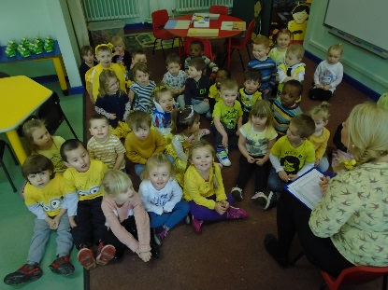
The Foundation Stage aims to provide an environment in which a child can develop social skills through interaction with other children and adults. From the start emphasis is placed on personal and social development and speaking and listening. We aim to develop the natural curiosity which children have in the world around them, and to give them first hand experiences using a variety of different materials. Children are encouraged to be independent, confident and caring towards living things. An interest in books is nurtured and the children are encouraged to listen carefully and respond appropriately. Challenging physical play activities are offered.
Children are well prepared for their move from Nursery into Reception, and Nursery and Reception teachers plan closely together using the Early Years and Foundation Stage Curriculum to promote continuity. As the Reception year progresses, some more formal approaches are used to prepare children for the transition to the full National Curriculum in Year 1.
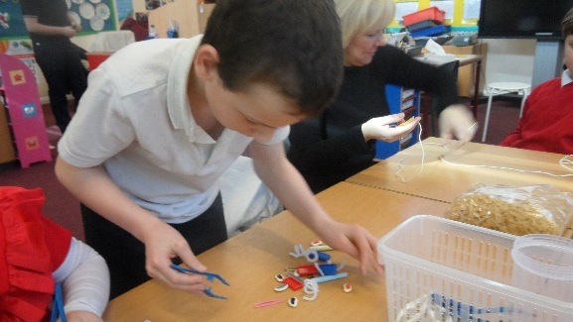
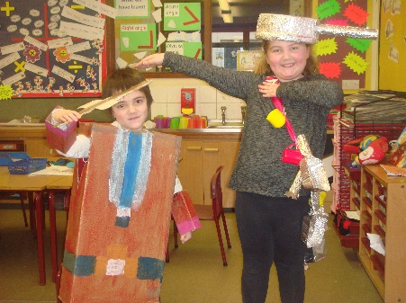
Key Stage 1 & 2
The academy aims to deliver a broad, balanced, relevant and differentiated curriculum to all pupils. We work hard to ensure that work meets the individual child’s needs.
All curricular areas are taught in accordance with the updated National Curriculum requirements. The core subjects are English, Maths and Science and these are taught in conjunction with Design and Technology (D&T), Art, Music, Physical Education (P.E.), Geography and History. Religious Education (R.E.) is also taught on a weekly basis, and Information Technology (I.T.) is taught across all areas of the curriculum.
The academy uses a variety of teaching methods including whole class, paired work, individual and group work to ensure that children get the most from their lessons. From Year 3 children work in targeted groups for Literacy and Numeracy.
Teachers quickly identify exceptionally bright children and every effort is made to encourage these children to develop their potential.
In addition to encouraging success in academic areas, we also endeavour through the curriculum to encourage children to be members of society by raising their awareness of such issues as citizenship, health and safety, the environment, personal and social education and economic and industrial understanding. Through teaching and example, we hope to pass on to each child the attitudes and values which will help them to be part of a helpful and caring society.
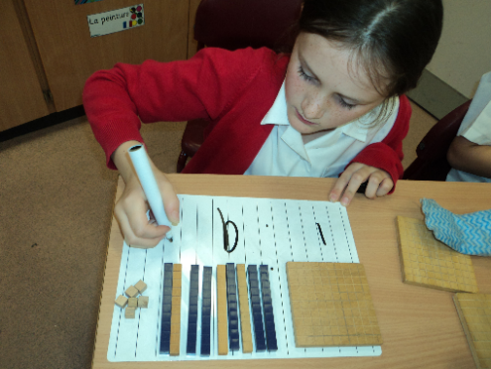
Maths
Mathematics is a core subject of the National Curriculum. We aim to foster a positive attitude to mathematics as an interesting and enjoyable subject, and to provide opportunities to undertake challenging investigations using number knowledge, and to practice number skills through mental, oral and practical work in number.
Whenever possible maths is used in a real and cross-curricular context to help solve a wide range of problems. We encourage children to use practical resources to help them to consolidate their understanding of number and other areas of maths. We aim to enable children to effectively use mathematics as a tool in a wide range of activities within school and adult life.
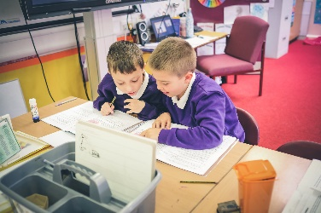
English
This is a core subject of the National Curriculum. Our
aim is to enable all pupils to develop fully their
abilities in the areas of speaking, listening, reading
and writing. Opportunities to use and practise these
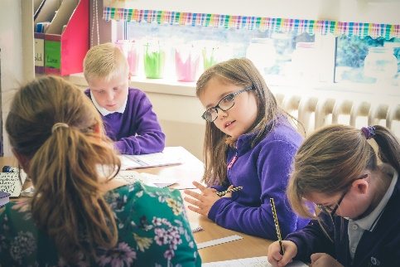
skills occur in all areas of the curriculum. Children
are encouraged to express their thoughts and ideas in
a variety of ways to enable them to acquire the skills
to express themselves clearly and purposefully.
In the area of reading and literature we aim to teach the children the skills to enable them to read with greater understanding and independence. A variety of approaches to reading are used and the children learn letter sounds phonics, basic sight vocabulary and also learn to read for enjoyment. Children gain experience of reading in all areas of the curriculum. All classes have the opportunity to use the well, stocked academy library.
Children are given the skills and opportunities to present their ideas, information and impressions in a variety of written forms. We also focus on how sounds are linked to letter formations to develop good handwriting. Spelling rules are also taught and developed in specific sessions.
Science
Young children are naturally curious about the world around them and so we aim to provide a science curriculum which extends this curiosity and gives our children every opportunity to observe at first hand, question, experiment, record and form conclusions. We believe that this should happen through practical activities where the children are encouraged to use a variety of materials and equipment suitable to their age and ability.
Our science work is organised through topic work based on investigative questions with cross-curricular links and complies with the requirements of the updated National Curriculum.
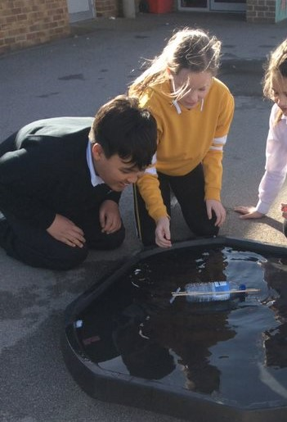
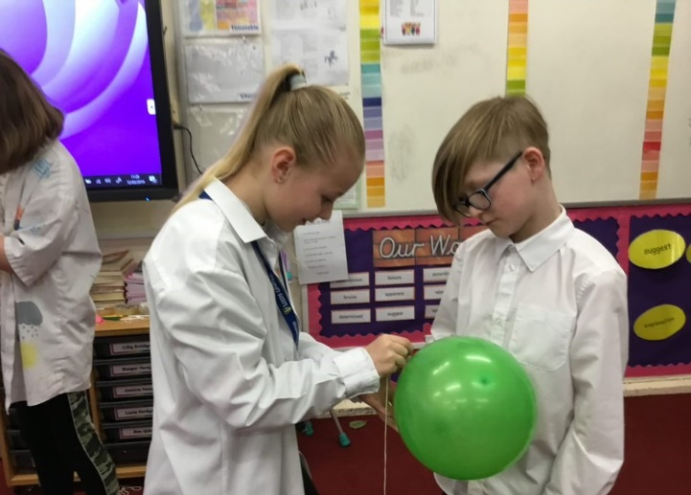
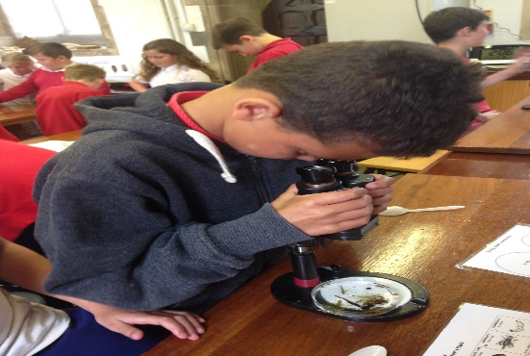

We aim to give the children ample opportunity to explore the immediate environment of the school grounds. All pupils have the opportunity during the year to visit our forest school site on our Academy Grounds and Thoroughsale Woods.

History and Geography Our aim is to develop the children’s knowledge, skills and understanding by encouraging them to develop an awareness of the past and how it was different from the present Topics will have a ‘big question’ for the children to investigate. Children will have the opportunity to develop simple mapping skills, field-work techniques, and to gain knowledge of both their local environment and places on other continents.
The children at Studfall Junior Academy gain an understanding of the past in relation to themselves, their families, their communities and the wider world. They investigate and learn to make deductions from historical sources, such as photographs, artefacts, film and buildings. Within their study of history, children will engage in creative approaches to learning, linking their understanding to other areas of the curriculum.

Understanding ourselves by understanding the past – British History
During their time at Studfall Junior Academy, the children will have the opportunity to develop a strong sense of chronology through their learning of history, which takes them on a journey from the Stone Age to 1066. They will explore the invasions and the settlements of the Romans, the Anglo Saxons and the Vikings; recognising the influences of each era and their impact on Britain. Children will also embark on a local history study; enriching their understanding of the town and their local heritage.

Understanding ourselves by understanding the past- The Wider World
Children will learn about the life and the achievements of the Ancient Greeks, the Ancient Egyptians and the Islamic Golden Age. Children will explore the different ancient civilizations and will begin to identify how they have all contributed to and influenced our lives today.

Thinking skills
When our pupils learn history, they are not just gaining chunks of knowledge about people and events. They are also developing thinking skills - particularly critical thinking - and attitudes that will stand them in good stead elsewhere in the curriculum and throughout life. One key example is distinguishing between fact and opinion, when examining evidence. In an information age it is increasingly important to be able to evaluate the reliability of your sources. Within history pupils are introduced to this way of thinking.

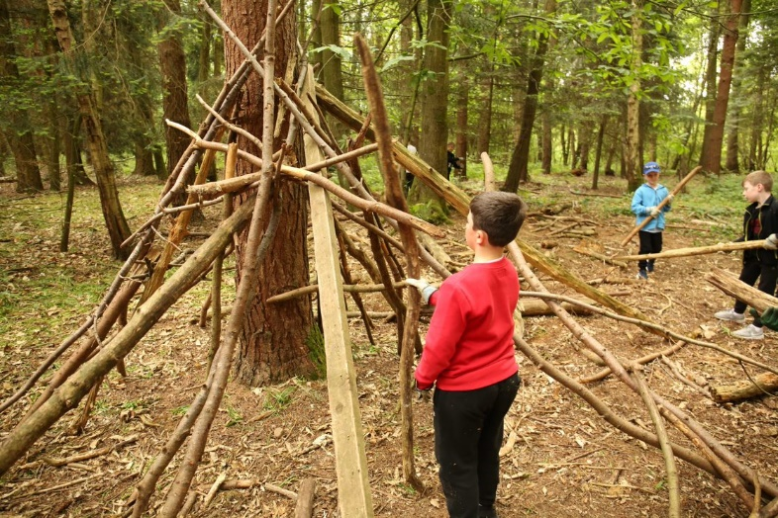

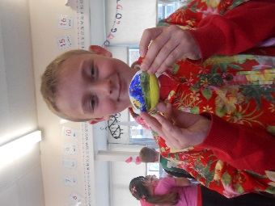
Art
We aim to give children first-hand experiences using a variety of media, and to provide the opportunity to study the work of well-known artists and develop their skills of fine-art appreciation.

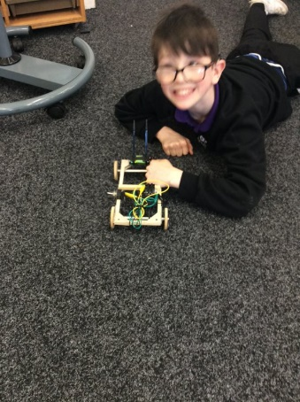
Design and Technology
Work in this subject is based on the National Curriculum and is often linked with a topic the children are working on. Children are given a wide experience of different materials and techniques, and are taught basic skills and the correct use of tools. Through Design and technology activities, we aim to develop the children’s creativity, resourcefulness and confidence. Children are introduced to the design process and are also encouraged to comment on the end product.
Computing
At Studfall Junior Academy, we embrace current and emerging technologies to facilitate the learning experience of the whole school community. We aim for our children to be confident, competent and discerning users of digital technology which will prepare them for participation in a rapidly changing world. At Studfall, children are encouraged to incorporate ICT in everyday school life, across all areas of the curriculum. The school has a state-of-the-art dedicated computer suite. ICT lessons are delivered by the class teachers. Each class room is equipped with class computers connected to the school system enabling the children and staff to access their own folders, programmes and internet from anywhere in school. Laptops and iPads are also available and are used for individuals and small or large group situations. We have interactive whiteboards in all classrooms so children can enhance their learning via Interactive Teaching and Learning Tools. As well as computers, at Studfall we are encouraged to use data logging equipment, digital microscopes, digital cameras (still and video), movie making software and other audio-visual equipment. All stakeholders model how to use technology safely, respectfully and responsibly.




Music
We aim to provide a curriculum, which encourages listening skills, singing, music making and an appreciation of a variety of forms and styles of music. We use an interactive programme to help to develop children’s ability in music.
Children are encouraged to perform at other events in the school year such as Harvest Festival and Christmas. Children have the opportunity to play a variety of percussion instruments, and also to make and play their own instruments.

Physical Education
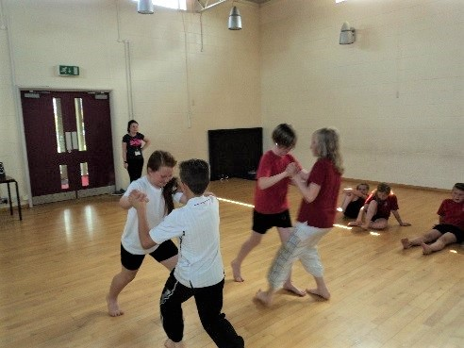
We aim in this subject to offer great opportunities for developing a healthy, active life-style through a variety of physical experiences - gymnastics, dance including country dancing, games, athletics, outdoor activities and team work. The children receive up to 2 hours of P.E. a week including both indoor and outdoor facilities, weather permitting, lunchtime play and Activate.

Children will have the opportunity to develop their potential for physical fitness and skill, in individual performance; and as a member of a group. Children will also be encouraged to contribute to the assessment of their performance. They enjoy competition particularly during our sports day and inter class competitions. Our school also takes teams of children to join in with Corby wide sporting competitions.

Religious Education and Assembly

Through our approaches to Religious Education and Assembly and Worship, we aim to enhance the spiritual, moral, and cultural development of each child. This forms part of the whole ethos of the academy, which emphasises care for each other and the environment, tolerance, understanding and discipline.
In keeping with the community of which the school is a part, our approach to religion is broadly Christian in nature and we have developed close links with St. Columba’s church in Studfall Avenue. However, reference is made to other cultures and religions by using festivals, celebrations and customs from other religions to raise the child’s awareness of other faiths.
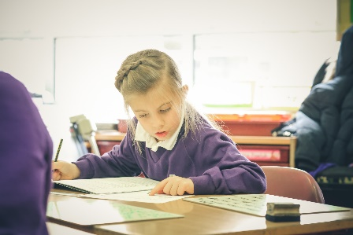
Our academy has adopted the Northamptonshire Agreed Syllabus for R.E. Through this, the children are introduced to the main concepts of Christianity. Their awareness of other cultures and religions is raised through festivals and celebrations - in particular those of Judaism. Links are formed with local churches for visits and services. Children are encouraged to discuss their own beliefs and the beliefs of others, being tolerant and understanding about differences.
Parents may request to withdraw their children from religious Education and from Assembly and worship on religious grounds.
Drama
Through Drama, we aim to provide opportunities for the children to develop a range of practical skills which inter-relate within the working classroom. Drama focuses on confidence building and working together with their peers, which is always approached in a positive and non-threatening environment throughout the academy.

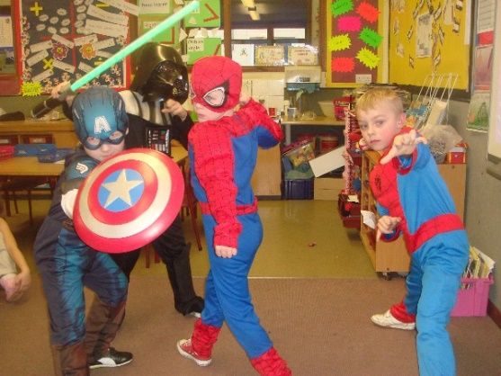
Personal, Social and Health Education
We aim to give the children an awareness of the need to care for their own bodies through health care, diet and cleanliness. We also aim to teach them to apply the knowledge and skills of safety education in the home, at play and on the roads as well as at the academy.

The academy has adopted the Circle Time model, which encourages all children to be aware of their role in promoting a happy healthy and safe community. During circle time, classes discuss issues relating to PSHE and citizenship. This is linked to the school Behaviour Policy. We also teach children to reflect on their own feelings and how they relate to others.
Children participate in academy and class councils which encourage them to discuss issues relating to the academy and the environment and to have their say.

Personal Development Education
Through National Curriculum Programmes of study and Religious Education, we begin to lay the foundations for this subject using topic work which deals with relationships. In Years 5 & 6, a parent meeting is held to discuss the programme content for the Personal Development Education we undertake in these year groups.
Parents have the right to withdraw their children from any part of sex education which is not linked with the National Curriculum. The policy for PDE which was agreed with parents and Governors is available from the school.

Drugs Education
The academy has a policy for drug education which has been written in conjunction with Studfall Infant Academy, local secondary schools, LA advisory teachers and the local health authority. In the KS2, the focus is on knowing what is good for you and medicines are safe for you. Children are encouraged to reflect on safe, healthy practices.



