Colour
Texture
Tone
Form & Space
Line & Shape
Pattern
Units of Study
National Curriculum 2014
Pupils should be taught six key themes of colour, pattern, texture, line, shape, form and space throughout each academic year. The scheme is designed flexibly so that these can either be:
- six half termly units married to the curriculum map
- or, six themes that are woven from elements of each strand across all the six half termly/three termly topic plans for each year group.
They are encouraged to explore art and design through a creative approach whilst at the same time developing skills in art, design and craft.
Throughout Key Stage 1 and 2 pupils should be taught about the work of famous Global and British artists and sculptors, craftsmen and designers, classical artists and architects through history – this is linked to the curriculum map for core and foundation national curriculum subjects.

Year group | AUTUMN | SPRING | SUMMER
3 | Driver: CORBY  Skill: Drawing  Focus: Tone  Suggested Outcomes: Industrial scene drawing | Driver: WHAT’S IT LIKE TO LIVE BESIDE THE SEA?  Skill: Collage/textiles  Focus: Texture  Suggested Outcomes: Coastal collage | Driver: MEDITERRANEAN  Skill: Drawing and Painting  Focus: Colour  Suggested Outcomes: Still life painting
4 | Driver: VIKINGS  Skill: 3D Structures  Focus: Form & Space  Suggested Outcomes: Hygge room model | Driver: WATER & THE WORLD  Skill: Drawing, Painting and Digital Media  Focus: Pattern  Suggested Outcomes: Digitally manipulated self-portrait or other image | Driver: GREEKS  Skill: Printing  Focus: Line & Shape  Suggested Outcomes: Screen printed merchandise for the Olympics
5 | Driver: WHY SHOULD WW2 NEVER BE FORGOTTEN?  Skill: Drawing & Colour and Collage  Focus: Colour  Suggested Outcomes: Mixed media war art, propaganda posters | Driver: WHY IS THE RAINFOREST AMAZING?  Skill: Collage  Focus: Tone  Suggested Outcomes: Rainforest collage, collaborative installation in communal area | Driver: HOW CAN WE REDISCOVER THE WONDERS OF ANCIENT EGYPT?  Skill: 3D and sculpture  Focus: Form & Space  Suggested Outcomes: Clay canopic jars, death masks
6 | Driver: HOW DO WE VIEW OTHERS AND OURSELVES?  Skill: Drawing and Painting  Focus: Line & Shape  Suggested Outcomes: Portraits in the style of another artist | Driver: WHY WAS 1066 A TURNING POINT?  Skill: Textiles  Focus: Texture  Suggested Outcomes: Collaborative art | Driver: WAS THE GOLDEN AGE OF ISLAM REALLY GOLDEN?  Skill: Printing  Focus: Pattern  Suggested Outcomes: Lino print

Year Groups | Suggested Global and British artists, sculptors, designers & architects to be studied across the units and key experiences linked to the curriculum map and academy schemes of work.
 | Painters &  Sculptors | Designers & Architects
Year 3 | Lowry  Monet  Paul Cezanne
Year 4 | Yayoi Kusama  Dan Mather  Joan Miro  Blexbolex | Cath Kidston  Orla Kiely  William Morris
Year 5 | Norman Wilkinson  Henri Rousseau  Georges Seurat | Shepherd Fairey
Year 6 | Henri Matisse  Amadeo Modigliani  Pablo Picasso  Frida Kahlo | Greyson Perry  Gaudi

Year 3
 | Autumn Term |  | Spring Term |  | Summer Term
 | Drawing - Tone |  | Collage/Textiles - Texture |  | Drawing/Painting - Colour
 | Autumn 1 | Autumn 2 | Spring 1 | Spring 2 | Summer 1 | Summer 2
Overview | 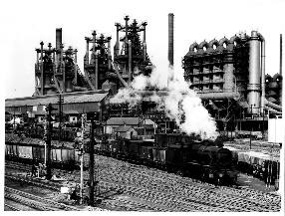  History of Corby including the Steelworks | D&T | 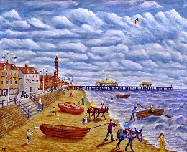  What do our coasts look like? | D&T | 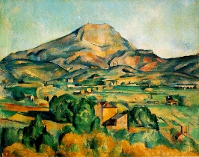  Mediterranean | D&T
Suggested Outcomes | Tonal drawing inspired by |  | Collaborative collage |  | Painting on canvas
Key Experiences | Experiment with media  Light and dark in the environment  Recognise different tones of one colour |  | Combine a range of materials  Embellish on collage work  Simple weaving |  | Harmonious colours  Tertiary colours (mixture of secondary colours and their opposite primary colours in the circle)  Matching colour to environment
Key Skills | Drawing: Select and record from first hand observation, experience and imagination, and explore ideas for different purposes.  Question and make thoughtful observations about starting points and select ideas to use in their work.  Make marks and lines with a wide range of drawing implements e.g. charcoal, pencil, crayon, chalk pastels, pens etc.  Experiment with different grades of pencil and other implements to draw different forms and shapes. Begin to show an awareness of objects having a third dimension.  Experiment with different grades of pencil and other implements to achieve variations in tone. Apply tone in a drawing in a simple way. |  | Collage: Experiment with a range of collage techniques such as tearing, overlapping and layering to create images and represent textures.  Use collage as a means of collecting ideas and information and building a visual vocabulary.  Textiles: Use a variety of techniques, e.g. printing, dyeing, weaving and stitching to create different textural effects.  Match the tool to the material.  Develop skills in stitching, cutting and joining.  Experiment with batik/ paste resist. |  | Painting: Experiment with different effects and textures inc. blocking in colour, washes, thickened paint creating textural effects.  Work on a range of scales e.g. thin brush on small picture etc. Create different effects and textures with paint according to what they need for the task. Colour mix colours and know which primary colours make secondary colours.  Use more specific colour language  Mix and use tints and shades.  Compare ideas and methods in their own and others work.  Explore the roles of artists, craftsmen and designers working in different times and cultures.
Key Vocab | Dark, light, tone |  | Texture, textiles, embellish, weave |  | Primary, secondary, harmonious, tertiary colours, observe, still life
Suggested Artists/  Stimuli | Lowry, industrial landscape by day/night/sunrise/set, any appropriate artists conveying dark/light to reinforce objectives |  | Impressionist other than Monet and Van Gogh, any real or imaginary composition, Kurt Schwitters |  | Paul Cezanne
Suggested Materials | Chalk, charcoal, pastels, paint – mix with most appropriate colour to darken/lighten, paint colour swatches |  | Strips of fabric, lace, ribbon, etc. Beads, pasta, threads, recycled materials, tissue, paint, magazines |  | Ready mixed paint, palettes, variety of brushes, watercolour palettes

Year 4
 | Autumn Term |  | Spring Term |  | Summer Term
 | 3D and Sculpture – Form & Space |  | Mixed Media - Pattern |  | Printing – Line & Shape
 | Autumn 1 | Autumn 2 | Spring 1 | Spring 2 | Summer 1 | Summer 2
Overview | 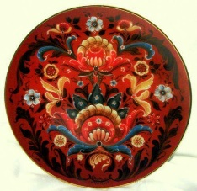  3D Structures | D&T | 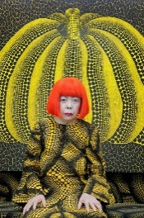  Drawing, Painting & Digital Media | D&T | 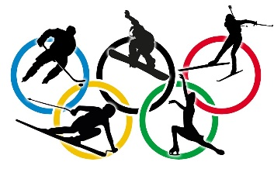  Printing  Block printing & screen printing | D&T
Suggested Outcomes | Hygge room models, |  | Digitally manipulated self-portrait, design own wrapping paper/gift bag/tag/card for a given occasion |  | Screen printed tote bags, block prints,
Key Experiences | Rigid materials  Place objects in a real space  Constructions of exploring space  Construct models  Model over armature |  | Recognise and use pattern  Camouflage and patterns in nature  More complex tessellation  Devise own motif |  | Make a collection of drawn shapes  Record simple shapes in more complex situations (lettering, logos)  Looking for shapes inside the outline of bigger shapes
Key Skills | 3D and Sculpture: Plan, design and make models from observation and imagination.  Use papier mache to create a simple 3D object.  Use recycled, natural and manmade materials to create sculptures. |  | Digital Media: Experiment with colours and textures by making an appropriate choice of special effects and simple filters to manipulate and create images for a particular purpose. |  | Printing: Create printing blocks using a relief or impressed method.  Create repeating patterns.  Create prints with two colour overlays.
Key Vocab | 3D, structure, recycle, form, manmade, natural, model, construct, maquette |  | Tessellation, shape, symmetry, manipulate |  | Block-print, overlay, impressed, relief, intaglio, screen print,
Suggested Artists/  Stimuli | Rosemaling (Norwegian Folk Art), Cath Kidston, William Morris, suspended forms (mobiles, macrame hanging shelves/plant holders |  | Yayoi Kusama, Frida Kahlo, Dan Mather, patterns in nature, wallpaper samples, wrapping paper, Maths tessellation: shape, symmetry, rotational symmetry |  | Joan Miro, Blexbolex, any merchandise appropriate to the topic, logos, lettering
Suggested Materials | Cardboard boxes, PVA glue, wire, paper, tissue, polystyrene, printing ink, newspaper, junk materials, art straws, pipe cleaners |  | Sketching pencils, paint, ICT, paper, pastel, felt tips, card, string |  | Printing rollers, screens, squeegees, ink trays, printing ink, polystyrene sheets

Year 5
 | Autumn Term |  | Spring Term |  | Summer Term
 | Mixed Media - Colour |  | Collage - Tone |  | 3D and Sculpture – Form & Space
 | Autumn 1 | Autumn 2 | Spring 1 | Spring 2 | Summer 1 | Summer 2
Overview | 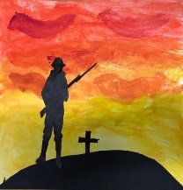  Drawing & Colour and Collage  War Art | D&T | D&T | 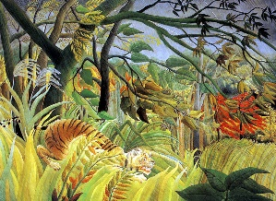  Collage  Rainforest Art | D&T | 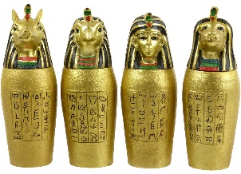  3D and Sculpture  Egyptian Art
Suggested Outcomes | Mixed media war art, propaganda posters |  | Collaborative installation in corridor, |  | Canopic jars, death masks,
Key Experiences | Emotional colours  Harmonious colours  Explore colours to describe space - perspective |  | Experiment with a range of media  Recognise and order tone in different colours  Tone in artists paintings  Textured surfaces  Represent texture via drawings  Choose appropriate materials |  | Clay models and glazing  Produce intricate patterns and textures
Key Skills | Drawing: Use dry media to make different marks, lines, patterns and shapes within a drawing. Explore colour mixing and blending techniques with coloured pencils.  Begin to use simple perspective in their work using a single focal point and horizon.  Begin to develop an awareness of composition, scale and proportion in their paintings e.g. foreground, middle ground and background.  Collage: Add collage to a painted, printed or drawn background.  Use a range of media, techniques, colours and textures etc when designing and making pieces of work. |  | Collage: Add collage to a painted, printed or drawn background.  Use a range of media to create collages.  Use different techniques, colours and textures etc when designing and making pieces of work.  Use collage as a means of extending work from initial ideas. |  | 3D and Sculpture: Shape, form, model and construct from observation and imagination.  Use recycled, natural and manmade materials to create sculptures.  Plan a sculpture through drawing and other preparatory work.  Develop skills in using clay inc. slabs, coils, slips etc.  Produce intricate patterns and textures in a malleable media.
Key Vocab | Primary, secondary, harmonious colours |  |  |  | Adhesive, score, slip, intricate, glaze, form, shape, sculpt, model
Suggested Artists/  Stimuli | Norman Wilkinson, Herbert Mason, propaganda posters (from WWII and present – stay home, save lives, protect the NHS), Shepard Fairey |  | Henri Rousseau, commercially produced colour charts as examples, Georges Seurat, Joseph Cornell |  | Egyptian canopic jars and death masks
Suggested Materials | Colouring pencils, felt tip pens, white chalk, masking tape, hairspray, oil pastels, paint, watercolours, ICT (cameras) |  | Tissue paper, string, corrugated cardboard, art straws, lace, ribbon, tissue, crepe, paper, card, pencils of different types |  | Clay, paint, clay shaping tools, papier mache materials (paper, PVA), tissue

Year 6
 | Autumn Term |  | Spring Term |  | Summer Term
 | Drawing and Painting – Line & Shape |  | Textiles - Texture |  | Printing - Pattern
 | Autumn 1 | Autumn 2 | Spring 1 | Spring 2 | Summer 1 | Summer 2
Overview | D&T | 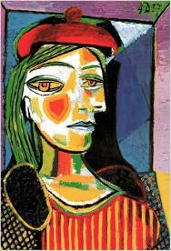  Drawing and Painting-  How we view others and ourselves | D&T | 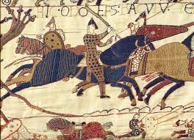  Textiles:  The Bayeux Tapestry | 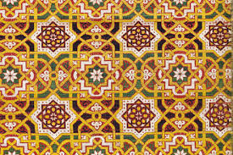  Printing  Islamic Art
Suggested Outcomes | Portraits in the style of different artists |  | Collaborative art |  | Lino print – tessellating picture
Key Experiences | Recording a variety of more complex shapes to create depth in a picture.  Positive and negative shapes.  Proportion.  Use and apply emotional colours.  Experiment and select a range of media.  Tone in artists’ paintings. |  | Textured surfaces.  Experiment with and select appropriate materials. |  | Recognise patterns.  Patterns in nature/architecture/clothing.  Patterns in calligraphy.  Patterns on fabric/paper.  Recognise more complex shapes seen in combination and repetition.
Key Skills | Drawing: Explore colour mixing and blending techniques with coloured pencils.  Use different techniques for different purposes i.e. shading, hatching within their own work.  Start to develop their own style using tonal contrast and mixed media.  Painting: Develop a painting from a drawing.  Carry out preliminary studies, trying out different media and materials and mixing appropriate colours.  Create imaginative work from a variety of sources e.g. observational drawing, themes, poetry, music.  Colour mix and match colours to create atmosphere and light effects.  Work with complementary colours. |  | Textiles: Use different grades of threads and needles.  Experiment with a range of media to overlap and layer creating interesting colours and textures and effects. |  | Printing: Create printing blocks by simplifying an initial sketchbook idea.  Use relief or impressed method.  Create prints with three overlays.  Work into prints with a range of media e.g. pens, colour pens and paints.
Key Vocab | Mixing, blending, shading, tone, contrast, observational, complementary |  | Embroidery, stitch, thread |  | Overlay, blocking, colour scheme, block printing
Suggested Artists/  Stimuli | Matisse, Picasso, Modigliani, Hans Holbein, Frida Kahlo, Jenny Saville, Cindy Sherman, Tim Walker, Rankin |  | The Bayeux Tapestry, Grayson Perry |  | Islamic architecture, Jacques Hnizdovsky, Sorrell Kinley, M C Escher, tessellation
Suggested Materials | Paint, chalk pastels, coloured pencils |  | Embroidery needles, embroidery thread, embroidery fabric |  | Knives, printing material (lino?), coloured printing ink

