These plans are used as a guide for teachers to use in their maths planning. However, teachers use assessments and analysis of data which will inform planning and may mean that some of the long-term plans will be adapted to meet the needs of the children in each class.
Teachers may refer to the previous year’s long-term plan for children who are not working within the age-related expectations for their year group.

Maths Long-Term Plan 2020-2021
Year 1

Autumn Term
Number: Place Value (within 10)
Number: Addition and Subtraction (within 10)
Geometry: Shape
Number: Place Value (within 20)

Spring Term
Number: Addition and Subtraction (within 20)
Number: Place Value (within 50- - Multiples of 2, 5 and 10 included)
Measurement: Length and Height
Measurement: Weight and Volume

Summer Term
Number: Multiplication and Division (Reinforce multiples of 2, 5, 10 included)
Number: Fractions
Geometry: Position and Direction
Number: Place Value (to 100)
Measurement: Money
Measurement: Time

Autumn 1 | Autumn 2 | Spring 1
Number: Place Value (within 10)  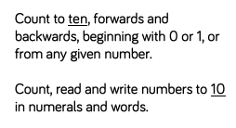  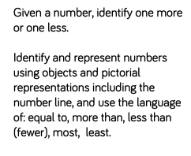  Number: Addition and Subtraction (within 10)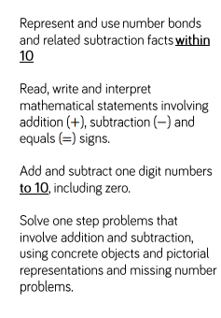 | Geometry: Shape  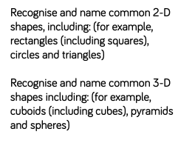  Number: Place Value (within 20)  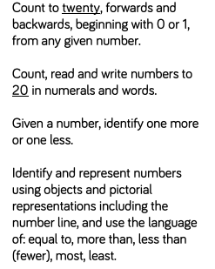 | Number: Addition and Subtraction (within 20)  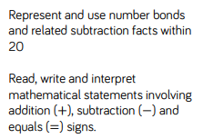  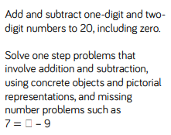  Number: Place Value (within 50- - Multiples of 2, 5 and 10 included)  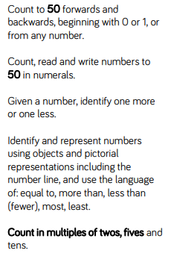

Spring 2 | Summer 1 | Summer 2
Measurement: Length and Height  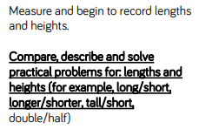  Measurement: Weight and Volume  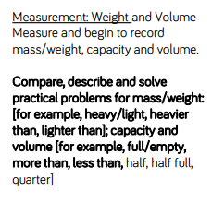 | Number: Multiplication and Division (Reinforce multiples of 2, 5, 10 included)  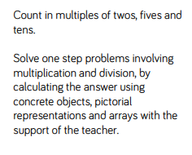  Number: Fractions  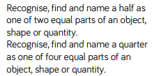  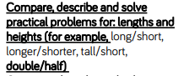  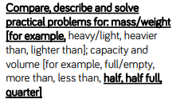 | Geometry: Position and Direction  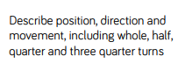  Number: Place Value (to 100)  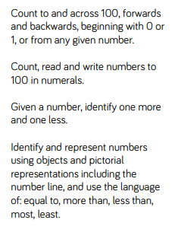  Measurement: Money  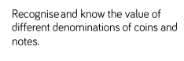  Measurement: Time  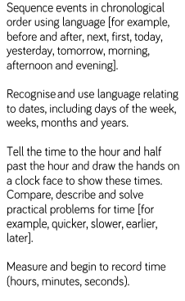

Year 2

Autumn Term
Number: Place Value
Number: Addition and Subtraction
Measurement: Money
Number: Multiplication and Division

Spring Term
Number: Multiplication and Division
Statistics
Geometry: Properties of Shapes
Number: Fractions
Measurement: Length and Height

Summer Term
Geometry: Position and Direction
Problem Solving and Efficient Methods
Measurement: Time
Measurement: Mass, Capacity and Temperature
Investigations

Autumn 1 | Autumn 2 | Spring 1
Number: Place Value  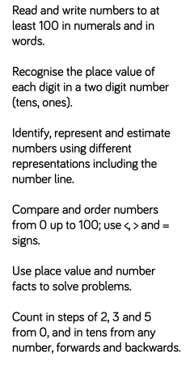  Number: Addition and Subtraction  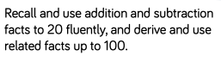  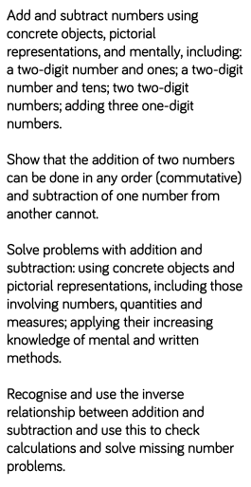 | Measurement: Money  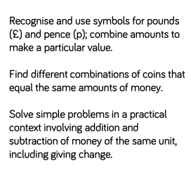  Number: Multiplication and Division  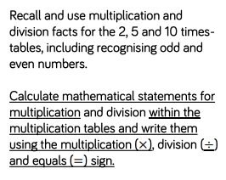  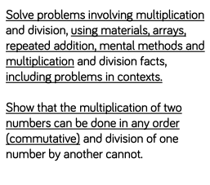 | Number: Multiplication and Division  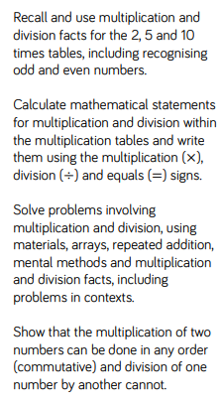  Statistics  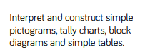  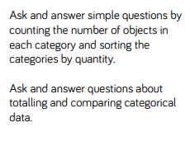  Geometry: Properties of Shapes  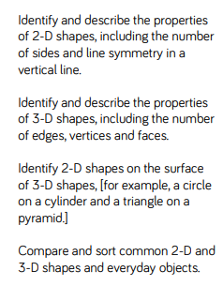

Spring 2 | Summer 1 | Summer 2
Geometry: Properties of Shapes  Number: Fractions  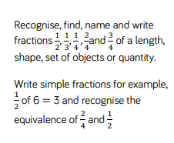  Measurement: Length and Height  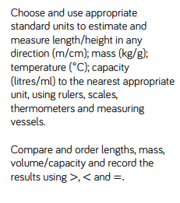 | Geometry: Position and Direction  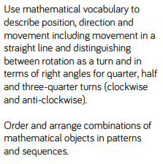  Problem Solving and Efficient Methods | Measurement: Time  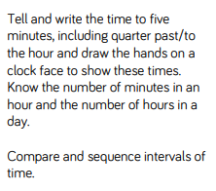  Measurement: Mass, Capacity and Temperature  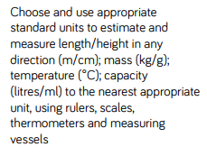  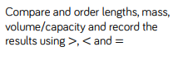  Investigations

Year 3

Autumn Term
Number: Place Value
Number: Addition and Subtraction
Number: Multiplication and Division

Spring Term
Number: Multiplication and Division
Measurement: Money
Statistics
Measurement: Length and Perimeter
Number: Fractions

Summer Term
Number: Fractions
Measurement: Time
Geometry: Properties of Shapes
Measurement: Mass and Capacity

Autumn 1 | Autumn 2 | Spring 1
Number: Place Value  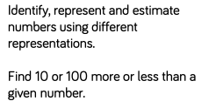  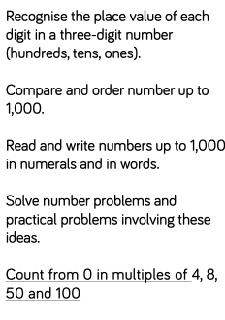  Number: Addition and Subtraction  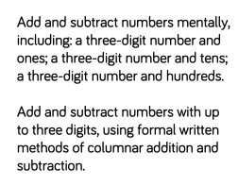  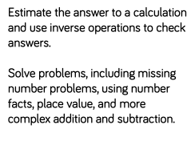 | Number: Multiplication and Division  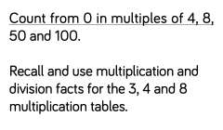  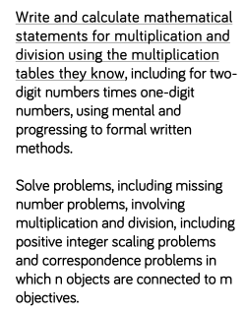 | Number: Multiplication and Division  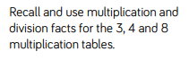  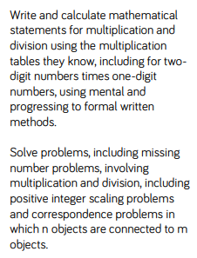  Measurement: Money  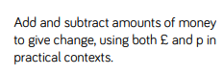  Statistics  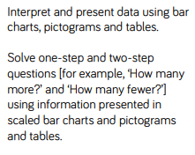

Spring 2 | Summer 1 | Summer 2
Measurement: Length and Perimeter  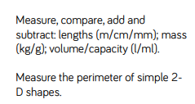  Number: Fractions  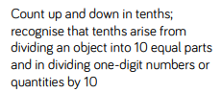 | Number: Fractions  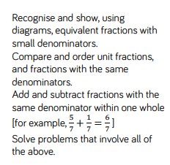  Measurement: Time  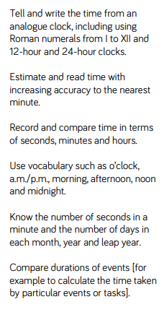 | Geometry: Properties of Shapes  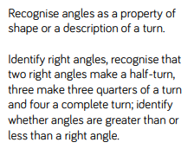  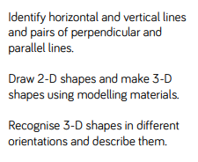  Measurement: Mass and Capacity  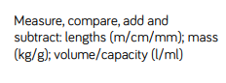

Year 4

Autumn Term
Number: Place Value
Number: Addition and Subtraction
Measurement: Length and Perimeter
Number: Multiplication and Division

Spring Term
Number: Multiplication and Division
Measurement: Area
Number: Fractions
Number: Decimals

Summer Term
Number: Decimals
Measurement: Money
Measurement: Time
Statistics
Geometry: Properties of Shape
Geometry: Position and Direction

Autumn 1 | Autumn 2 | Spring 1
Number: Place Value  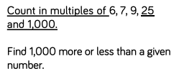  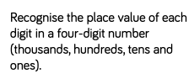  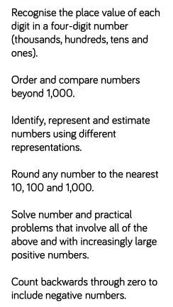  Number: Addition and Subtraction  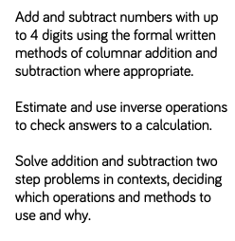 | Measurement: Length and Perimeter  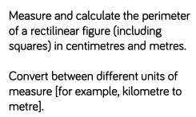  Number: Multiplication and Division  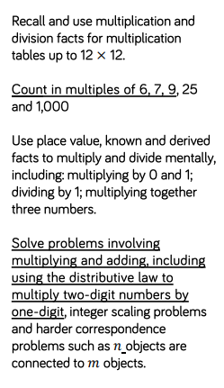 | Number: Multiplication and Division  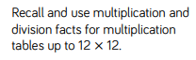  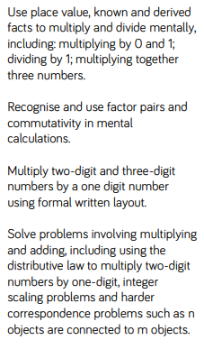  Measurement: Area  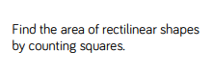

Spring 2 | Summer 1 | Summer 2
Number: Fractions  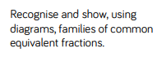  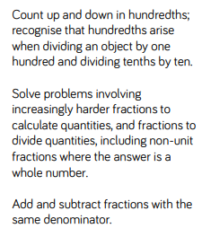  Number: Decimals  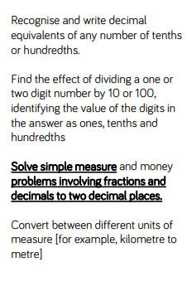 | Number: Decimals  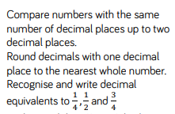  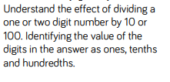  Measurement: Money  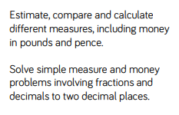  Measurement: Time  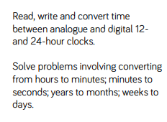  Statistics  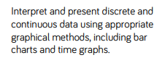  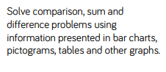 | Geometry: Properties of Shape  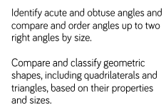  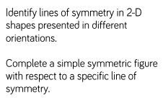  Geometry: Position and Direction  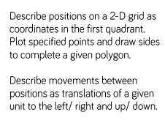

Year 5

Autumn Term
Number: Place Value
Number: Addition and Subtraction
Statistics
Number: Multiplication and Division
Measurement: Perimeter and Area

Spring Term
Number: Multiplication and Division
Number: Fractions
Number: Decimals and Percentages

Summer Term
Number: Decimals
Geometry: Properties of Shape
Geometry: Position and Direction
Measurement: Converting Units
Measurement: Volume

Autumn 1 | Autumn 2 | Spring 1
Number: Place Value  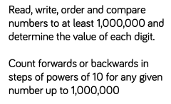  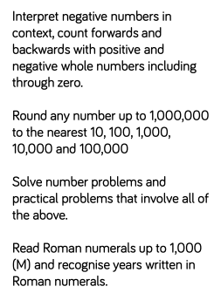  Number: Addition and Subtraction  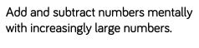  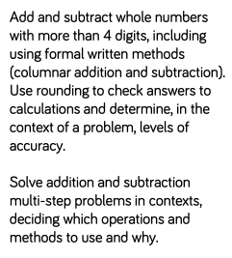  Statistics  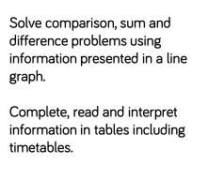 | Number: Multiplication and Division  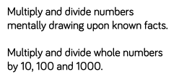  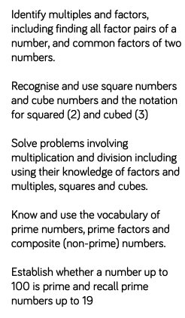  Measurement: Perimeter and Area  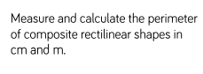  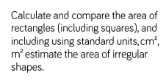 | Number: Multiplication and Division  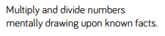  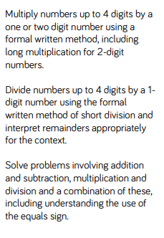  Number: Fractions  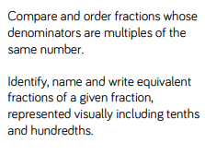  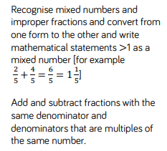

Spring 2 | Summer 1 | Summer 2
Number: Fractions  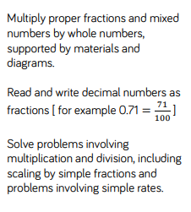  Number: Decimals and Percentages  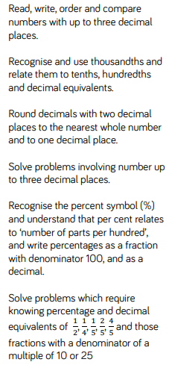 | Number: Decimals  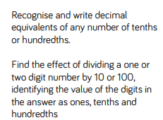  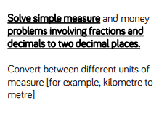  Geometry: Properties of Shape  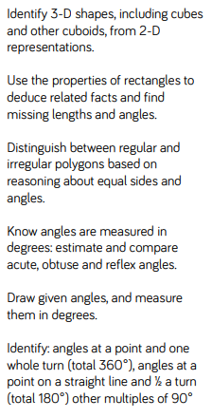  Geometry: Position and Direction  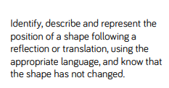 | Measurement: Converting Units  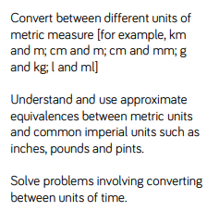  Measurement: Volume  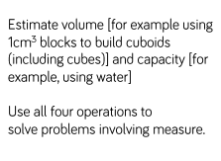

Year 6

Autumn Term
Number: Place Value
Number: Addition, Subtraction, Multiplication and Division
Number: Fractions
Geometry: Position and Direction

Spring Term
Number: Decimals
Number: Percentages
Number: Algebra
Measurement: Converting Units
Measurement: Perimeter, Area and Volume
Number: Ratio

Summer Term
Geometry: Properties of Shape
Problem Solving
Statistics
Investigations

Autumn 1 | Autumn 2 | Spring 1
Number: Place Value  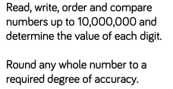  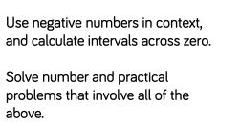  Number: Addition, Subtraction, Multiplication and Division  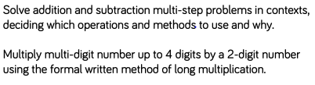  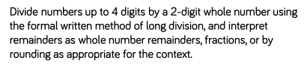  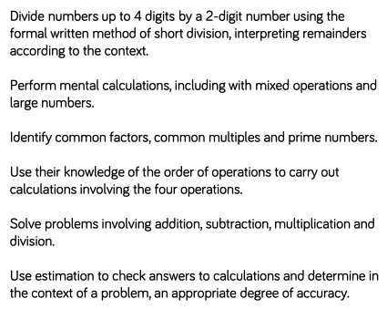 | Number: Fractions  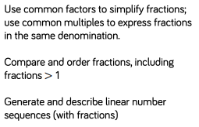  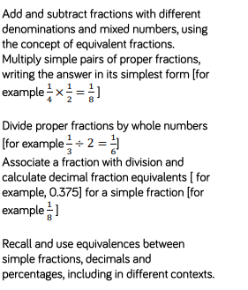  Geometry: Position and Direction  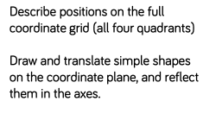 | Number: Decimals  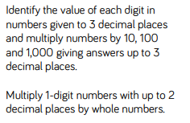  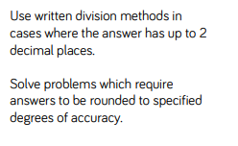  Number: Percentages  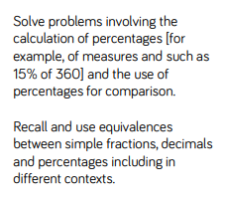  Number: Algebra  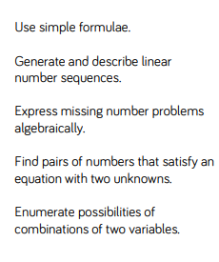

Spring 2 | Summer 1 | Summer 2
Measurement: Converting Units  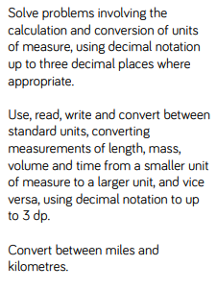  Measurement: Perimeter, Area and Volume  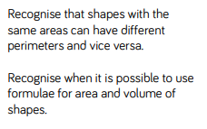  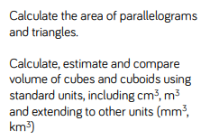  Number: Ratio  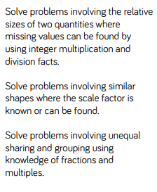 | Geometry: Properties of Shape  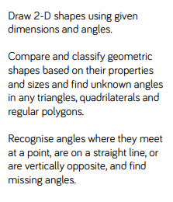  Problem Solving | Statistics  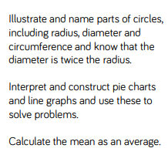  Investigations

