First Access Brass Lessons

The government tell us this in ‘The Importance of Music (DFE 2011 – The National Plan)’. Let us help you deliver the government’s aspiration in your school.
To support this aspiration, NMPAT is devolving £310,000 of government money to schools as a grant to enable every child to have a First Access experience during their primary school experience. Quote from NMPAT.
At Studfall the children are given the opportunity to learn to play a brass instrument. Each of the 4 classes has 8 1 hour lessons within the school year, which lead to a concert to parents at the end of the sessions.
We have selected year 4 to take part in these sessions. This is an ideal time for the children to experience brass as they are physically ready for this, as most children have their 2 front adult teeth by this stage. Brass is an instrument which appeals widely to both boys and girls, who talk enthusiastically about their experience.
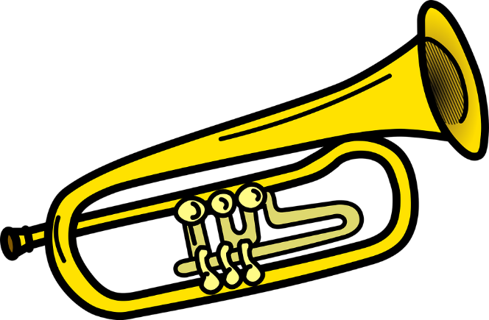
Learning an instrument allows the children the opportunity to develop their knowledge of the key elements of music, such as pulse, rhythm, musical vocabulary, performance and listening to others, as well as allowing them to play a variety of genres. This supports and enhances their class music lessons, and for many encourages a desire to learn to play an instrument.

​​​

